Name: ______Answer Key__________________
- Stirring Spoon Scenario: A spoon is used to stir sugar into a very hot cup of coffee. The spoon heats up very quickly to the temperature of the coffee when it is immersed in the cup. Once the spoon has been used to stir in the sugar, it is very hot and removed from the coffee and set down and begins to cool.

Which graph best fits the temperature of the spoon after it is taken out of the coffee cup? Explain your answer below.

A 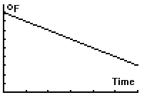 | B 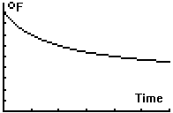 |  | C  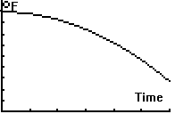
D  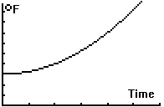 |  | E  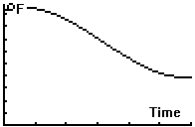

Possible answer: This is because the temperature of the spoon decreases rapidly at first (when there is the greatest difference in its temperature and that of the room), then it decreases more slowly until it levels off at the room temperature (which would not be zero).

- Banquet Seating Scenario: You are organizing a banquet and need to determine how many people can be seated around a rectangular configuration of square tables. Each table seats a single person on each of its four sides. To form the long rectangular banquet table, the smaller square tables are configured where one side of a square table lines up completely with one side of another table. For example, if four tables are pushed together, as shown below, then a total of 10 people could sit at the rectangular banquet table.

- Complete a table with the inputs being the number of small square tables that are being pushed together in a line and the outputs being the maximum number of people the new rectangular configuration would accommodate (in other words, how many would fit around that new long table?). Note that two values were given to you.

Number of  small square tables | Maximum number of people who could be seated at the rectangular table
1 | 4
2 | 6
3 | 8
4 | 10
5 | 12
6 | 14
7 | 16
8 | 18
9 | 20
10 | 22
11 | 24
12 | 28
13 | 30
14 | 32
15 | 34

- What is the maximum number of people who could sit at n small square tables arranged in a row to form a rectangular table (if n > 1)? Write your answer as an equation where M is the maximum number of people and n is the number of small square tables. Be sure to explain your answer.

Possible answer:
Each table added increase the number of seats on the longer edges of the rectangle by 2. The ends always only have space for one person each. So, the equation is M = 2 + 2n.

- How many small tables would be needed to be pushed together in a rectangular configuration to seat 40 people?

Students could count up from the table or solve 40 = 2 + 2n to find that n is 21.

- Graph the relationship where the number of small tables, n, is the input and the maximum number of people who could sit at the rectangular table formed, M, is the output. Be sure to label each access and use possible values.
See graph below.
