INSTRUCTOR’S GUIDE

TITLE OF LESSON:
An Exploration of Mathematical Representations with Applications

ESTIMATED TIME FOR LESSON:
80-90 minutes (NOTE: It is best to have students complete Tasks 1 and 2 on the first day,
then to complete Task 3 on the second day)

SUGGESTED FORMAT:
- Individual in-class
- Collaborative in-class

PREREQUISITE IDEAS AND SKILLS:
- Basic graphing skills
- Concept of a variable and variation
- Definition of a function
- Discrete vs. continuous data
- Multiple representations of functions (moving between verbal description, table, algebraic equation, and graph)

MATERIALS NEEDED TO CARRY OUT LESSON:
- Paper and pencil
- Instructor Presentation Slides:
https://docs.google.com/presentation/d/1-t9iYmXOIcJz5gafeEVmsjubNi2vB4yQRst4dKTHI6U/edit?usp=sharing
- Student Worksheet

OVERVIEW:
Students will develop a deeper understanding of representing real-world scenarios through various mathematical representations, focusing on applied situations that involve covariation. Students will consider the temperature change of a spoon over time, seating arrangements as smaller tables are pushed together, and lawn mowing and the time it takes. Besides being introduced to the idea of mathematical models, the students will practice transitioning between verbal, numeric, and graphical representations while recognizing the differences between continuous and discrete data. Students will also explore dynagraphs to help develop a more nuanced understanding of data representation that emphasizes covariation.

MIP PRINCIPLES ADDRESSED IN THIS ACTIVITY:
Mathematical Understandings
This activity is meant to help students understand that
- proportionality as a constant ratio between two quantities
- a relationship between two variables can be represented in a number of different ways (e.g., numeric, graphical, tabular, verbal forms), and any two representations of a given relationship are simply different forms of the same relationship that still show the same function
- a problem that is situated in a real-world context provides information about the domain of a function
- a function whose domain and range are integers will have a graph that is a set of discrete points, not a continuous graph that is a line
Active Learning
This activity meets the MIP definition of active learning since students:
- select values of a function (for its domain and range) that make sense for a given context-embedded activity
- evaluate whether particular graphs show proportional and/or linear relationships
Meaningful Applications
In this activity, students engage in tasks that involve both continuous and noncontinuous domains. The noncontinuous situation allows students to interpret proportionality in context, when the continuous situations involved exponential and linear functions.
Academic Success Skills
In this activity, the tasks help students engage in productive struggle because they are designed to be at a level where students understand what is being asked, while the task still poses a problem for students that must be pondered to solve. For example, a students’ struggle might look like drawing some images to understand what is going on in the situation before recording some data for the situation and developing a formula.
ACTIVITY:
An instructor might want to use some, or all of, the presentation slide deck found at: https://docs.google.com/presentation/d/1-t9iYmXOIcJz5gafeEVmsjubNi2vB4yQRst4dKTHI6U/edit?usp=sharing
Optional Slides
These first five slides in the slide deck are to help students with the foundational ideas needed for the tasks.
- The first three slides remind students that a letter, often called a variable, can be used to represent an unknown or varying quantity.
- The fourth slide gives an example of a variable in an equation in which the value of the variable actually can vary (assume different values) as well as a “variable” that is really an unknown, with only a single possible value. Slide 4 is meant to help students better understand what variation means and to recognize that the word “variable” is often used interchangeably in algebra classes with “unknown.”
- The fifth slide is to be used to get students thinking about covariation, where two variables are involved and linked in how they change values.
- Slides 6-11 help students review common (algebraic, numeric, graphical) representations. These are representations they should have seen previously, but often have never explicitly been asked to think about the ways in which we represent mathematical relationships.

Task One - Stirring Spoon
Introduction to the Scenario
Slides 12 and 13 then introduce a verbal representation that leads into Task 1. Provide students with the following scenario. Have students read Slide 13 first, which is a lower reading level that is the same, but less detailed, than the scenario that is written below for the instructor to verbalize.
A spoon is used to stir sugar into a very hot cup of coffee. The spoon heats up very quickly to the temperature of the coffee when it is immersed in the cup. Once the spoon has been used to stir in the sugar, it is removed from the coffee and set on a saucer, where it begins to cool.

Discussion
Lead a general discussion about the scenario. Ask students what they think of the scenario. Here are some prompting questions with likely answers in red.
- How hot do you think the coffee was when it was poured?
Probably close to boiling, which might prompt a discussion of what that would be in both °C and °F
- What factors affect the cooling rate of the spoon?
Temperature of the coffee, temperature of the room (which will be addressed); some might add the material or even the shape of the spoon (but we won’t go into that much detail in this task)

Continue to facilitate the class discussion on the spoon temperature and its expected changes over time, including the highest and lowest temperatures; also, prompt students to estimate the spoon’s temperature immediately after stirring and at various time intervals (e.g., 10 seconds, 1 minute, 2 minutes, 10 minutes). This helps students conceptualize the scenario without relying on exact numbers. It might also prompt discussion for students to consider that the rate of change for the temperature is not constant.

Exploration of Graphical Interpretation
Provide students with a series of graphs that represent different cooling rates and patterns. Note that this is the first task given on the Student Worksheet. In small groups of 3-4 students, have learners discuss and determine which graph best fits the scenario. They should consider the principles of heat exchange and cooling rates.
- The specific quantities (numeric values) are purposefully left off the axes below to allow for more conversations. All discussion should be in the context of the scenario.
- Students should consider how the time elapsed and the temperature of the spoon covary.

A 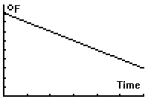 | B 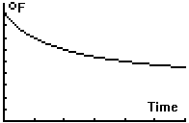 |  | C  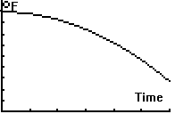
D  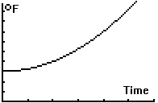 |  | E  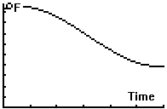

- Student groups should be able to recognize that the increasing graph “D” is not valid, since the temperature of the spoon would not increase.
- The “A” and “C” scenario would not be reasonable either since both show end behavior of the graphs intercepting the x-axis.

The instructor should then provide this scientific explanation of the phenomenon to help the students: The rate at which an object cools is proportional to the difference between its temperature and the temperature of the surrounding environment.

Encourage the small groups to try to put the phenomenon into their own words. This will provide information on how the occurring covariation. To help students interpret the graph that best fits the scenario “B,” the instructor might want to offer some ideas as in Slide 15 for more common language explanation such as what follows (or in Slide 16): The bigger the difference between the object’s temperature and the environment, the faster the object’s temperature changes. The spoon would cool off quickly at first and then level off at room temperature.

This statement will guide students in interpreting the correct graph that represents the cooling process since it emphasizes the initial rapid cooling, that begins to slow, and then eventually levels off as the spoon reaches room temperature.

Conclusion
To conclude the task, point out how the students were moving from the verbal representation (the given scenario) to the numeric representation (using some specific ordered pairs) that led to consider the geometric representation (the graph) of the task. Use Slide 17 if you would like to talk about math modeling. This is especially important if a student has brought up the material of the spoon as a consideration. While this is exponential behavior, that is not the focus of the lesson. It is more on just the focus of covariation and providing a graphical representation that corresponds to the scenario.

Extension (optional) Task students with creating real-world scenarios that are representative of the four remaining graphs. After working independently, allow students to share their scenarios. Students could also create additional graphs for their own real-world situation. Some examples might include charging a cell phone, tablet battery life, population growth, radioactive decay, learning curve, air pressure in a leaking tire, etc.

Task Two - Banquet Seating
Introduction to the Scenario
Slides 18 and 19 introduce a new scenario where students will need to use mathematical representations to model the situation. First introduce the scenario.

You are organizing a banquet and need to determine how many people can be seated around a rectangular configuration of square tables. Each small square table seats a single person on each of its four sides. To form the long rectangular banquet table, the smaller square tables are pushed together where one side of a square table lines up completely with one side of another table. If you have one table, there are seats on its four sides, but when you add another table, you need to account for shared sides between adjacent tables where nobody can sit.

For example, if four tables are pushed together, as shown below, then a total of 10 people could sit at the rectangular banquet table.

Lead a whole class discussion until the students are clear that the students understand the configuration of the rectangular tables formed from pushing together square tables. Then have students refer to the second task on the Student Worksheet. On the worksheet, students are to fill out a table with the inputs (number of small square tables used) and corresponding outputs (maximum number of people the rectangular table can seat), for inputs from 1 to 15.
Students are then asked to identify the pattern so that they can identify the output for any input, called n. Circulate as students are working on this in their groups. Help students identify the pattern. If they are struggling, ask them to draw out the scenario. They should notice that there are always two end seats in addition to two seats per table.
    - 1 table has 4 seats: 2 + 2(1)
1
1 1
1
    - 2 tables in a row have 6 seats: 2 + 2(2)
1 1
1. 1
1 1
    - 3 tables in a row have 8 seats: 2 + 2(3)
1 1 1
1. 1
1 1 1
    - 4 tables in a row have 10 seats: 2 + 2(4)
1 1 1 1
1. 1
1 1 1 1
So, for n tables, there should be 2 + 2n seats. This equation is then useful to solve the next question that gives an output and asks for an input: How many connected tables do you need to seat 40 people?

Next students are asked to graph the scenario. Even though students are prompted on the worksheet to use possible values, many will connect the order pairs they graph to form a line. It is often helpful to ask the small groups if their domain really makes sense, then walk away. This prompting is usually enough for students to realize that only positive integers should be in the domain. It may be the first time they have dealt with a function that is made of discrete, rather than continuous points, as shown below.

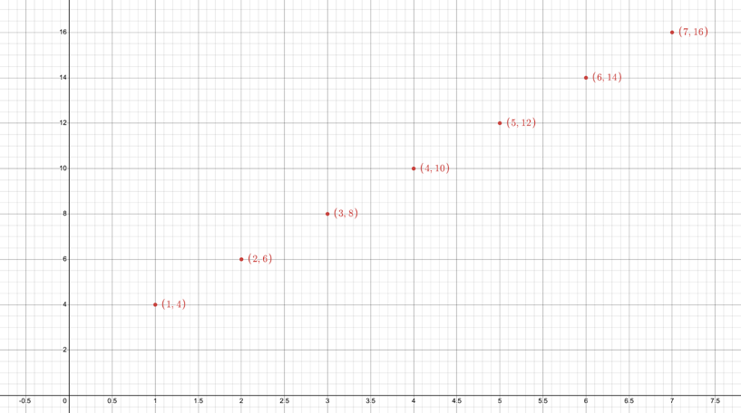
Conclusion
Recap how the scenario helped students understand the importance of using reasonable domains and how the graphical representation reflects the discrete nature of the data. Highlight how the transition from verbal description to numeric and graphical models helps in accurately representing and solving real-world problems.

While the students worked on a worksheet, it may not be one that you collect for a grade, but rather one that you might give everyone credit for completing.

Extensions (optional)
Challenge students to explore similar problems with different configurations. Such as tables arranged in a different pattern (e.g., in a grid) or with different shapes (triangular, hexagonal).
For example, if the tables were equilateral triangles with each side seating one person, what would the equation be? M = 2 + n

If the tables were equilateral hexagons with each side seating one person, what would the rule be? M = 2 + 4n

Encourage students to generalize the structure of the function to these new contexts.

Task Three - Lawn Mowing
Introduction to the Scenario
Once students have completed the worksheet, this next task will introduce what is likely to be a new representation to students. That is why it is nice to start this on a second day. Start with the following scenario.

A person mows lawns in a neighborhood where each lawn is the same size. The goal is to understand the relationship between the number of lawns mowed and the time spent mowing them. To simplify the scenario, we will not take any setup time into account and just will consider time mowing.

Discussion
Present this dynagraph (https://www.geogebra.org/classic/pux8spss) with two parallel axes. The input variable is the number of lawns mowed. The output variable is the time spent (in hours).
You can display the dynagraph, but it is more powerful to have the students manipulate the dynagraph themselves. Give them time to explore.

Discussion of Numeric Representation
Ask what they notice. Here are some possible instructor questions to get you started and likely student answers in red.
- What do the inputs represent?
Lawns mowed
- What do the inputs represent?
Time elapsed (in hours)
- What does the ordered pair (2, ½) mean?
That when 2 lawns are mowed, it takes ½ hour.
- What does the ordered pair (4, 1)?
When 4 lawns are mowed, it takes 1 hour.
- What does the ordered pair (8, 2)?
When 8 lawns are mowed, it takes 2 hours.

Exploration of Graphical Interpretation
Have students plot the data points from their table on a Cartesian graph in groups. Have them discuss how the dynagraph and the Cartesian graph differ even though both represent the same scenario. Ask them about possible benefits and drawbacks of each representation.

Here is one possible table. Note that the inputs should be zero or positive, but that it is possible to use values other than integers since it is possible to only consider the time after a part of a yard has been mowed.
Input (Lawns mowed, L) | Output (Time in hours, T)
0 | 0
1 | .25
2 | .5
3 | .75
4 | 1
5 | 1.25
6 | 1.5
8 | 2
10 | 2.5
12 | 3
14 | 3.5
16 | 4

Development of Equation
Guide students to derive an equation that represents the time, T, as a function of the lawns mowed, L. They should see through the table that the rate of change is constant, every lawn takes ¼ of an hour. So, the equation is T = ¼ L.

Conclusion
Have students discuss the affordances and constraints of the different representations (not just graphical but also algebraic, verbal and numeric) and why it is important to understand how to navigate between each. Here are some sample points to help guide the discussion toward.
- Being able to switch between representations allows students to choose the most appropriate tool for the task at hand, improving their problem-solving skills.
- Different mathematical problems and real-world scenarios require different approaches. Mastering multiple types of representations equips students with the versatility to handle a wide range of problems effectively.
- Comparing the affordances and constraints of each representation encourages students to critically analyze which graph is most appropriate for a given situation, fostering better analytical and critical thinking skills.

