**TITLE OF LESSON: Cube Painting Activity**

**ESTIMATED TIME FOR LESSON:** 50-75 minutes (this is best started with about 30-40 minutes of class time remaining, and then finished on the next class period)

**SUGGESTED FORMAT (check all that are appropriate):**

* Individual in-class
* Collaborative in-class
* Individual homework
* Collaborative homework

**OVERVIEW:**

The key idea of this hands-on collaborative activity is to help facilitate students conceptualizing that covariation is about two quantities varying together in tandem by working in a learning space that allows them to communicate with others, to visualize a geometric context, and to work to understand and resolve the tasks given. These actions will be designed to culminate in students identifying the mathematical relationships and then generalizing across increasingly larger cubes to identify the patterns that develop. This will be done with symbolic and tabular representations.

**PREREQUISITE IDEAS AND SKILLS:**

* Functions, especially polynomials
* Multiple representations of functions (moving between verbal description, table, algebraic equation, and graph)
* Basics of geometry, e.g., volume of cube = (side length)3, area of a square = (side length)2

**MATERIALS NEEDED TO CARRY OUT LESSON**:

* Cube paint activity; here is the link: <https://docs.google.com/document/d/1Cs_CB0RVic1V1R8V_Q0sq4bQZpWy2zyB/edit?usp=sharing&ouid=108364140338221372212&rtpof=true&sd=true>
* Activity Answer Key; here is the link:

<https://docs.google.com/document/d/1IGC0tSKnhkFFLqrlNta9bGonBj4f8qHX/edit?usp=sharing&ouid=108364140338221372212&rtpof=true&sd=true>

* Optional: cm2 paper and scissors (to cut out paper to form cube to aid in student visualization). Here is the link: <https://www.hand2mind.com/media/contentmanager/content/gridpaper.pdf>

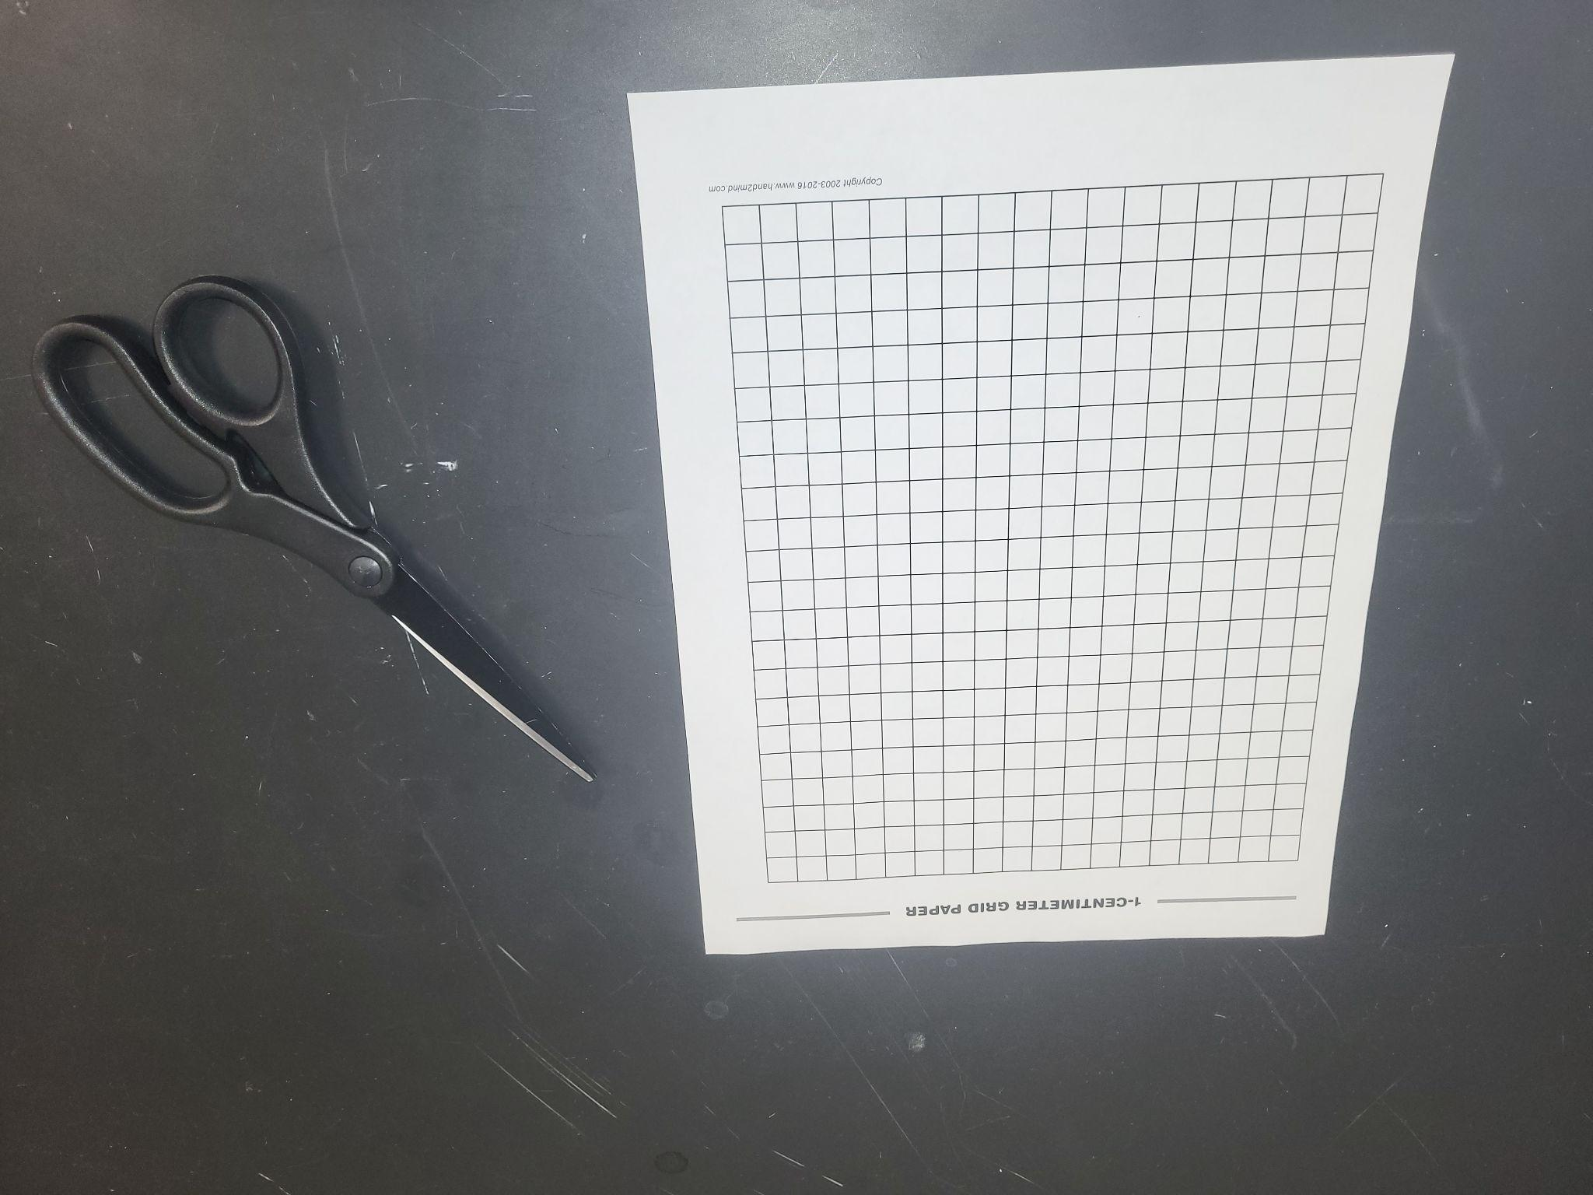

**MATHEMATICAL UNDERSTANDING**:

Students will learn that covariation is about two quantities varying together in tandem by working in a learning space that allows them to communicate with others, to visualize the problematic situation that is geometrically based, and to work to understand and resolve the tasks given across representations. These actions will be designed to culminate in students identifying the mathematical relationships and then generalizing across increasingly larger cubes to identify the patterns that develop.

In engaging in this activity, students will develop a deeper understanding of:

* Covariation -
  + as the relation between two quantities, where the functions that are used involve output values that is determined by input values where changes in one quantity (side length of the big cube) often cause related changes in another (e.g., the number of small cubes that compose the big cube with two faces painted)
  + how quantities can covary in a non-linear fashion, that in this particular example is still dependent on the geometry of the context presented
  + that involves different types of relations in functions, where the focus is on the differences between:
    - constant functions
    - linear functions
    - quadratic functions
* Mathematical Models -
  + how functions can relate to and provide a way to consider quantities in context, even when numbers are unknown or too large, through the use of variables
  + that, given a context, only certain inputs make sense for the given scenario resulting in limited domains based on the context and not the mathematical function
  + how different mathematical representations (tables, graphs, equations) can be used to communicate one’s geometric understanding of a physical situation
* Rates of Change -
  + as occurring naturally in an applied geometric/physical context
  + as being represented in tabular form as a means to make covariational patterns more obvious
  + as being represented using symbolic representations that display the use of the following rates of change:
    - constant (0 rate of change)
    - linear (slope is the constant rate of change)
    - quadratic (rate of change is changing)

**INSTRUCTIONAL PLAN**:

*Preparation (before class)*

* Instructor should read through the entire lesson.
* Paper preparation (optional, but helpful)
  + Copy the cm2 paper
  + Cut out the paper to make different sized cubes (with side length of 2 cm, 3 cm, etc.) to help students with visualization

*Activity*

1. The instructor presents the following scenario to the entire class:

*An 2 x 2 x 2 cube is made from gluing together 8 small 1 x 1 x 1 (unit) cubes. If the large cube is painted, allowed to dry and then broken apart into the small unit cubes, how many of them have paint on*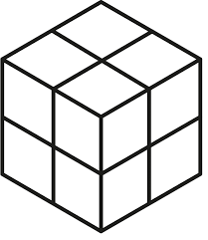

* + *no faces?*
  + *only 1 face?*
  + *two faces?*
  + *three faces?*
  + *four faces?*

It is helpful to provide a visual for the students. At minimum, include the drawing of the cube that is above. (It is even better to use the cm2 paper to cut out the paper to make the outside to appear as being a 2 cm x 2 cm x 2 cm cube.) The instructor should allow students some time to reflect on the scenario and let them discuss the task as naturally occurs between writing the following table for them to record their thoughts.

|  |  |  |  |  |  |
| --- | --- | --- | --- | --- | --- |
| **Side Length of Big Cube** | **Small cubes have paint on…** | | | | |
| **No Faces** | **1 Face** | **2 Faces** | **3 Faces** | **4 Faces** |
| **2 cm** |  |  |  |  |  |

2. The instructor should let students share their thoughts so that all are able to see that each of the 8 small cubes lies in a “corner” position so that each has exactly 3 faces painted. So, the table should be completed as follows.

|  |  |  |  |  |  |
| --- | --- | --- | --- | --- | --- |
| **Side Length of Big Cube** | **Small cubes have paint on…** | | | | |
| **No Faces** | **1 Face** | **2 Faces** | **3 Faces** | **4 Faces** |
| **2 cm** | 0 | 0 | 0 | 8 | 0 |

To help students develop a sense of functions. Suggestion that the following notation be used.

𝑓𝑖(𝑘) to refer to the number of small cubes that have paint on 𝑖 faces when the side length is 𝑘 cm. So,

* 𝑓0(2) stands for how many cubes have 0 faces painted on a 2 cm x 2 cm x 2 cm cube;
* 𝑓1(2) stands for how many cubes have 0 faces painted on a 2 cm x 2 cm x 2 cm cube;
* 𝑓2(2) stands for how many cubes have 0 faces painted on a 2 cm x 2 cm x 2 cm cube;
* 𝑓3(2) stands for how many cubes have 0 faces painted on a 2 cm x 2 cm x 2 cm cube;
* 𝑓4(2) stands for how many cubes have 0 faces painted on a 2 cm x 2 cm x 2 cm cube.

Note that all of the above equal zero except 𝑓3(2) = 8.

3. After presenting the scenario, the instructor should have students form small groups then distribute the cube painting activity worksheet to the groups. While the students are working on the worksheet, the instructor should circulate about the room. It is usually helpful to stop the entire class after most have gotten an answer for the first task on the worksheet to make sure that they realize there are 6 faces (which impact the number of unit cubes with only 1 face painted), there are 12 edges (which impact the number of unit cubes with 2 faces painted), and hidden “inside” the big cube is a slightly smaller cube that has no faces painted (once the big cube is large enough) for which the external unit cubes that are being painted act as a 1-cm shell. It is helpful to solicit student responses so that they can communicate these ideas in their own words rather than telling them these things.

4. Once this seems to be clear to most students, allow them to continue completing the worksheet. Some might need to take it home to finish it as individual homework.

5. To start the next class, we suggest giving a completion grade to all who make an honest effort and submit the worksheet. Start the class by going over the table below as a class, filling in the table row-by-row with student discussion.

|  |  |  |  |  |  |
| --- | --- | --- | --- | --- | --- |
| **Side Length of Big Cube** | **Number of small cubes have paint on…** | | | | |
| **No Faces**  *i* = 0 | **1 Face**  *i* = 1 | **2 Faces**  *i* = 2 | **3 Faces**  *i* = 3 | **4 Faces**  *i* = 4 |
| **3 cm**  𝑓i(3) | 1 | 6 | 12 | 8 | 0 |
| **4 cm**  𝑓i(4) | 8 | 24 | 24 | 8 | 0 |
| **5 cm**  𝑓i(5) | 27 | 54 | 36 | 8 | 0 |
| **6 cm**  𝑓i(6) | 64 | 96 | 48 | 8 | 0 |
| ***n* cm**  𝑓n(6) | (n - 2)3 | 6(n - 2)2 | 12(n - 2) | 8 | 0 |

6. Help the students discuss why the last row is what it is. Here are some points to include:

* There are always eight corners with three faces painted. There are no small cubes with four faces painted.
* The n - 2 that appears repeatedly is the side length of the big cube that has the two “corners” removed.
* The exponent that appears on the final row corresponds with the fact that a line is one-dimensional, an area is two-dimensional, and a volume is three-dimensional.
* The (n-2)3 is a cube that fits inside the big cube. Its units are cubed since they are for volume.
* The 6, which appears in the expression for 1-face painted small cubes, is due to the fact that there are 6 faces on any cube; so, these cubes form a square on each face.
* The 12, which appears in the expression for 2-face painted small cubes, is due to the fact that there are 12 edges; these cubes form a “line” on each edge (minus the corner cubes).

7. Once the table is complete, you should discuss the domain and range of the graphs created from the table above.

* Discuss what domain and range of functions are - not just in terms of ***x*** and ***y*** but also the values that can be inputted versus what can be an outcome. For example, the range of 𝑓0 is the set of positive integer cubes {1, 8, 27, 64, …} due to the interior cube being the only one where none of its smaller cubes have any faces painted. The domain of 𝑓0 is the set {0, 1, 2, 3, 4, 5, 6} since each small cube can only have 0 to 6 faces painted. (Note that only 0, 1, 2, 3, and 4 are considered in the activity though.) Often students are only asked what the domain/range are in instances where the answer is “all real numbers” or “all real numbers greater than 1” or “all real numbers except 1 and -1,” so this is an opportunity to help students better understand discrete domains and ranges based on the context of the function.
* Discuss the differences in the range, depending on whether the general equation has outputs of all real numbers or from zero to infinity and how to know the difference.
* Once you have reviewed the general concepts, remind students that sometimes the physical constraints of the topic will affect what values would be contained within the domain and thus change the range as well.
* Also, it is a good time to remind them to always check for reasonableness in the domain and range. The underlying topic of the problem will dictate the answers and outcomes of their problems.

8. Below are links to the graphs of the table data for No faces painted, One face painted, and Two faces painted.

* [Cube Painting - No faces painted](https://www.desmos.com/calculator/qkjsufkaul)

Link found at: <https://www.desmos.com/calculator/qkjsufkaul>

* [Cube Painting - One face painted](https://www.desmos.com/calculator/aqby7t1aik)

Link found at: <https://www.desmos.com/calculator/aqby7t1aik>

* [Cube Painting - Two faces painted](https://www.desmos.com/calculator/0lcisouxku)

Link found at: <https://www.desmos.com/calculator/0lcisouxku>

**EXTENSION ACTIVITIES**

1. As a whole class discussion, show how tedious it is to determine the following algebraically

(n − 2)3 + 6(n − 2)2 + 12(n − 2) + 8 = n3

Then guide students to instead relay on a geometric explanation that takes into account the physical context to show that

(n − 2)3 + 6(n − 2)2 + 12(n − 2) + 8 = n3

is the same as

𝑓0(n) + 𝑓1(n) + 𝑓2(n) + 𝑓3(n) = n3

Students should be relying on the context of the small cubes and if they are in the interior cube, which is n3 or 𝑓0(n), or if they are part of the exterior layer of the cube where there are:

* 6 faces (each with (n − 2)2 small cubes with 1 face painted); this is 𝑓1(n)
* 12 edges (each with (n − 2) small cubes with 1 face painted); this is 𝑓2(n)
* 8 corners (each with 3 faces painted); this is 𝑓3(n)

2. Begin by discussing the concept of linear equations and what it means to be linear in relation to the idea of adding the same number each time - a constant difference in the outputs. Have the students find the difference between the outputs.

|  |  |  |
| --- | --- | --- |
| Side Length of Big Cube | Small cubes have painted on | Difference |
|  | Two Faces 12(n-2) |  |
| 3 | 12 |  |
| 4 | 24 | 12 |
| 5 | 36 | 12 |
| 6 | 48 | 12 |
| 7 | 60 | 12 |
| 8 | 72 | 12 |
| 9 | 84 | 12 |

3. Continue this discussion by having the students find the differences in the outputs for the quadratic equation (One Face Painted). Ask if they see any patterns in those differences or any patterns that emerge with these numbers. Once they see the pattern emerging in the second difference, discuss why they think the second difference for a quadratic function might be constant. Here, your discussion will depend on how far into derivatives or tangent lines you have gone.

|  |  |  |  |
| --- | --- | --- | --- |
| Side Length of Big Cube | Small cubes have painted on | Difference | Difference |
|  | One Face 6(n-2)2 |  |  |
| 3 | 6 |  |  |
| 4 | 24 | 18 |  |
| 5 | 54 | 30 | 12 |
| 6 | 96 | 42 | 12 |
| 7 | 150 | 54 | 12 |
| 8 | 216 | 66 | 12 |
| 9 | 294 | 78 | 12 |

4. Now take a look at the cubic function. By now, they will know to find the differences between the outcomes for this function. When they do not see the difference in the outcomes, they will move to finding the second difference. Since they will not find a constant difference in the second difference, they will move to the third difference and see the pattern. Again, discuss why a cubic function might have a constant third difference. Here, your discussion will depend on how far into derivatives or tangent lines you have gone.

|  |  |  |  |  |
| --- | --- | --- | --- | --- |
| Side Length of Big Cube | Small cubes have painted on | Difference | Difference | Difference |
|  | No Faces (n-2)3 |  |  |  |
| 3 | 1 |  |  |  |
| 4 | 8 | 7 |  |  |
| 5 | 27 | 19 | 12 |  |
| 6 | 64 | 37 | 18 | 6 |
| 7 | 125 | 61 | 24 | 6 |
| 8 | 216 | 91 | 30 | 6 |
| 9 | 343 | 127 | 36 | 6 |

**POST-ACTIVITY INSTRUCTOR REFLECTIONS**

1. In engaging in this activity, did the students develop a deeper understanding of:

* *Mathematical models*:
  + How functions can relate to and provide a way to consider quantities in context, even when numbers are unknown or too large, through the use of variables.
  + How, given a context, only certain inputs make sense for the given scenario resulting in limited domains based on the context and not the mathematical function.
  + How a *geometric understanding of a physical situation* can be written using different mathematical representations (tables, graphs, equations)
* *Covaration*:
  + How changes in one quantity (side length of the square that is cut from each corner) cause changes in another (the volume of the box).
  + How quantities can covary in a non-linear, non-monotonic way, resulting in identifiable behaviors including increasing/decreasing, maximum/minimum, concave up/concave down, etc.

1. Did I allow for:
   * *Active Learning:* This activity is meant to engage students as active participants in their own learning through an emphasis on visualization, reflection, and communication with others. Are there any modifications that I could make in future use of this activity that would allow students to be more actively engaged? Are students selecting, performing, and evaluating actions that reflect single-variable functions as mathematical models that represent situations involving covariation? Were they able to fluidly move across the different mathematical representations as needed?
   * *Meaningful Application:* This activity leverages a geometric context that should resonate with students. Did I tie back to the context to make sure that students’ responses were based in the geometry of the situation? Are students able to reason about the connections between the units used, the dimensions measured, and the fact that the mathematical models are constant, linear, quadratic, and cubic functions that correspond with the units used?
   * *Student Academic Success:* The activity allows students to productively engage in the activity through visualization of the geometric situation that was presented. Did I allow enough time for students to engage in productive struggle? Did I allow them to come to their own conclusions without telling them the answers?