**Linear or Not?**

1. The following data shows the effects of exercising daily (minutes) has on the levels of cholesterol (mg/dl) for a group of adults ranging in age from 24 - 34.

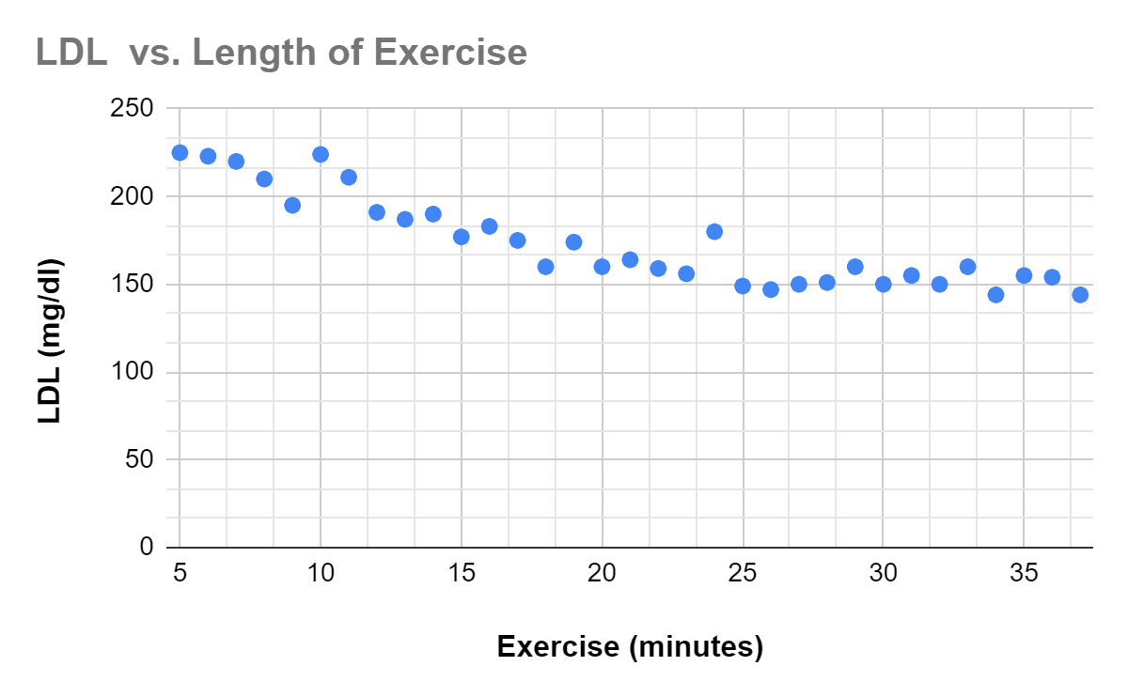

1. Organize the data into a table. Use this data to determine a proper model for cholesterol levels versus daily exercise.

|  |  |
| --- | --- |
| **Exercise (minutes)** | **LDL (mg/dl)** |
| 5 |  |
| 6 |  |
| 7 |  |
| 8 |  |
| 9 |  |
| 10 |  |
| 11 |  |
| 12 |  |
| 13 |  |
| 14 |  |
| 15 |  |
| 16 |  |
| 17 |  |
| 18 |  |
| 19 |  |
| 20 |  |
| 21 |  |
| 22 |  |
| 23 |  |
| 24 |  |
| 25 |  |
| 26 |  |
| 27 |  |
| 28 |  |
| 29 |  |
| 30 |  |
| 31 |  |
| 32 |  |
| 33 |  |
| 34 |  |
| 35 |  |

1. Does this data suggest an exact or regression model? Describe how you make your choice.
2. What is your function? Utilize a graphing utility to create your function (graphing calculator or Desmos). If there are maximum(s), minimum(s), slope, intercepts, or concavity, interpret in terms of the context of the data. Be sure to include units.
3. What trend do you notice from the data? Does your model confirm this trend? Why or why not?
4. If a person has a cholesterol level of 100 mg/dl, what duration of exercise does your model suggest? Suppose the exact amount of exercise required to achieve a cholesterol level of 100 mg/dl is 60 minutes, how accurate was your model?
5. Why does a linear model for this data seem more appropriate than a quadratic (or non-linear) model?
6. What are some factors which could lead to outliers (people with low cholesterol and low exercise minutes; people with high cholesterol and high exercise minutes)? What improvements can be made to the study to determine how daily exercise affects cholesterol levels?

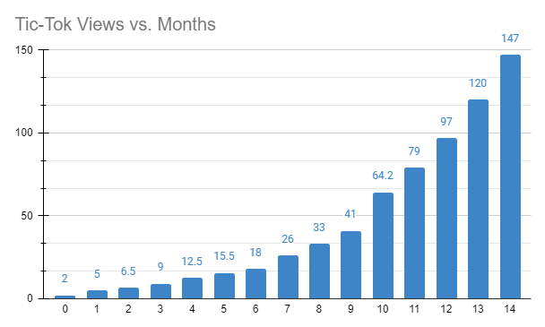

2. The following data shows the number of total views (in thousands) on a TikTok page from the creation of the page to 14 months after the start.

a) Does the data suggest using an exact or regression model? Will a linear, or nonlinear regression model best represent the data? Explain your reasoning.

b) Between a linear or nonlinear model, which fits the data better? How can you tell?

c) The data can be modeled by the following function:

$T(m) = 3.393(1.325)^{m}$,

where

*T* = TikTok views (thousands) and *m* = months since channel was created.

What does this model suggest the total views will be in two years? Write your answer in function notation and include appropriate units.

d) The actual number of views was $2.134⋅10^{3}$ thousand views. Why do you suspect the actual amount differs from the theoretical amount?