**Exploring Rates of Change**

1) The graph shows information about the revenue per streaming customer for Netflix starting in 2016 and ending in 2023.

a) Describe, in words, how the revenue is changing over time.

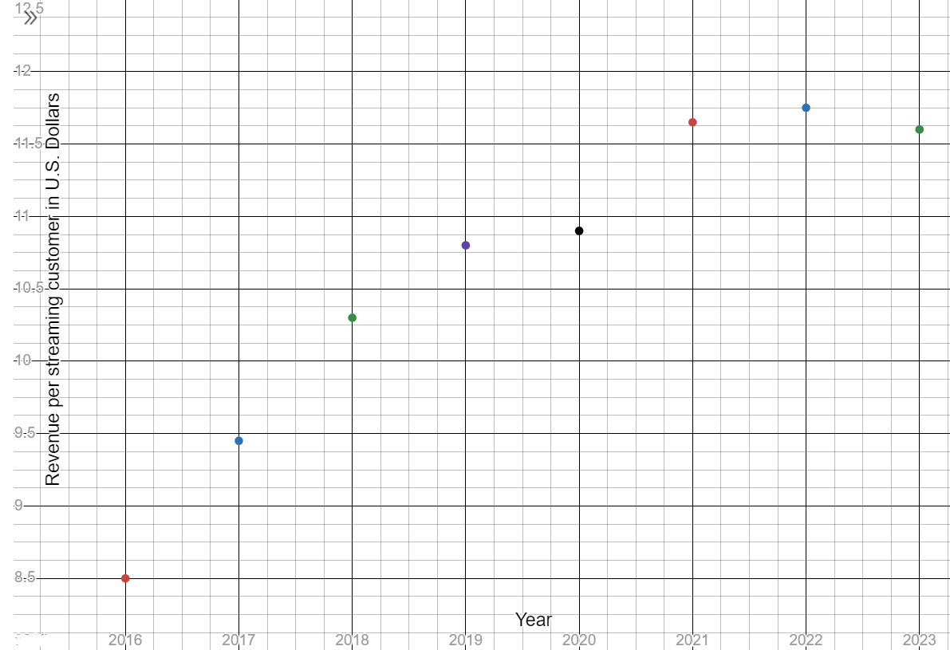

b) Find the average rate of change for each interval by using estimations of each revenue value.

|  |  |  |  |  |  |  |  |
| --- | --- | --- | --- | --- | --- | --- | --- |
| Years | 16-17 | 17-18 | 18-19 | 19-20 | 20-21 | 21-22 | 22-23 |
| AROC |  |  |  |  |  |  |  |

What are the units for the AROC? How did you determine the units?

c) For which one-year time period is the revenue increasing the most rapidly? Increasing the least rapidly? Describe how you know.

2) The table below shows values of the height $h$ of a roof as a function of distance $d$ from the outside wall of a building. Both measurements are given in feet.

|  |  |  |  |  |
| --- | --- | --- | --- | --- |
| Distance $d$, in feet | 0 | 2 | 6 | 7 |
| Height $h$, in feet | 10 | 11 | 13 | 13.5 |

10 feet

Distance

a) Describe, in words, how the height changes in terms of distance.

b) Find the average rate of change for each interval.

Distance 0 feet to 2 feet:

Distance 2 feet to 6 feet:

Distance 6 feet to 7 feet:

c) What do you notice? How does this compare to your answers for AROC in problem 1?

d) Suppose this rate of change applies to the entire roofline. Fill in the missing values of the table. Describe, in words, how you determined the missing values.

|  |  |  |  |  |  |  |  |  |
| --- | --- | --- | --- | --- | --- | --- | --- | --- |
| Distance $d$ in feet | 0 | 1 | 2 | 3 |  | 5 | 6 | 7 |
| Height $h$ in feet | 10 |  | 11 |  | 12 |  | 13 | 13.5 |

e) The graph to the right is a scatter plot of the table in part (c). What do you notice about this graph?

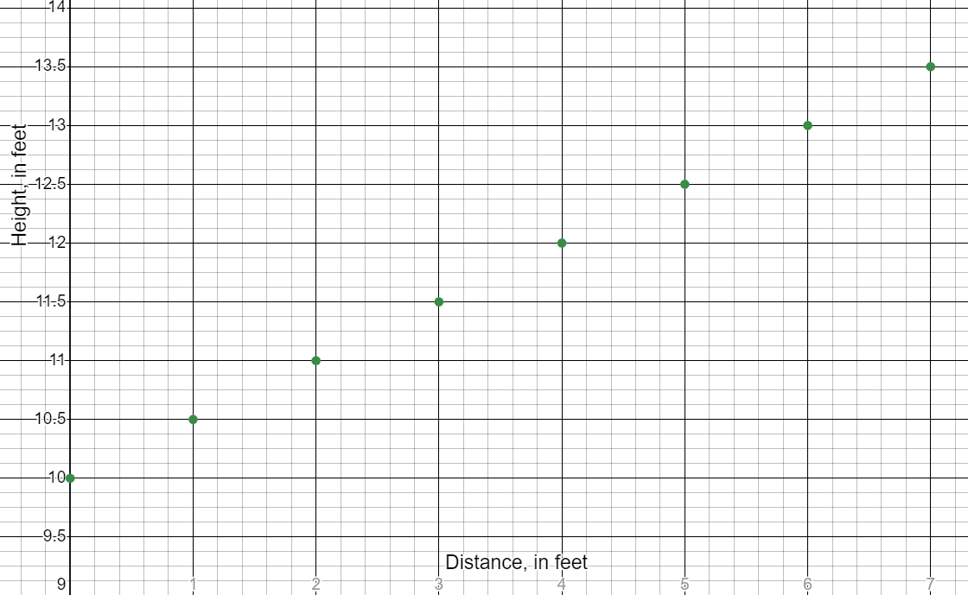

f) Why do you think this graph looks the way it does?

3) The revenue of video game consoles worldwide in 2018 was $16.52 billion. Each year after 2018, it increased by approximately 1.43 billion.

a) Estimate the revenue of game consoles in 2019.

b) Estimate the revenue of game consoles in 2024.

c) Describe, in words, what the calculation $16.52+12(1.43)$ would represent in terms of this scenario.

d) Describe, in words, what the calculation $16.52-3(1.43)$ would represent in terms of this scenario.

e) What is the average rate of change for this scenario (include appropriate units)? Is it constant?

f) Write a function $R$ that represents the scenario, $t$ years after 2018. Describe how your function relates to the scenario.

g) What type of function did you write in part (f)? Why is this type of function appropriate for this scenario?

h) Calculate $R(12)$ and $R(-3)$ using the function found in part (f). How do these calculations relate to parts (c) and (d) in this problem?