**Activity**

*Exercise 1*

1. Think about the definition and the characteristics of a function. How would you explain what it means for a relation to be a function to someone about to take this class?
2. We can describe a function several ways: *graphically, algebraically, verbally, and numerically*. Give an explicit example of a function which has time as an input and velocity as an output:
   1. Graphically
   2. Algebraically
   3. Verbally
   4. Numerically
3. Why do you think that expressing a function in different ways might be helpful/useful?

*Exercise 2*

For each part of this exercise, you will be given a function in one of the four forms mentioned in Exercise 1. For each part, do the following:

1. Convert from the given form to each of the three other forms.
2. Give an explanation about how you came to your answer for each representation.
3. Supply one (or more!) examples describing why a particular representation could be useful. Which one do you feel would be best for communicating the situation?
4. Reflect: do your verbal description, table, graph, and equation all show the same relationship between the variables? Why or why not?
5. The cumulative amount of lettuce eaten by a guinea pig is given by $L(g) = 2g + 1$ kilograms, after g feedings.
6. A firecracker is shot from a platform 47 feet high, and an engineer records its position (relative to the ground) before it explodes. *Hint*: This should be a quadratic function. Think about using vertex form!

| Time (in seconds) | Distance (in feet) |
| --- | --- |
| 0 | 47 |
| 1 | 132 |
| 2 | 183 |
| 3 | 200 |
| 4 | 183 |
| 5 | 132 |

1. The rate of change of the bird population in East Sussex county is given below.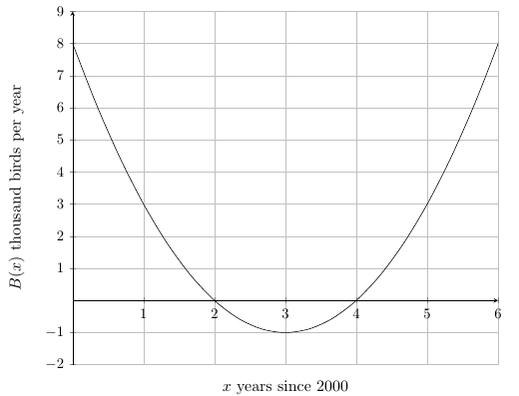
2. The stock of a certain NASDAQ company began the day trading at 75 dollars per share, but decreased by 2 dollars per hour.
3. An enthusiastic gardener measured the growth of a new plant:

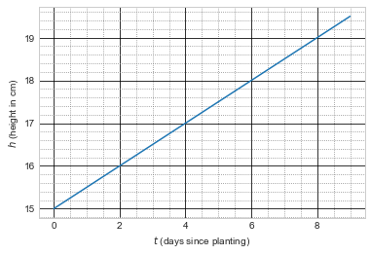

1. The value of a utility bill is given by $B(t) = t^{2} + 40$ dollars, t weeks since the beginning of the month.

Here are some other options, if the instructor wants to “plug-and-play” with different types of functions as the semester progresses:

1. In Nowheresville, the average monthly temperature follows a cyclic pattern. The average temperature is highest in July, when it is 90 degrees Fahrenheit; the average temperature is lowest in January, when the temperature is 49 degrees Fahrenheit.
2. Noel noticed a rabbit in his yard. The rabbit hopped toward the back fence along the garden, and Noel recorded the distances traveled in the table below. *Hint:* Your answer should be logarithmic, in the form $D(t) = a log(t-b)$.

| **t (seconds)** | **D(t) (feet)** |
| --- | --- |
| 1 | 0.6021 |
| 5 | 1.5563 |
| 9 | 2 |
| 13 | 2.2923 |

1. The amount of bacteria growing in a petri dish is given by $B(t) = 50(1.02^{t})$ thousand bacteria, t hours after the experiment began.
2. A flag was placed on a waterwheel. Its height relative to the water level is given below.

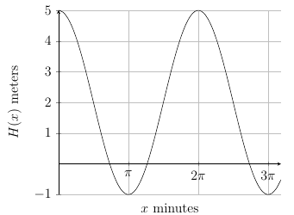

1. The cell phone data Marcus has used is given by the equation $D(t) = 3ln(t+1) + 5$ gigabytes, t months since purchasing his phone
2. When 500 bushels of a prize variety of corn are planted, the amount of corn increases by 25% per month.