**Activity**

1. Exercise 1
   1. Let [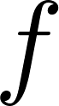](https://www.codecogs.com/eqnedit.php?latex=f#0) be the function [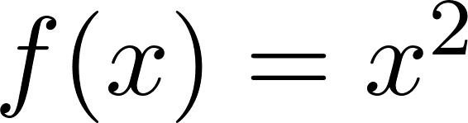](https://www.codecogs.com/eqnedit.php?latex=f(x)%20%3D%20x%5E2#0). What function is the inverse of this function? Label it [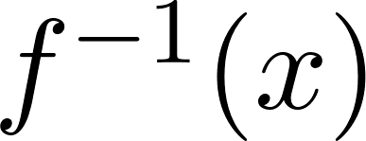](https://www.codecogs.com/eqnedit.php?latex=f%5E%7B-1%7D(x)#0).
   2. Draw a graph of [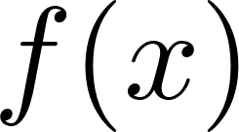](https://www.codecogs.com/eqnedit.php?latex=f(x)#0) and the inverse function, [](https://www.codecogs.com/eqnedit.php?latex=f%5E%7B-1%7D(x)#0)

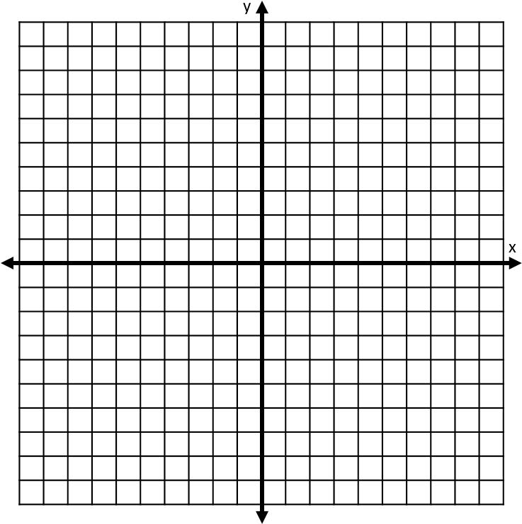

* 1. Make some observations about the graphs. Some possible things to discuss are the domain and range of each graph, the shape of each graph, any similarities or any differences between the two graphs, etc.

1. Exercise 2
   1. Now, let us explore this idea of inverse functions as it pertains to trigonometric functions. For the functions [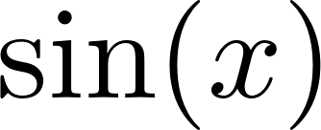](https://www.codecogs.com/eqnedit.php?latex=%5Csin(x)#0), [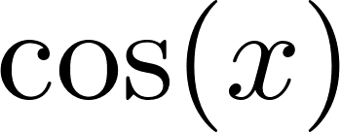](https://www.codecogs.com/eqnedit.php?latex=%5Ccos(x)#0), and [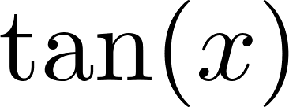](https://www.codecogs.com/eqnedit.php?latex=%5Ctan(x)#0), first graph two periods of the function, and then graph the curve corresponding to switching the inputs and the outputs. What is “wrong” with this picture?

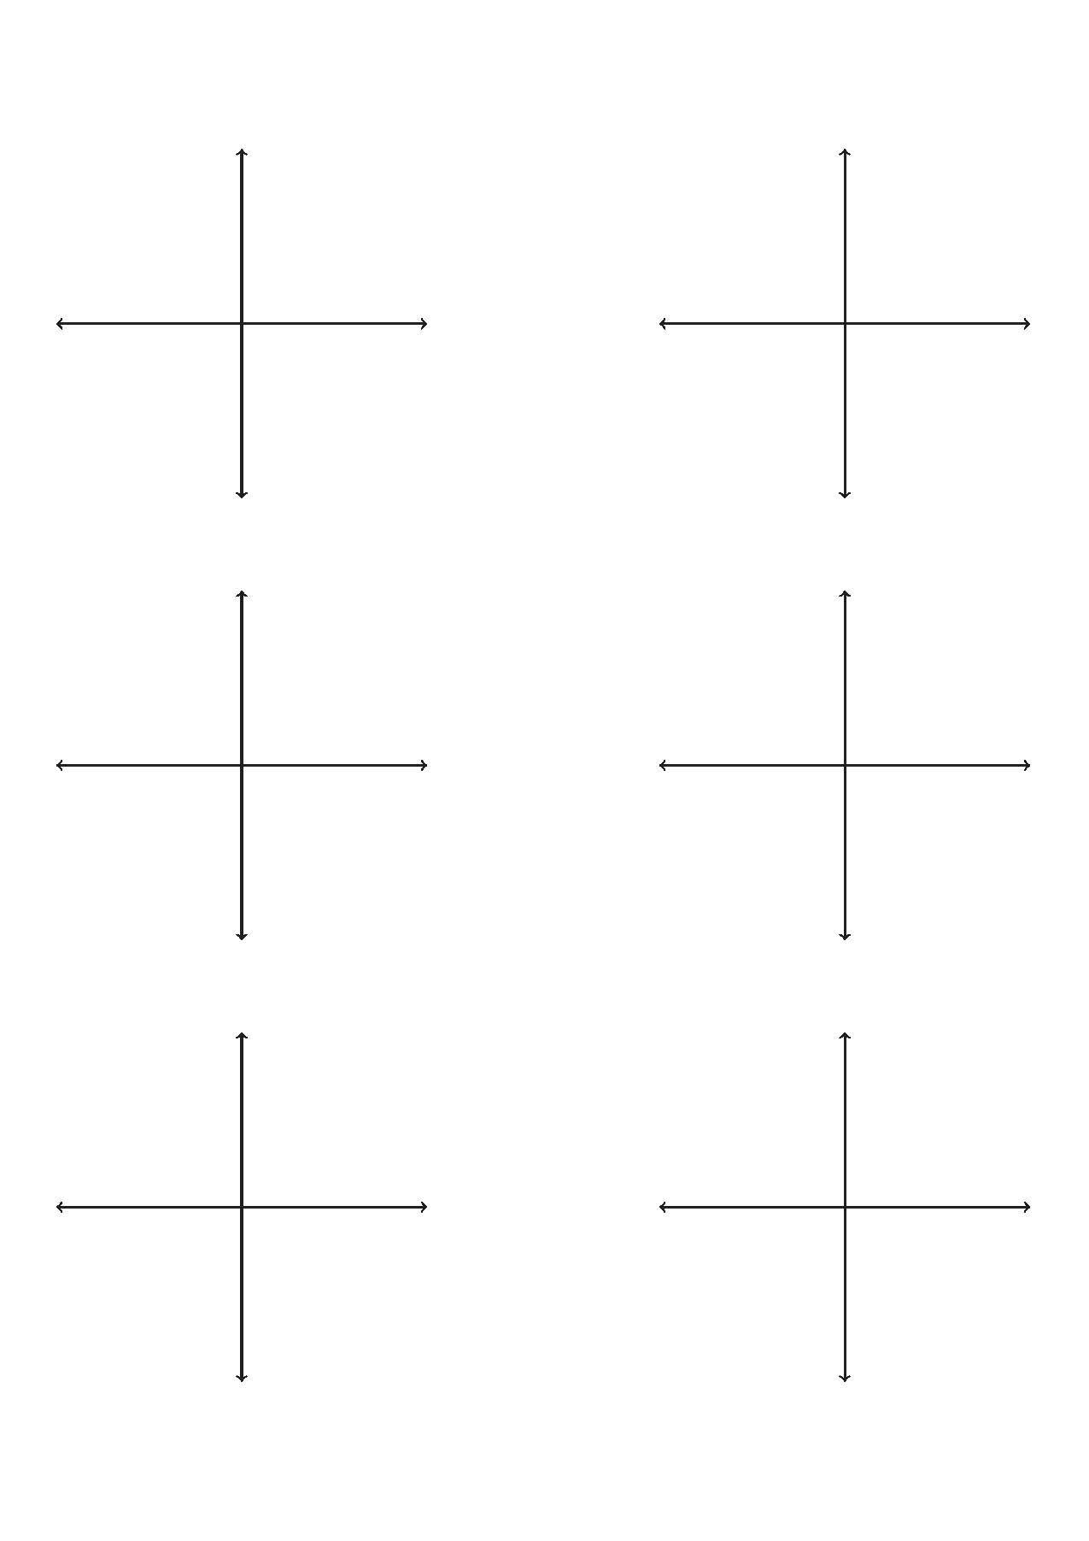

1. Exercise 3
   1. Let [](https://www.codecogs.com/eqnedit.php?latex=f(x)#0) and [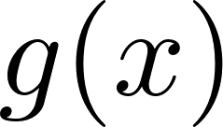](https://www.codecogs.com/eqnedit.php?latex=g(x)#0) be two one-to-one functions. If [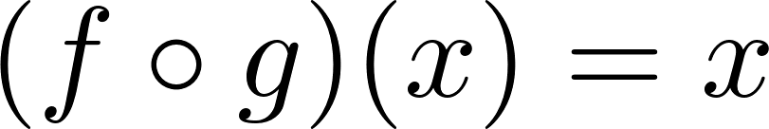](https://www.codecogs.com/eqnedit.php?latex=(f%5Ccirc%20g)(x)%20%3D%20x#0) and [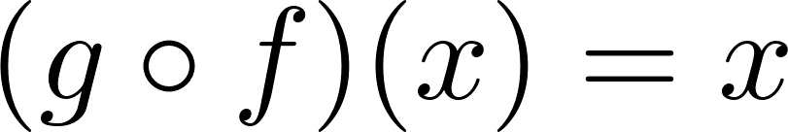](https://www.codecogs.com/eqnedit.php?latex=(g%5Ccirc%20f)(x)%20%3Dx%20#0), then we say that [](https://www.codecogs.com/eqnedit.php?latex=f(x)#0) and [](https://www.codecogs.com/eqnedit.php?latex=g(x)#0) are inverses of each other. We denote [](https://www.codecogs.com/eqnedit.php?latex=g(x)#0) by [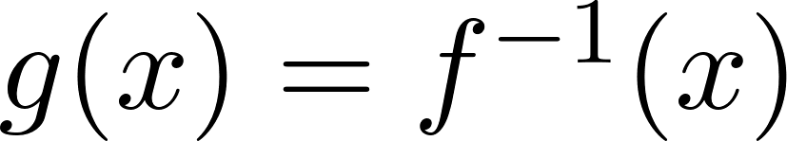](https://www.codecogs.com/eqnedit.php?latex=g(x)%3D%20f%5E%7B-1%7D(x)#0). Our definition of inverse function includes the phrase “one-to-one.” What does one-to-one mean?
   2. Refer to the inverse graphs in Exercise 2. What do we need to change about our trigonometric functions to fit the definition of one-to-one?
   3. What is an appropriate domain for sine, if it is to be one-to-one?
   4. What is an appropriate domain for cosine, if it is to be one-to-one?
   5. What is an appropriate domain for tangent, if it is to be one-to-one?
   6. Most real-world applications where triangle side lengths are given will produce only a small subset of possible solutions. Additionally, conventional mathematics requires specific Restricted Domains for sine, cosine, and tangent in order to discuss inverse trig functions. Note, however, that we can invert any function that is one-to-one, as long as a domain is restricted appropriately. Filling out the table below will allow you to understand typical restricted domains used in most classes, as well as on your calculators. If a question is asked without specifying the domain, these are the ones assumed.

| Function | Restricted Domain |
| --- | --- |
| Sine |  |
| Cosine |  |
| Tangent |  |

List a restricted domain for each that does not allow them to be one-to-one.

1. Exercise 4  
   Find the values for the following.
   1. [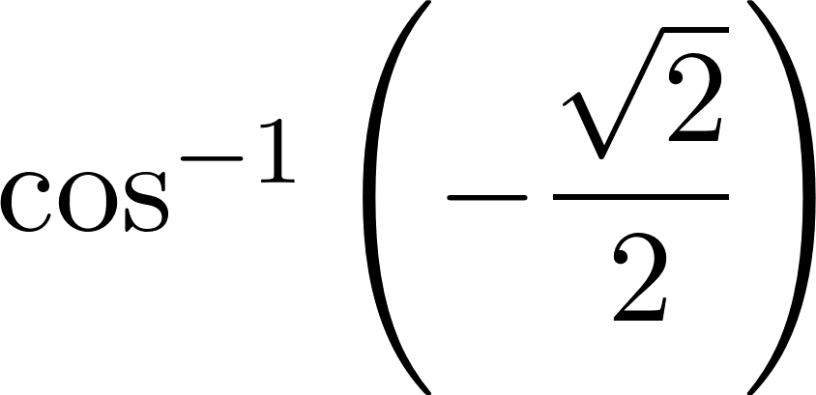](https://www.codecogs.com/eqnedit.php?latex=%5Ccos%5E%7B-1%7D%5Cleft(-%5Cdfrac%7B%5Csqrt%7B2%7D%7D%7B2%7D%5Cright)#0)on [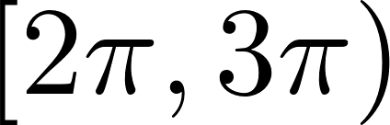](https://www.codecogs.com/eqnedit.php?latex=%5B2%5Cpi%2C3%5Cpi)#0)
   2. [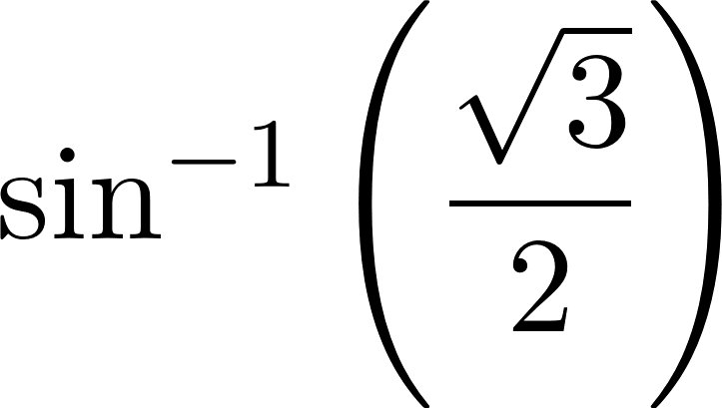](https://www.codecogs.com/eqnedit.php?latex=%5Csin%5E%7B-1%7D%5Cleft(%5Cdfrac%7B%5Csqrt%7B3%7D%7D%7B2%7D%5Cright)#0)
   3. [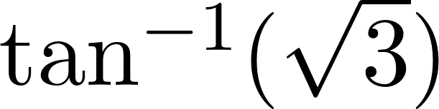](https://www.codecogs.com/eqnedit.php?latex=%5Ctan%5E%7B-1%7D(%5Csqrt%7B3%7D)#0) on [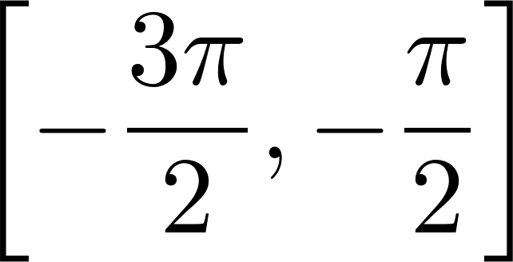](https://www.codecogs.com/eqnedit.php?latex=%5Cleft%5B-%5Cdfrac%7B3%5Cpi%7D%7B2%7D%2C-%5Cdfrac%7B%5Cpi%7D%7B2%7D%5Cright%5D#0)