**Activity**

1. When we write an equation like , we are always referring to an *input* and an *output*. In this expression, which number is the input and which number is the output? 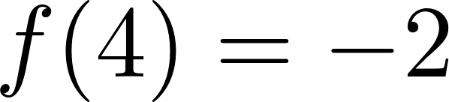
   1. Identify the input and output of the expression [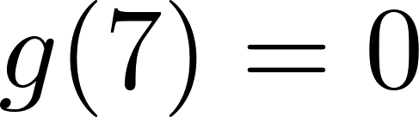](https://www.codecogs.com/eqnedit.php?latex=g(7)%20%3D%200#0).
   2. Identify the input and output from this description: The function gives the profit a coffee shop makes [](https://www.codecogs.com/eqnedit.php?latex=t#0) days after May 1, 2024. On May 29, the coffee shop made $175. 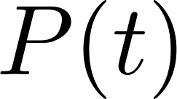
2. Usually, we are given inputs to plug into a function; for example, when given the input [](https://www.codecogs.com/eqnedit.php?latex=x%3D4#0) for the function , the output is found by replacing [](https://www.codecogs.com/eqnedit.php?latex=x#0) with 4, so in this case . 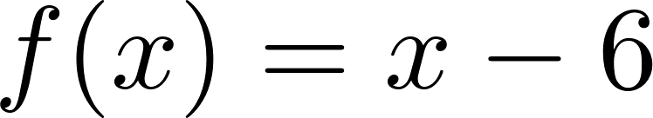
   1. If [](https://www.codecogs.com/eqnedit.php?latex=f(x)%3Dx-6#0), what input value creates an output value of 5? Be explicit with your reasoning.
   2. Again using , what input value creates an output value of 0? 
   3. If we are given an output and want to find an input, we solve this by using the idea of an *inverse*; for a function $f$, we denote its inverse using this notation: [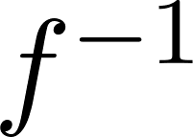](https://www.codecogs.com/eqnedit.php?latex=f%5E%7B-1%7D#0). Using the example from Part 1, if [](https://www.codecogs.com/eqnedit.php?latex=f(4)%20%3D%20-2#0), then we would write [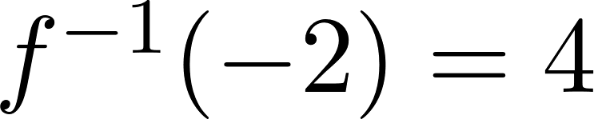](https://www.codecogs.com/eqnedit.php?latex=f%5E%7B-1%7D(-2)%20%3D%204#0). Write your answers to (a) and (b) using this inverse notation.
   4. The inputs of a function [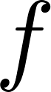](https://www.codecogs.com/eqnedit.php?latex=f#0) are the outputs of the function [](https://www.codecogs.com/eqnedit.php?latex=f%5E%7B-1%7D#0). Similarly, the outputs of [](https://www.codecogs.com/eqnedit.php?latex=f#0) are the inputs of [](https://www.codecogs.com/eqnedit.php?latex=f%5E%7B-1%7D#0)
      1. At 3:00pm on June 8, 2023, OnCue sold gas for $2.50 per gallon. Julia pumped exactly 12 gallons of gas. How much did she spend? How do you know? As a function, what was your input and what was your output? Be descriptive!
      2. Julia overheard a customer at another pump. The other customer told his partner that he spent $22.50 on gas. Think about part (i); did the other customer talk about an output or an input? What leads you to this conclusion?
      3. Use your answer to (ii) to find the amount of gas purchased.
      4. We want to relate the idea of functions and their inverses to this problem. If “gallons of gas” is the input, what describes the output? What is your reasoning?
      5. Come up with your own situations that require the idea of an inverse. You can (and should!) use the previous parts to help guide your construction, but your situations should be distinct!
      6. What are some real-world reasons why finding the inverse of a function would be important?
   5. The table below gives numerical values for some mysterious function *M*:

| **t** | -3 | 0 | 3 | 7 |
| --- | --- | --- | --- | --- |
| **M(t)** | 5 | -1 | 2 | 0 |

* + 1. What is ? 
    2. What is ? Use the table to justify your answer.
    3. What is ? 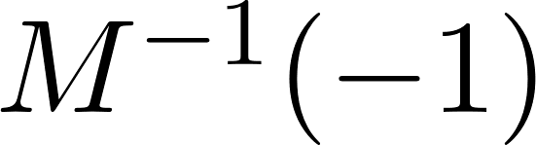
    4. We cannot use the table to find [](https://www.codecogs.com/eqnedit.php?latex=M%5E%7B-1%7D(7)#0). Why not?

1. Remember that a function is a special kind of relation, where each input is paired with exactly one output.
   1. The relation below is not a function. Give at least one reason why. You can (and should!) give more than one reason why (plotting the points might help you see!)

| **x** | 0 | 0 | 2 | 3 | 4 | 5 |
| --- | --- | --- | --- | --- | --- | --- |
| **y** | 5 | 0 | 4 | 0 | 3 | 1 |

* 1. Now let’s reverse the roles of the variables. Plot the points from the table below, with [](https://www.codecogs.com/eqnedit.php?latex=y#0) on the horizontal axis and [](https://www.codecogs.com/eqnedit.php?latex=x#0) on the vertical axis. This still isn’t a function; give at least one reason why. Try giving more than one reason why!

| **y** | 0 | 0 | 2 | 3 | 4 | 5 |
| --- | --- | --- | --- | --- | --- | --- |
| **x** | 5 | 0 | 4 | 0 | 3 | 1 |

* 1. Take the plot from part (c) and rotate it so that [](https://www.codecogs.com/eqnedit.php?latex=y#0) is now the vertical axis and [](https://www.codecogs.com/eqnedit.php?latex=x#0) is the horizontal axis. How does your reasoning from part (b) change?
  2. There is a graphical method to determine if a relation is a function of [](https://www.codecogs.com/eqnedit.php?latex=x#0) or if it is a function of [](https://www.codecogs.com/eqnedit.php?latex=y#0). Based on your work above, what do you think the graphical method might be?
  3. If you had to explain to someone in another class about why this graphical method works, how would you do so?

| **x** | 1 | 1 | 2 | 2 | 3 | 3 |
| --- | --- | --- | --- | --- | --- | --- |
| **y** | 3 | 3 | 4 | 5 | -1 | -2 |

* 1. The relation in the table is not a function of [](https://www.codecogs.com/eqnedit.php?latex=x#0). Argue why this is true.
  2. We can modify the table to make the relation a function. What must be done in order to do this? Rewrite the new table below (you may or may not need all cells).

| **x** |  |  |  |  |  |  |
| --- | --- | --- | --- | --- | --- | --- |
| **y** |  |  |  |  |  |  |

* 1. The relation in the table below is a function of [](https://www.codecogs.com/eqnedit.php?latex=x#0), but *not* a function of [](https://www.codecogs.com/eqnedit.php?latex=y#0); what about the table causes this to happen?

| **x** | 1 | 2 | 3 | 4 |
| --- | --- | --- | --- | --- |
| **y** | 1 | 0 | 1 | 2 |

* 1. We can modify the table to be a function of [](https://www.codecogs.com/eqnedit.php?latex=x#0) *and* a function of [](https://www.codecogs.com/eqnedit.php?latex=y#0). What must be done in order to make this true? Rewrite the new table below (you may or may not need all cells).

| **x** |  |  |  |  |
| --- | --- | --- | --- | --- |
| **y** |  |  |  |  |

* 1. The process of modifying a relation so that it is a function of [](https://www.codecogs.com/eqnedit.php?latex=x#0) and [](https://www.codecogs.com/eqnedit.php?latex=y#0) is called *restricting the domain*. How could we restrict the domain in the graph below to make a function of [](https://www.codecogs.com/eqnedit.php?latex=x#0) and [](https://www.codecogs.com/eqnedit.php?latex=y#0)? 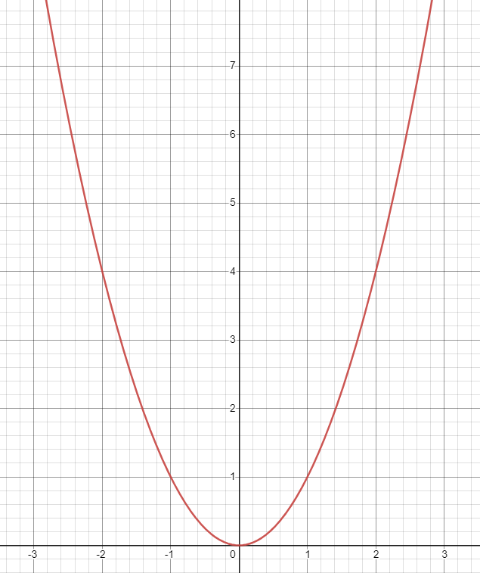

1. Practice your understanding of inverses on the following problems. For each one, describe why an inverse function exists OR why an inverse function does not exist. In addition, find the following values. If an inverse does not exist, identify and use a restricted domain that would allow an inverse function to exist.
   1. 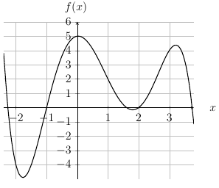
      1. [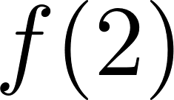](https://www.codecogs.com/eqnedit.php?latex=f(2)#0)
      2. [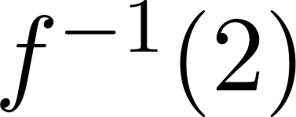](https://www.codecogs.com/eqnedit.php?latex=f%5E%7B-1%7D(2)#0)
      3. [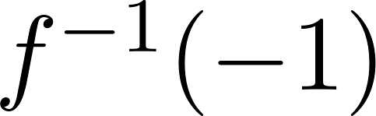](https://www.codecogs.com/eqnedit.php?latex=f%5E%7B-1%7D(-1)#0)

| **x** | **f(x)** | **g(x)** |
| --- | --- | --- |
| 0 | 18 | 1 |
| 5 | -6 | 2 |
| 6 | 5 | -8 |
| 8 | 0 | 1 |

* + 1. [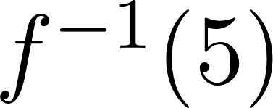](https://www.codecogs.com/eqnedit.php?latex=f%5E%7B-1%7D(5)#0)
    2. [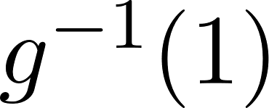](https://www.codecogs.com/eqnedit.php?latex=g%5E%7B-1%7D(1)#0)
    3. [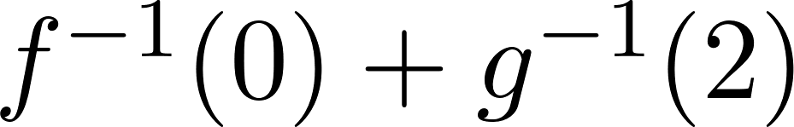](https://www.codecogs.com/eqnedit.php?latex=f%5E%7B-1%7D(0)%20%2B%20g%5E%7B-1%7D(2)#0)
  1. [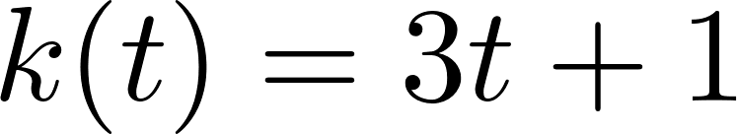](https://www.codecogs.com/eqnedit.php?latex=k(t)%20%3D%203t%2B1#0)
     1. [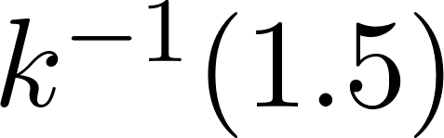](https://www.codecogs.com/eqnedit.php?latex=k%5E%7B-1%7D(1.5)#0)
     2. [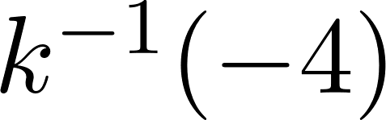](https://www.codecogs.com/eqnedit.php?latex=k%5E%7B-1%7D(-4)#0)
     3. [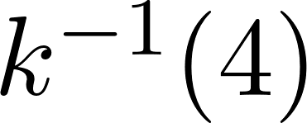](https://www.codecogs.com/eqnedit.php?latex=k%5E%7B-1%7D(4)#0)