**Activity**

1. Review determining slope in various manners by completing the following.
   1. Find the slope of the line that passes through [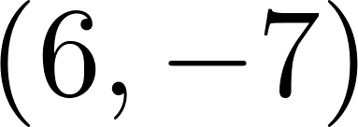](https://www.codecogs.com/eqnedit.php?latex=(6%2C%20-7)#0) and [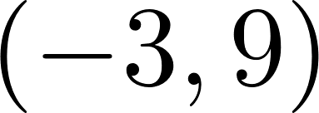](https://www.codecogs.com/eqnedit.php?latex=(-3%2C%209)#0).
   2. Find the slope of the line [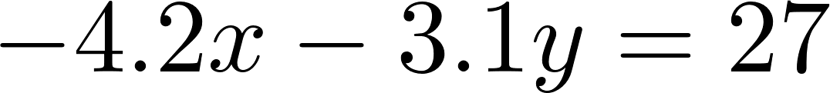](https://www.codecogs.com/eqnedit.php?latex=-4.2x%20-%203.1y%20%3D%2027#0)
   3. Find the slope of the line pictured in the graph below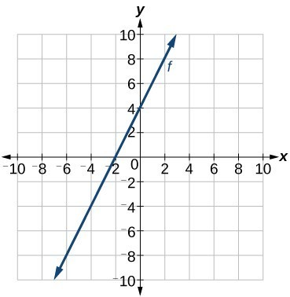
   4. If [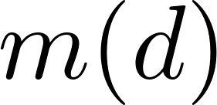](https://www.codecogs.com/eqnedit.php?latex=m(d)#0) represents the total amount of money (in dollars) spent in restaurants and [](https://www.codecogs.com/eqnedit.php?latex=d#0) is the number of days you dined out, interpret a slope of 10.
   5. Write a definition of slope in your own words; think in practical terms with units.
2. Consider a function that is not linear.
   1. Using the graph below, draw a line named L between the points [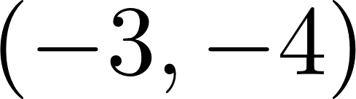](https://www.codecogs.com/eqnedit.php?latex=(-3%2C%20-4)#0) and [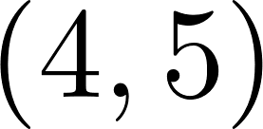](https://www.codecogs.com/eqnedit.php?latex=(4%2C5)#0).

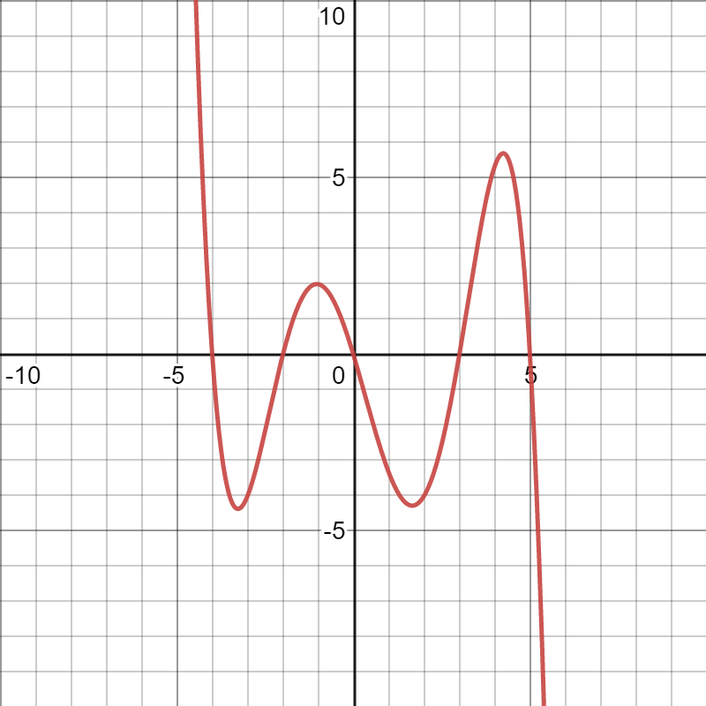

* 1. Calculate the slope of line L.
  2. Assume this function is named f, -3 is called x1, and 4 is called x2. Rewrite your calculation from part b) as a generalized formula.
  3. Line L is not the same shape as the graph on the interval from -3 to 4. Describe the relationship between the slope of line L and the function’s behavior.
  4. The average rate of change is a measure of how much a function changes per unit, on average, over an interval. How does this compare with the definition of slope?
  5. Now, draw a line named P between the points (-4,0) and (2,-4). Describe the relationship between the slope of line P and the function’s behavior.
  6. What limitations does the average rate of change have? What information can be learned from an average rate of change and what information is “missing”?

1. Practice calculating the average rate of change for the following functions.
   1. Estimate the average rate of change of h using the graph below: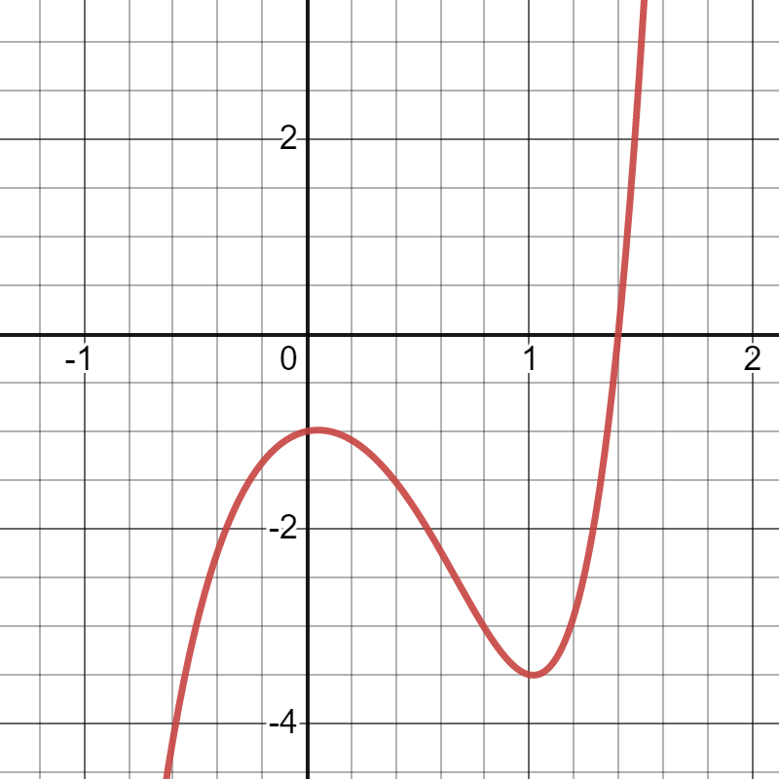
      1. when x1 = -0.6 and x2 = 0.4
      2. when x1 = 0 and x2 = 1
      3. when x1 = 0.4 and x2 = 1.4
   2. Find the average rate of change of g using the table:

| x | -4 | -3 | -1 | 0 | 1 | 2 | 4 | 5 |
| --- | --- | --- | --- | --- | --- | --- | --- | --- |
| g(x) | -328 | -160 | -16 | -4 | -8 | -10 | 64 | 176 |

* + 1. when x1 = -3 and x2 = 4
    2. when x1 = 0 and x2 = 2
    3. when x1 = -1 and x2 = 2
  1. Let f(x) = 2x2 + 3x − 6. Find the average rate of change of f
     1. when x1 = −2 and x2 = 1
     2. when x1 = 4 and x2 = 7
  2. A police department is monitoring a long stretch of road for which the speed limit is 65 miles per hour. The department has checkpoints 6 miles south of town and 21 miles south of town. A police officer sees a car pass through the first checkpoint at 2:04 pm traveling at 60 MPH, and another officer sees the same car pass the second checkpoint at 2:14 pm, traveling 63 MPH. The police officer gives the driver a speeding ticket, and the driver tries to argue that they were not speeding. What do you think? Explain your reasoning.
  3. If the average rate of change for a given function, [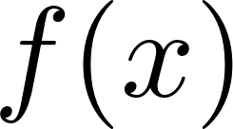](https://www.codecogs.com/eqnedit.php?latex=f(x)#0), is 2.5 on the interval from [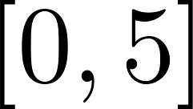](https://www.codecogs.com/eqnedit.php?latex=%5B0%2C5%5D#0). When [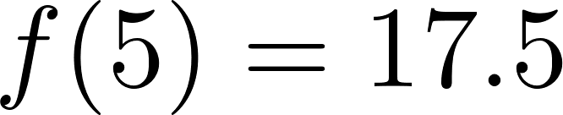](https://www.codecogs.com/eqnedit.php?latex=f(5)%20%3D%2017.5#0), what is [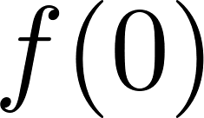](https://www.codecogs.com/eqnedit.php?latex=f(0)#0).
  4. If the average rate of change for a given function, [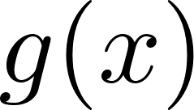](https://www.codecogs.com/eqnedit.php?latex=g(x)#0), is 8.2 on the interval from [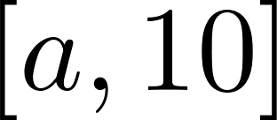](https://www.codecogs.com/eqnedit.php?latex=%5Ba%2C10%5D#0). Find *a*, when [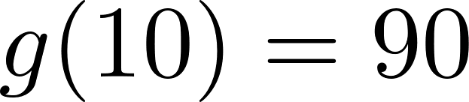](https://www.codecogs.com/eqnedit.php?latex=g(10)%20%3D%2090#0) and [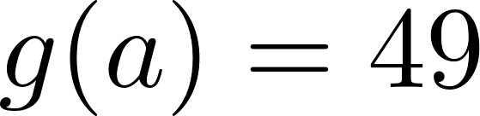](https://www.codecogs.com/eqnedit.php?latex=g(a)%20%3D%2049#0).
  5. You and a friend are driving to see a concert in another town. Your friend lives 10 miles from you. You will average a speed of 47 miles per hour. The town is 292 miles from your house. How long will it take you to get there from your friend's house?

1. What are some important characteristics of functions can we learn from the average rate of change? How would you describe it in your own words?