**Notes to Instructor**

Please read the activity descriptions in the Cover Page for specifics about measurables and expectations for students before you use this activity.

The activity is formatted so that you, as the instructor, have the freedom to arrange or include things as you wish; this also means that you will need to manually input the spacing you desire, as any rearrangement will necessarily modify any out-of-the-box spacing.

**Additional Information and Common Pitfalls**

1. If you choose to cover the concept of average rate of change before slope, then Part 1 will not be needed.  
   If this section is review, then it is very reasonable to be strict with the definitions, units, or explanations given by students. For example, it is more correct to say “on average, the total money spent in restaurants increased by $10 per day” than it would be to say “the money spent increased by 10”
2. This exercise is intended to make the connection between slope and average rate of change.
   1. For part a and b, the students will draw a line between two function values and calculate the slope of the line.
   2. The answer for part c is [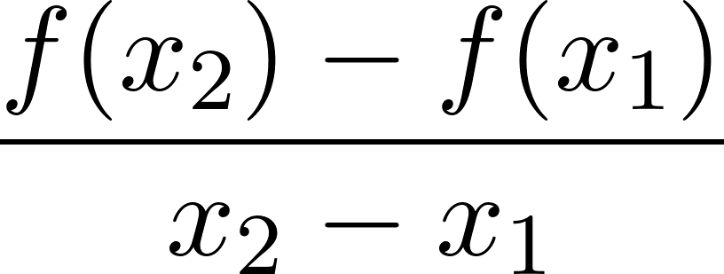](https://www.codecogs.com/eqnedit.php?latex=%5Cdfrac%7Bf(x_2)-f(x_1)%7D%7Bx_2-x_1%7D#0)
      1. If you have not covered slope yet, give the students the formula for ARoC, and remove part c and e from this exercise.
   3. For part d: If an observer was only given the information for (-3,-4) and (4,5), it appears that the function is increasing on the interval from [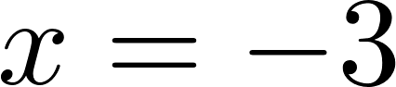](https://www.codecogs.com/eqnedit.php?latex=x%3D-3#0) to [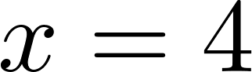](https://www.codecogs.com/eqnedit.php?latex=x%3D4#0). The slope of the line connecting these two points is positive, indicating an increase as the graph is read (“from left to right”)
   4. While the slope calculation and average rate of change calculation yield the same numerical value, the function characteristics described are different. Slope describes exactly how a linear function changes, whereas ARoC disregards function values in the interior of an interval and only indicates the change over that interval.
   5. For part f: If an observer was only given the information for (-4,0) and (2,4), it appears that the function is decreasing on the interval from [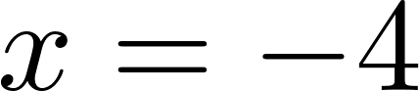](https://www.codecogs.com/eqnedit.php?latex=x%3D-4#0) to [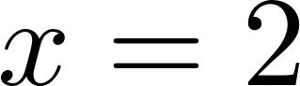](https://www.codecogs.com/eqnedit.php?latex=x%3D2#0). The slope of the line connecting these two points is negative, indicating a decrease as the graph is read (“from left to right”)
      1. Students might be sensing some cognitive dissonance between parts a-d and part f. If so, this leads directly to part g!!
   6. Part g leverages the tension parts a-d and part f. The “missing” information is literally the function and its specific behavior on the interval. Possible answers may include discussions of minimums and maximums, turning points, intercepts.
3. 1. For part a, students may find various answers as they will need to estimate the output values from the graph. It will be important to check on the process rather than the answer. This could be an opportunity to discuss how the average rate of change is different in various intervals. It might also be a good time to point out how the rates change from positive to negative or negative to positive at “interesting” points, specifically maximums or minimums.
   2. Without a graph to visualize the function, the students can estimate function behavior from various rates of change. For example, the graph appears to be increasing on the interval [-4,0] and decreasing on the interval [0,2]. However, because this is a table of discrete points, the behavior of the graph is not guaranteed on these intervals.
   3. [](https://www.codecogs.com/eqnedit.php?latex=%5Cdfrac%7B21%5Ctext%7B%20miles%7D-6%5Ctext%7B%20miles%7D%7D%7B2%3A14-2%3A04%7D%20%3D%20%5Cdfrac%7B15%5Ctext%7B%20miles%7D%7D%7B10%5Ctext%7B%20min%7D%7D%5Crightarrow%20%5Cdfrac%7B15%5Ctext%7B%20miles%7D%7D%7B10%5Ctext%7B%20min%7D%7D%5Ccdot%5Cdfrac%7B60%5Ctext%7B%20min%7D%7D%7B1%5Ctext%7B%20hour%7D%7D%20%3D%2090%5Ctext%7B%20mph%7D#0)  
      Students may attempt to calculate using the given speeds, finding a value of 18, which should indicate an unreasonable answer. The units (miles / hr2) should also indicate that the calculation should be reexamined.
4. Potential responses: increasing/decreasing, local extrema, concavity
5. **EXTENSION:** 
   1. Using any of the given graphs or functions, choose input values that approach a specific value. For example, using the function from #3c, choose x-values .9, .99, .999, .9999, .99999, 1.1, 1.01, 1.001, 1.0001, 1.00001. Ask students to find corresponding function values and, based on the values, estimate the rate of change at the instant x = 1.
   2. If using a graph, have the students draw the secant lines that represent the rates of change and observe how the secant lines appear more and more like a tangent line as the input values approach the specified value.