**TITLE OF LESSON: Water in the Tub (A Review of Functions and their Behavior)**

**ESTIMATED TIME FOR LESSON:** 50 minutes

**SUGGESTED FORMAT (check all that are appropriate):**

* Individual in-class
* Collaborative in-class
* Individual homework
* Collaborative homework

**OVERVIEW:**

We present an applied scenario of water level in a tub to help students consider appropriate units of measure for a piecewise function as well as the different rates of change. Here is the scenario: *Tina runs water for a bath in a straight-sided, right-angled bathtub with separate knobs for hot and cold water. She opens up both knobs so that both are going full stream. She shuts off the water and disrobes. She steps in, sits down, lies back, and decides the water is too hot. So, she jumps out and runs only the cold-water knob for a bit. Tina gets back in, bathes, and relaxes. While in the water, she notices it starts to cool off. So, she runs the hot water at a low rate for a little while. She relaxes some more then gets out and drains the tub. From the point at which she first turned on the water to the point at which the last of the water drained out of the tub, it took Tina 25 minutes to complete her bath. (Note: Assume that the water flow rates are instantaneous when a knob is turned on or off. Similarly, assume that when the plug is removed, the water flow immediately hits its maximum flow rate.)* 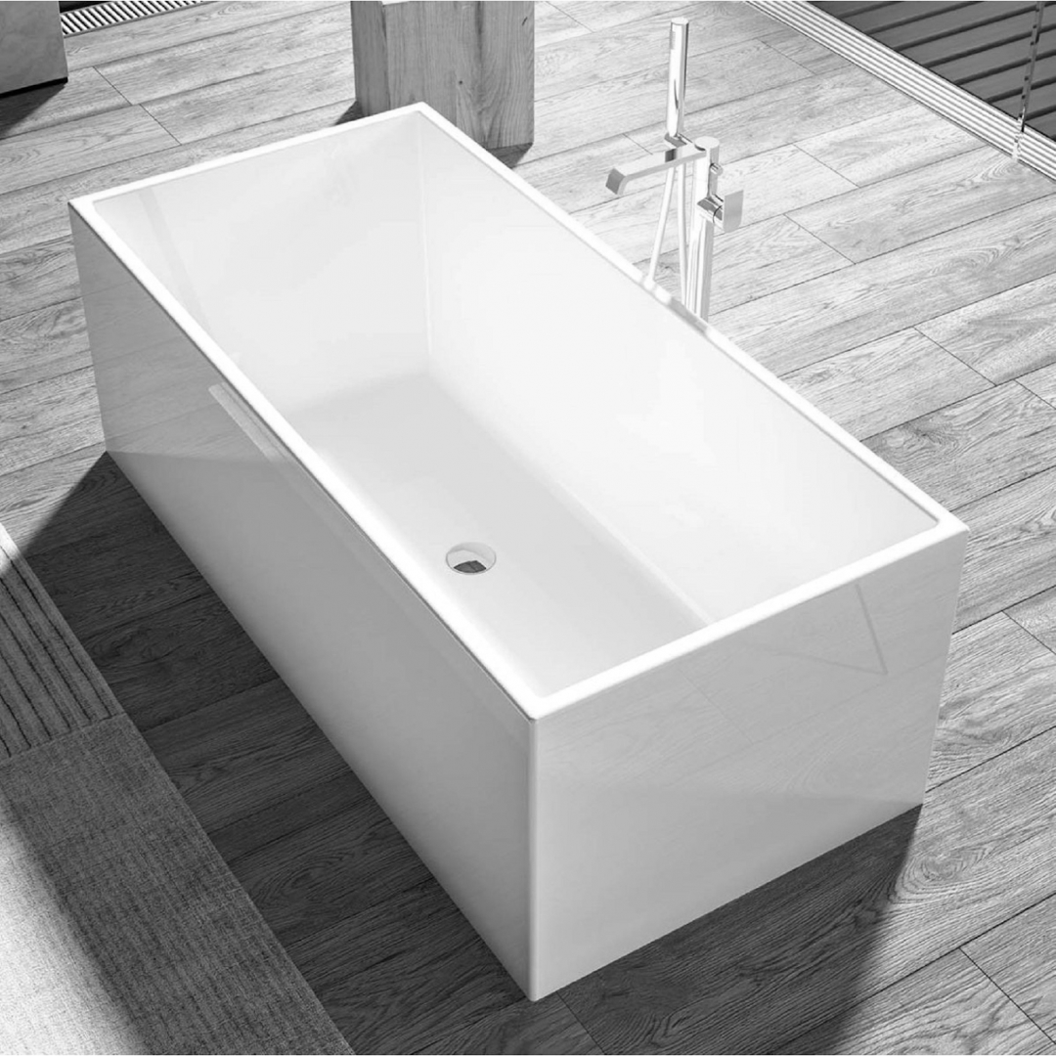

**Task:**

1. Make a graph of the height of the water in terms of time since Tina turned on the water; be sure to label it by key event. Use realistic units.
2. Select a time period for which the height of the water is increasing, a time period in which it is decreasing, and a time period in which it is constant. For each section of the graph:
   1. Determine the rate of change for the relevant time period.
   2. Using common, everyday language, explain what the calculated rate of change means.
   3. Explain how the pertinent section of the graph exemplifies that rate of change?
3. (Optional) Pick one of your time periods from part 2, and:
   1. State whether the rate of change for the selected time period relates to any trait of the line through the endpoints of the time period.
   2. If there is a relationship between some trait of the line and the rate of change for the chosen time period, state what that trait is and explain why the rate of change is related to that trait. If there is not a relationship between some trait of the line and the rate of change for the chosen time period, explain why no relationship exists.

**PREREQUISITE IDEAS AND SKILLS:**

* Concept of a variable and variation
* Definition of a function
* Multiple representations of functions (moving between verbal description, table, algebraic equation, and graph)

**MATERIALS NEEDED TO CARRY OUT LESSON**:

* Paper and pencil
* Graph paper makes the activity much easier and is highly recommended (Here is a link to [virtual graph paper](https://virtual-graph-paper.com/), but this activity works best on real paper.)

**MATHEMATICAL IDEAS ADDRESSED**:

Students will be reviewing key aspects of functions that are used when they model contextual situations. More specifically, the concepts that will be developed in this lesson include:

* **Quantification** – students need to think about both height and time as numerical attributes that can be measured
* **Measurement** - students need to situate the graph realistically, even though no specific numeric values are given, by selecting and using appropriate units of measure (for height and time) to the situation
* **Covariation** - students must reason about inputs and corresponding outputs simultaneously in the functional context presented
* **Rates of Change** - students must reason quantitatively to determine which intervals of the function are increasing, decreasing, and constant as well as differences in different increasing rates of change as part of the context provided
* **Piecewise-Defined Functions** - students must consider the domain in pieces that are given in the verbal description since the context dictates that the situation is not modeled by a single function but rather by multiple functions over different domains with intervals on which the function is increasing, decreasing and constant

**MATHEMATICAL UNDERSTANDING**:

This activity facilitates learning with respect to the processes of graph construction and interpretation since students interpret the verbal description of a function. Through the use and integration of multiple representations students give mathematical meaning to a realistic scenario. The activity also provides students a review of functions and how they behave in a way that allows students to access and build upon their mathematical knowledge and thereby, enhance their retention, recall and the ability to apply learning to novel contexts and problems. The facilitation of learning with respect to the noted concepts and processes also positions learners to more effectively:

* Create and use representations to organize, record, and communicate mathematical ideas;
* Select, apply, and translate among mathematical representations to solve problems;
* Use representations to model and interpret real-life phenomena;
* Use mathematical terminology in accurate and meaningful ways.

With respect to the 5 mathematical ideas to be addressed that were noted in the preceding section of this narrative:

1. Quantification:
   1. Students will understand that water height and time are measurable attributes of the situation).
2. Measurement:
   1. Students will understand that measuring the quantities entails assigning a unit to each).
3. Covariation:
   1. Students will understand that as time increases, water height varies based on whether Tina is in the tub or not, as well as the amount water drawn from the tap or drained from the tub over the relevant time period.
   2. Students will understand that different rates result in different amounts of change in the output values for a fixed change in the input.
4. Rates of Change:
   1. Students will understand that a rate is a measurable quantity made by coupling two quantities to make a new, third quantity.
   2. Students will understand that different rates cause different changes in the output for a fixed change in the input.
5. Piecewise Functions:
   1. Students will understand that a piecewise function is a function that is defined by multiple rules of correspondence, with each rule applying to a different interval of the domain that does not intersect or overlap with any of the intervals for other rules.
   2. Students will understand that the rule to be used for computing output or dependent variable values depends on which interval of the domain the input or independent value belongs to.

All of the above enhances students’ capacity to think flexibly in giving meaning to and solving non-routine problems. A benefit of this is that it affords students multiple entry and exit points to engage in the activity. Even students with less developed levels of mathematical knowledge and skills should be able to engage in the activity since it builds on a real-life context that all should understand. Moreover, all of this coalesces to allow the activity to address the three pillars of the MIP.

Active Learning:

The activity puts students in the position to learn actively by:

* selecting realistic quantities and corresponding appropriate measurement units to be use for the quantities for the water height and time;
* setting up corresponding axes that indicate the quantities and units selected;
* drawing an increasing line for a period of time that correspond to the first part of the scenario;
* drawing a second function (a constant function) that relates to the scenario when the rate of change switches, due to the water being turned off;
* reflecting on whether the two disjoint pieces need to be connected or not, and if so, where.
  + This process repeats each time the rate of change changes in the given scenario with the student having to consider:
    - whether or not the different linear section of the graph should be connected and if so, where;
    - whether or not the different linear pieces of the graph have increasing or decreasing rates of change
    - how steep should the slope of the linear piece be, in light of the higher and lower rates of change in the scenario.

Meaningful Applications:

The activity is designed to be a simple, relatable application that supports students’ identification of mathematical relationships. In the process of this activity, students will need to make and justify claims to create their graphs and functions. This will better position them to generalize across contexts, while noticing key features of functions (e.g., sharp points, increasing/decreasing/constant trends of functions over intervals, domain/range, etc.) and, thereby, infer mathematical structure.

If the extensions are used, students engage in the mathematically meaningful work of:

1. thinking about different quantities and how they are measured, because the difference between height and volume are measured could be nontrivial and
2. thinking about the relationship between quantities of height vs volume of water - because students who are struggling with the covariable relationship between height and volume in this scenario might compare their final graphs and wonder why the graphs look different.

Academic Success Skills:

The activity is a “low floor/high ceiling” activity that allows students to build their mathematical confidence. While engaging in the activity, students should be able to construct their identities as productive members of the classroom community, who are able to think and communicate mathematically. Accordingly, the instructional guidelines are written to encourage instructors to facilitate students’ use of mathematically appropriate terminology in the context of the situation provided.

**INSTRUCTIONAL PLAN**:

*Whole Class Discussion:*

The instructor should start by asking students what a function is. Once the instructor has guided the discussion so that students seem to have a good working understanding of functions, the instructor should remind students of the different ways that functions can be represented (by verbal scenarios, with tables, as graph, or using equations).

*Collaborative Work:*

Have the students break into small groups. Provide groups the following scenario.

Scenario: *Tina runs water for a bath in a straight-sided, right-angled bathtub with separate knobs for hot and cold water. She opens up both knobs so that both are going full stream. She shuts off the water and disrobes. She steps in, sits down, lies back, and decides the water is too hot. So, she jumps out and runs only the cold-water knob for a bit. Tina gets back in, bathes, and relaxes. While in the water, she notices it starts to cool off. So, she runs the hot water at a low rate for a little while. She relaxes some more then gets out and drains the tub. From the point at which she first turned on the water to the point at which the last of the water drained out of the tub, it took Tina 25 minutes to complete her bath. (Note: Assume that the water flow rates are instantaneous when a knob is turned on or off. Similarly, assume that when the plug is removed, the water flow immediately hits its maximum flow rate.)* A white bathtub on a wood floor

Ask the groups to create a graph of the scenario that is realistic and depicts the height of the water in the tub versus time (since Tina first turned on the water). Remind them to include labels (with appropriate units) on the graphs’ axes. Since no specific quantities are given, the instructor should encourage all groups to think about the context realistically and to use numbers that make sense for the situation. They should also encourage students to use appropriate mathematical terminology when discussing the scenario.

As the groups work, the instructor should circulate around the room encouraging students to use mathematics terminology. The instructor should listen for the different intervals that students are considering and verify that students are considering the rates of change for each interval in a way that make sense, but to do so by asking questions that guide or orient students’ thinking without telling them the answers.

One possible graph follows, but there are many possible correct graphs for the scenario.

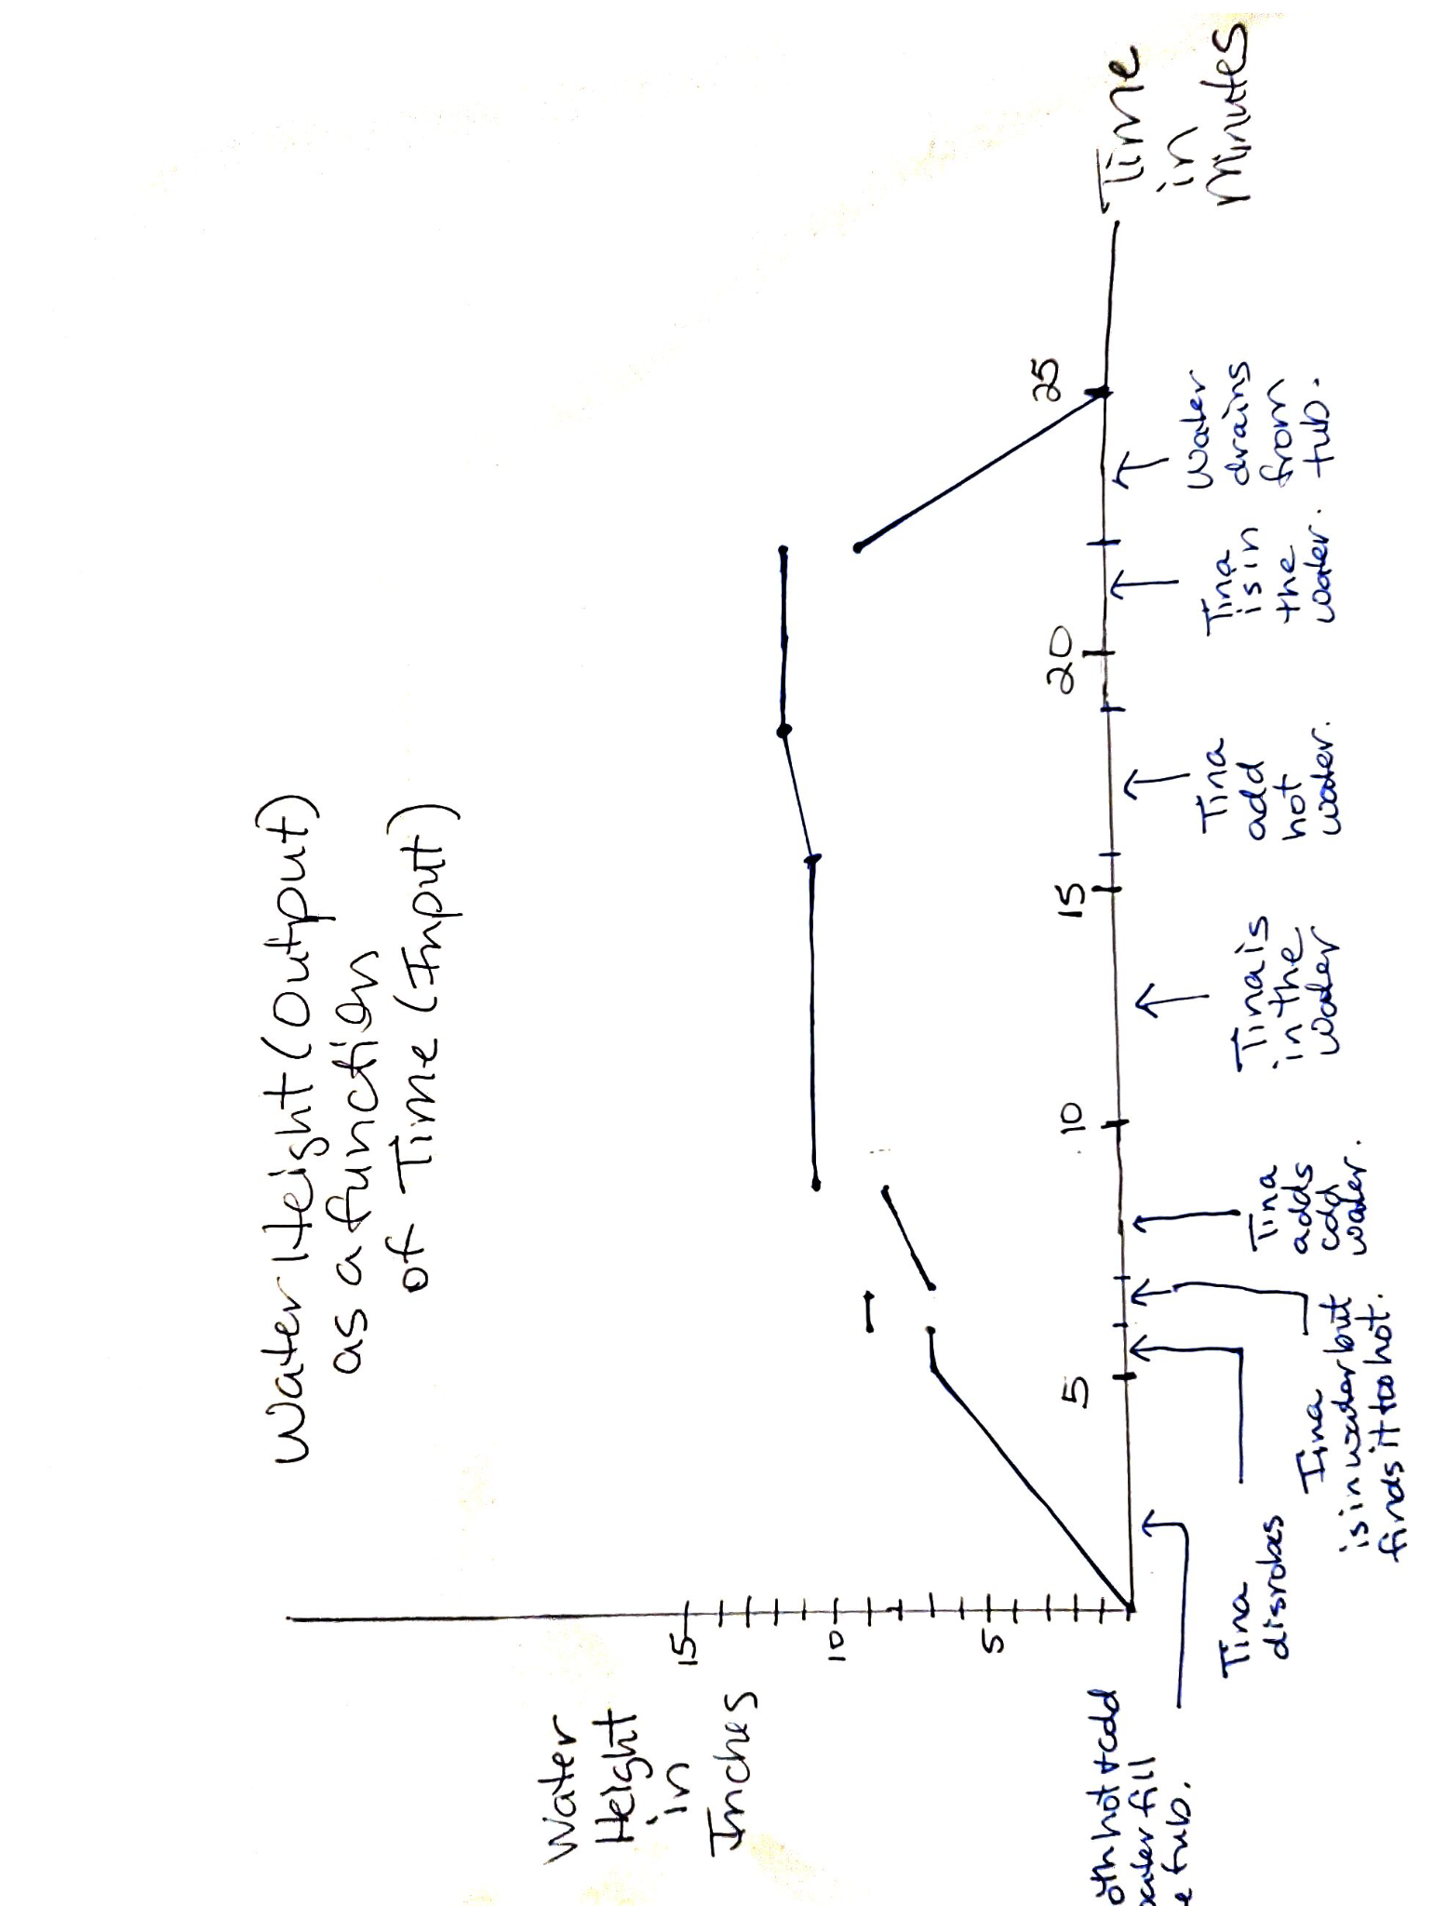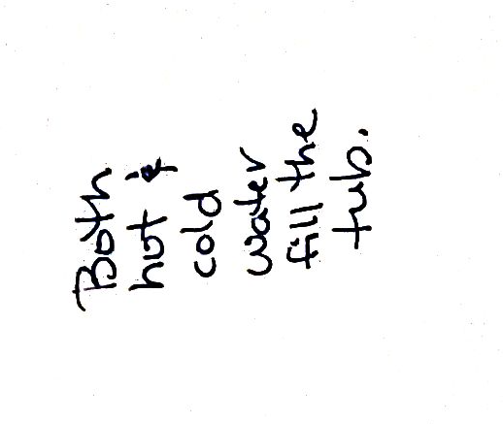

NOTE: If possible, this activity works very well if all groups are able to do their work on the boards around the class; however, that is not required. If it is possible, it makes it much easier for the instructor to monitor the groups’ progress. It also allows for each group to share their work with other groups once they are finished.

**EXTENSION ACTIVITY**

Using the same scenario, students could be asked to graph the volume of water in the tub versus time, the temperature of the water in the tub versus time, and the volume of the water in the tub versus the height of the water in the tub. (Here is the [worksheet](https://docs.google.com/document/d/1EW36ULHWVIyEsqC4iLYvodb20dMbDtel0Aj-Dbq9mVo/edit?usp=sharing).) It could be used in-class for collaborative group work, or it could be used as an individual homework assignment.

**TWO OTHER EXTENSION POSSIBILITIES**

OPTION 1:

If the instructor wants to focus students’ attention on different representations of functions, another possible extension is to have students create the equations that correspond to the graphs they created for the scenario. This would give students an opportunity to work more with piecewise functions, and, if students have only used linear and constant rates of change in their examples, the activity is relatively easy.

OPTION 2:

Use the same scenario but have students consider how the situation would change if the tub was not straight sided and looked more like this:

