1. Several quadratic functions are given below, along with their graphs. For each graph, find the x-intercepts and locate the vertex. What relationship do you see between its x-intercepts and the x-coordinate of its vertex? (Note: The vertex is the highest or lowest point on the graph.)

(1, 2)

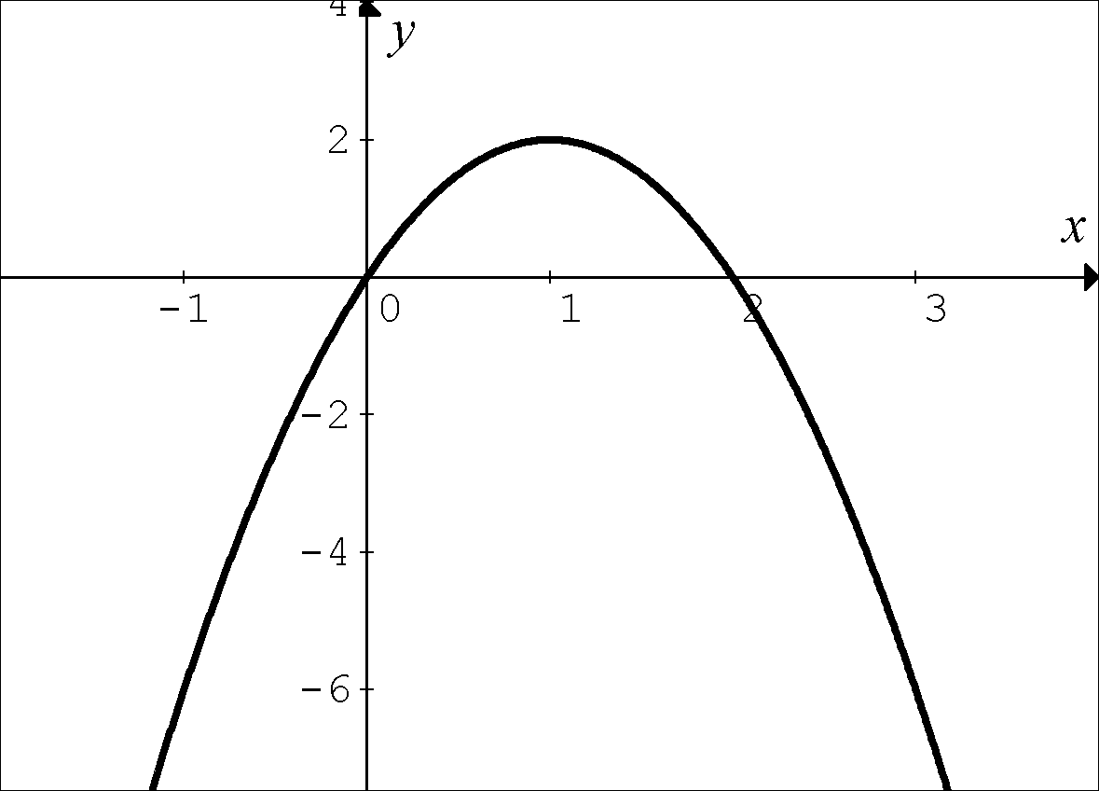
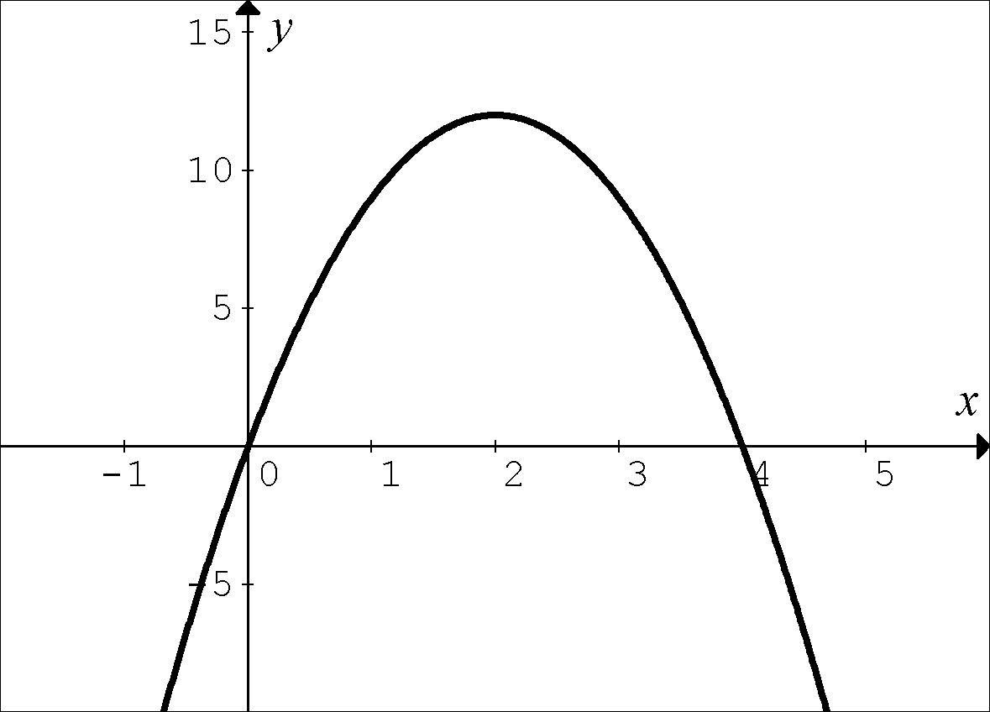
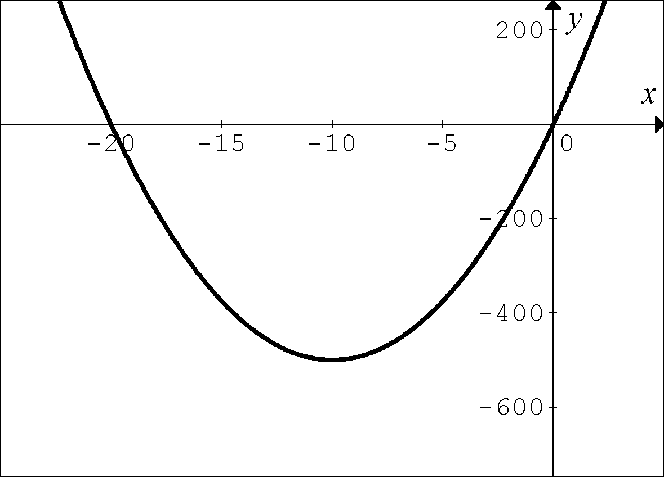
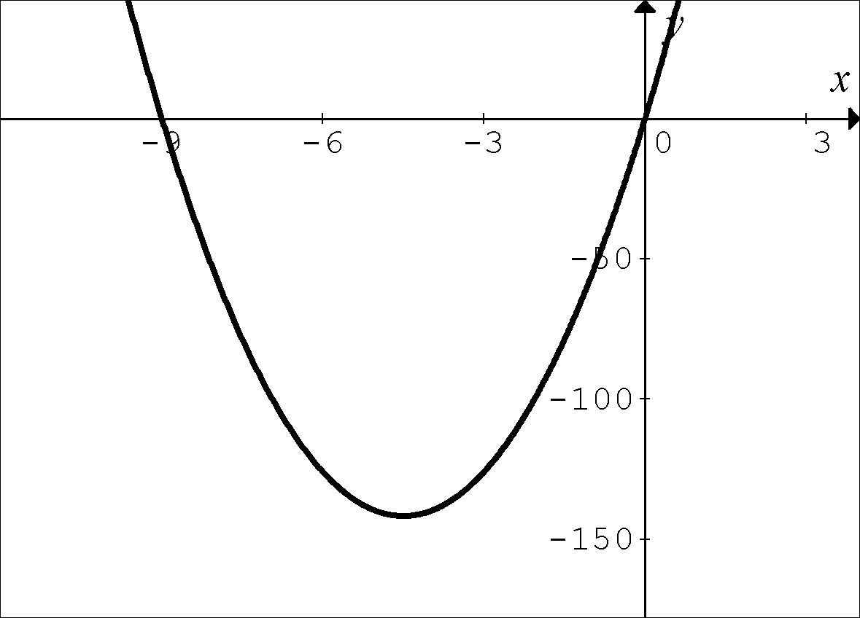
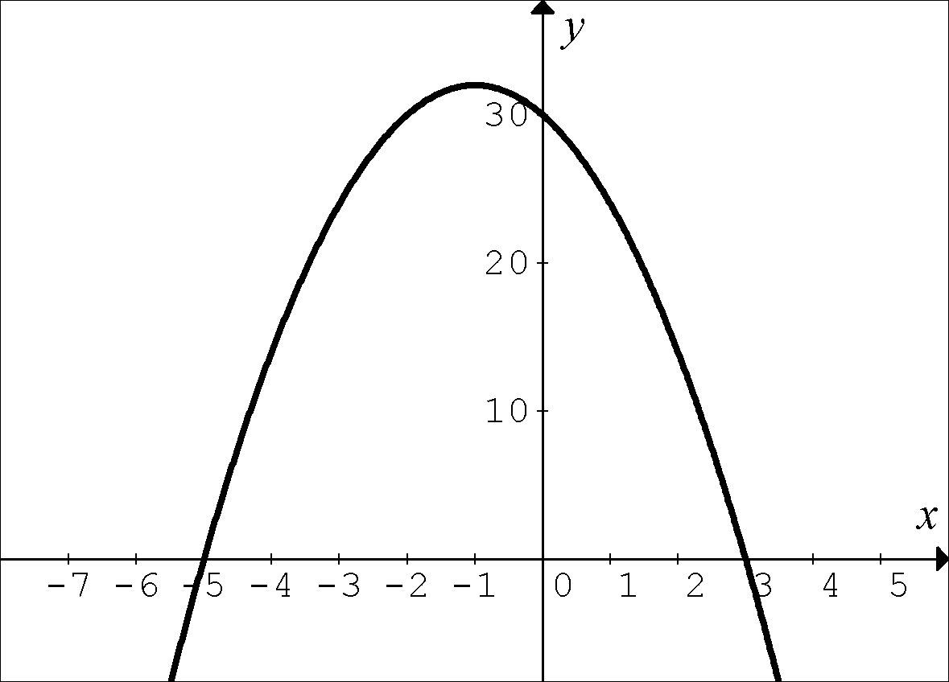
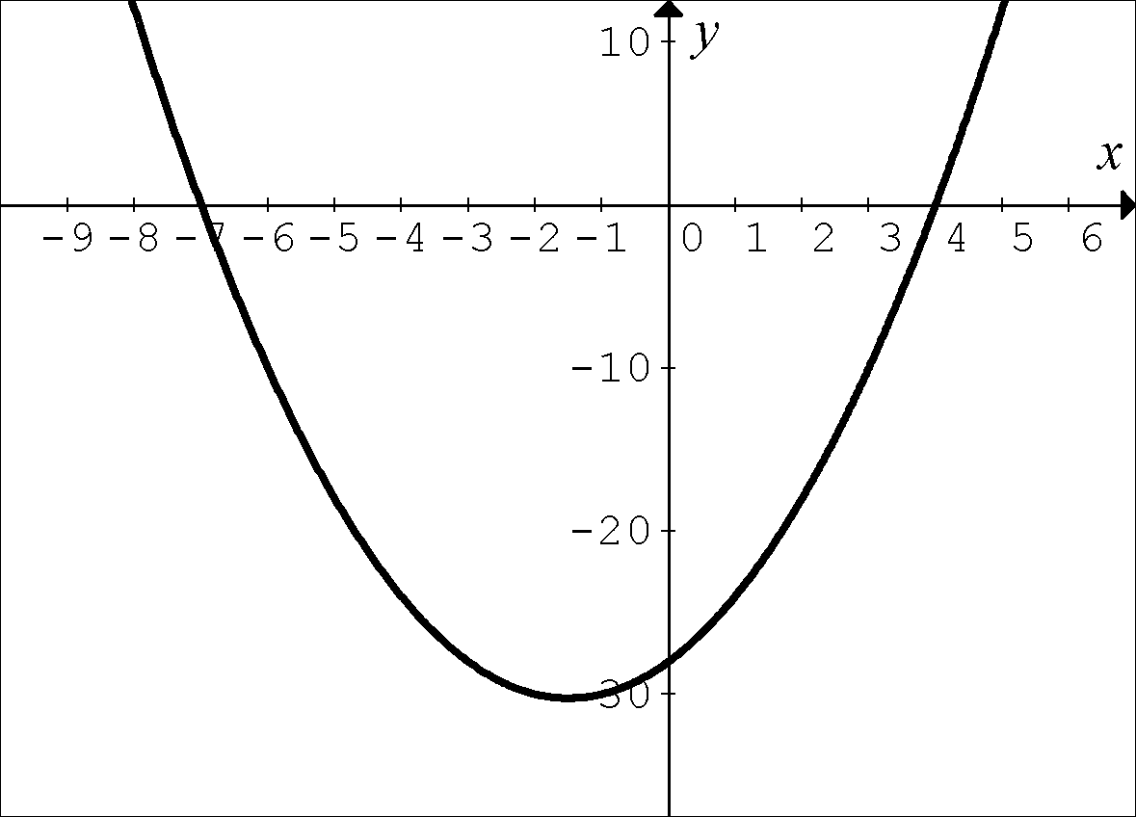

(1, 2)

(2, 12)

(–10, –500) 2)

(–4.5, –141.75) 2)
–

(–1, 32)

(–1.5, –30.25)
2. The quadratic function below has x-intercepts at x = 0 and $x=-\frac{b}{a}$. What is the x-coordinate of its vertex?
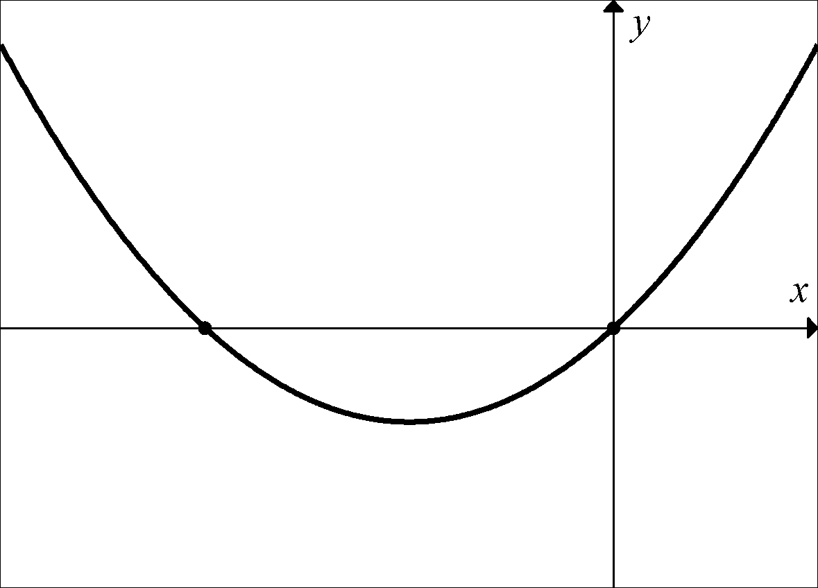

0

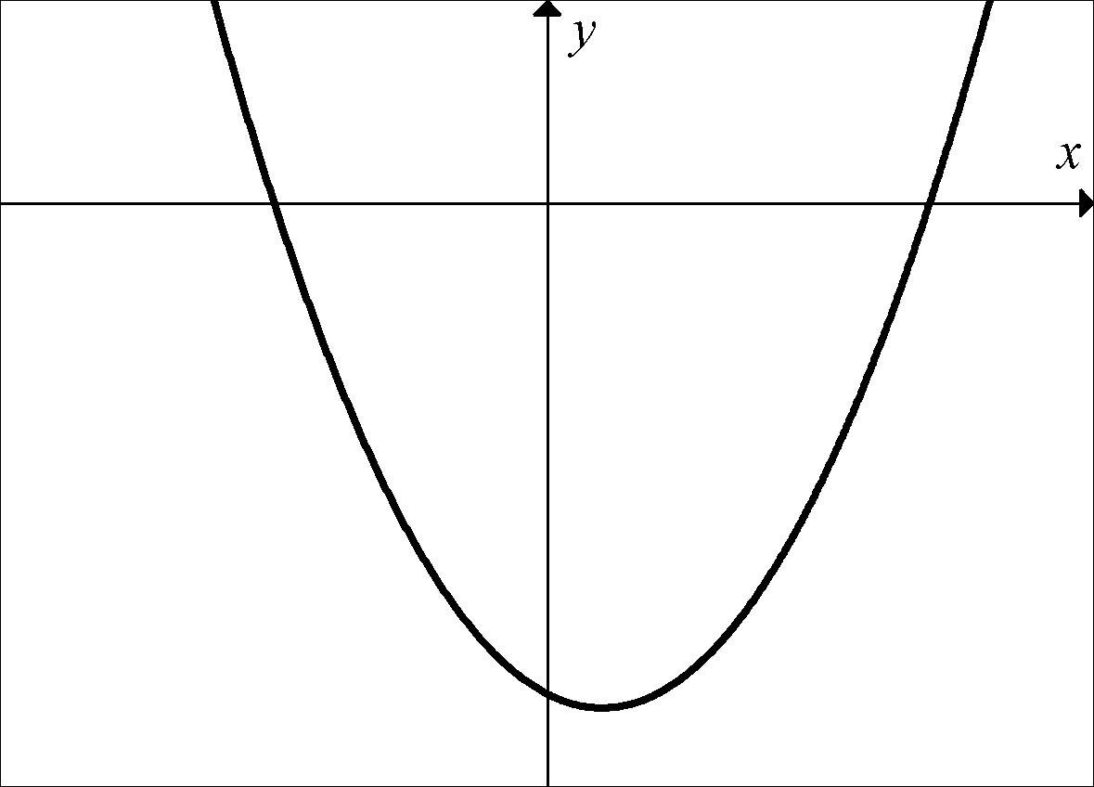
3. Challenge: Using what you learned from the previous problems, and what you know about the quadratic formula, what is the x-coordinate of the vertex of the quadratic below?

The x-intercepts of the quadratic are given by:

and

