This lesson is intended to show students an application of a trigonometric function to model a periodic situation involving tides.

**Guiding Principles**

1. Active Learning: Students will work together to find a solution to a problem that requires them to seek out or select the information required, perform calculations, and evaluate their actions in the context of the problem.
2. Meaningful Applications: Students will work on an interesting application with perhaps multiple solution paths, where they will identify a mathematical function that models the situation.
3. Academic Success Skills: Students use intuition and perseverance to recognize that they can find solutions to real-life problems.

**Prerequisite Knowledge**

1. Students should be able to read and interpret graphs of functions.
2. Students should know how to write a trigonometric function whose graph has certain properties (amplitude, period, phase shift, shift up). Alternatively, this activity could introduce these concepts by first utilizing the “Intro to Sine and Cosine Graphs” worksheet.
3. Students should be able to solve trig equations, either algebraically or using graphing technology.

**Materials**

Each student will need a blank sheet of paper for calculations and a graphing calculator or access to Desmos.

**Objectives**

1. Students will be introduced to a scenario involving modeling tides with trigonometric functions.
2. Students will determine properties of the trigonometric function and write a formula for the function.
3. Students will use estimation and knowledge of right triangles to write and solve a trigonometric equation.

**Teachers Guide (~45 minutes)**

Place students into groups of 2, 3 or 4.

1. Slide 1: Cover Slide.
2. Slide 2: Set up the problem with a short clip from the TV show *Bob’s Burgers*. (Ctrl+click to follow the link.)

1. Slide 3: Poses the question about whether the protagonist and his companion can be saved. It also prompts students to consider the information that would be needed to give a precise answer to this question. Have students talk in their groups about the clip and make a list of the information that they need to know. After a few minutes, ask the groups to report their lists to the class and compile a class list.

1. Slide 4: Asks students to look at a tide chart.

1. Slide 5: Introduces the tide chart showing when the tide will be at various levels. Students should be able to make their answer more concrete at this point. Give students time in groups to look over the chart and gather information from it. The teacher should circulate around the room and check on the groups and what they are taking from this chart. At this point they should take note of the approximate period of the function, the approximate amplitude of the function, and the time at which the tide is highest.

1. Slide 6: Gives hints as to how the situation can be idealized. With this information, students should be able to write a trigonometric function that gives the height of the tide as a function of time. Because the graph is real data, it isn’t a perfect trigonometric function. They will have to decide what to use for the period, amplitude, etc. The file “Intro to Sine and Cosine Graphs” can be helpful to introduce students to how to take information from the physical situation to create a function to model the situation.

The graph has the vertical units in meters, but students may be more comfortable using feet, so you could decide as a class what to use.

We will assume that the period is about 12 hours (or 11.5), the amplitude is 9 feet (2.75 meters), the vertical shift is 9 feet (2.75 meters). Students can choose to use a sine or cosine function, and then determine what the horizontal shift will be based on that decision. If they use a negative cosine function, they can use the horizontal shift +5, or they may choose +4.5.

Using this function, the students should be able to arrive at a fairly accurate estimate as to when the water will be over the character’s heads.

1. Slide 7: We pose an additional question. Since this is happening on a TV show, we know that our main character will be rescued. However, help isn’t going to show up until the situation is dire. During the show we would expect the camera to cut back to our dudes in distress periodically. For example, the producers would show us Bob and Mr. Fishoeder when the water has reached their feet. Students should be able to create a reasonable estimate as to when that would be.

Encourage the groups to type their function into Desmos or their graphing calculator to graph it. They can use the crossing graphs method to determine when the height of the water is to their feet. (i.e. they can enter the trigonometric function into y_1, and in y_2, enter the height of the tide when the water is near their feet, then find the intersection of the two graphs).

1. Slide 8: This slide asks when the water level is at their waist level. Students will need to make an estimate of “waist level” on an average man, and solve a trigonometric equation (either algebraically or by graphing with technology).

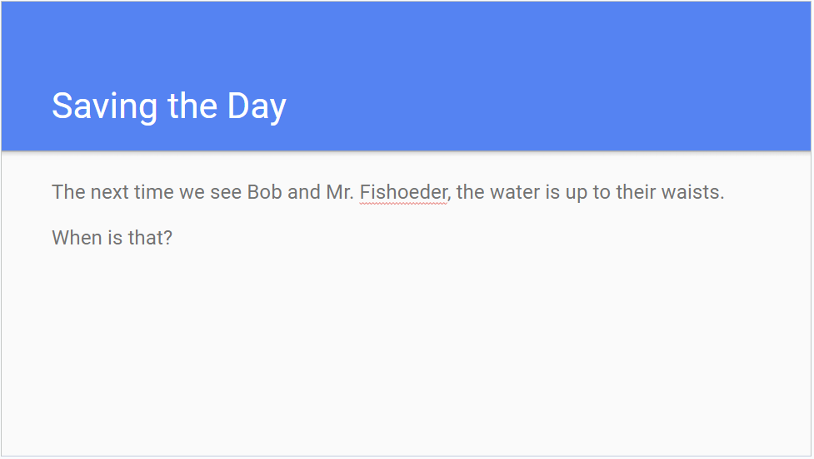

1. Slide 9: This slide asks when the water level is up to their necks. Students will need to make an estimate of that height on an average man, and solve a trigonometric equation (either algebraically or by graphing with technology).A screenshot of a computer

   Description automatically generated
2. Additional discussion questions:

a. Did you use a sine or a cosine function to model the tide’s height? If you used sine, could you have used cosine (or vice-versa)?

b. Comparing the tide chart to your trigonometric model, which features of your model (amplitude, period, phase shift, shift up/down) would need to be adjusted if this scenario had taken place on June 12 instead of June 11?