Painter’s Assistant

This lesson reinforces the idea of a rational function with a real-world situation. It is designed to highlight the concept of a horizontal asymptote as a limiting value as the independent variable approaches infinity.

**Guiding Principles**

1. Active Learning: Students will work together to find a solution to a problem that requires them to seek out or select the information required, perform calculations, and evaluate their actions in the context of the problem.
2. Meaningful Applications: Students will work on an interesting application with perhaps multiple solution paths, where they will identify a mathematical function that models the situation.
3. Academic Success Skills: Students use intuition and perseverance to recognize that they can find solutions to real-life problems.

**Prerequisite Knowledge**

1. Sketching graphs
2. Solving Rational Equations

**Objectives**

1. Students will demonstrate knowledge concerning practical interpretation of horizontal asymptotes.
2. Students will be able to choose a shape for the graph that fits their expectations.
3. (Optional) Students will be able to write a rational function that models given data

**Materials**

The PowerPoint, a blank sheet of paper for each student, and a graphing tool (Desmos, a graphing calculator, or similar graphing device).

Teacher’s Guide (~ 45 minutes)

1. Slide 1: Cover slide. Each student should have a blank sheet of paper to take notes and do calculations.

1. Slide 2: Sets up the problem by giving some background information

1. Slide 3: Continues to set up the problem by giving more relevant information. And introduces the main question for this problem.

1. This slide prompts the students to think carefully about an important variable in the problem: the rate at which each painter can paint a home in (houses/hour). Note, that since no painter can paint an entire house in one hour or less, the answers will be fractional. For instance, Alvin’s rate to paint is 1/12 of a house per hour.

1. Slide 5: This slide gives the answer to questions in the previous slide.

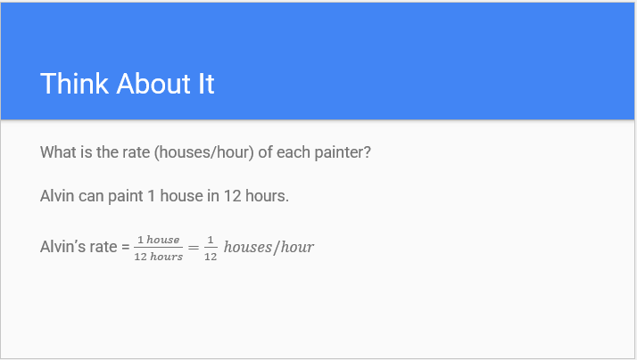

1. Slide 6: This slide continues to build off the other slides adding in the next step of complexity: working together.

1. Slide 7: This slide prefaces the main question (slide 3) by asking how much work two painters can get done in a certain amount of hours. Students should try to arrive at the equation:

$$rate×time=work done$$

To help them arrive at this equation, you can ask them to analyze the units

$\frac{house}{hour}×hour=house$,

where the $house$ unit is.

1. Slide 8: Introduces a question that gets to the heart of the problem. How many hours, $h$, would it take Alvin with an assistant painter who paints at a rate of $\frac{1 house}{x hours}$, to paint one entire house. Write $h$ as a function of $x$ (the number of hours it takes to paint one house). Students may need help finding the formula: rate × time = 1 (house), where the time is *h* hours, so (1/12 + 1/*x*)·*h* = 1, or alternatively 1/12 + 1/*x* = 1/*h*. Solving for *h* gives the required function, .

1. Slide 9: Gives a link to the Desmos graph of the problem, <https://www.desmos.com/calculator/crbkc57dmu>. Students can use the slider to visualize. Ask students what the *y*-axis represents. Ask what the *x*-axis represents. Move the slider for the input variable to get points on the graph. Ask students what each point means.

1. Slide 10: Revisits and answers the main question on slide 3. Be careful with the answer to “12 hours?” It’s a trick question: Al can do it by himself in 12 hours!

**Common Student Pitfalls**

1. The idea of the combined rate may be difficult for students. It may help to draw a picture of a simplified situation. Suppose one painter can paint a tiny house in 2 hours and another can paint it in 4 hours. So, in one hour the first painter paints ½ the house and the second painter paints ¼ of the house. Together, they can paint ¾ of the house in one hour: ½ + ¼ = ¾ . Setting up the equation ½ + ¼ = 1/*h* yields *h* = 4/3 hours to paint the entire house.

Remind students that Alvin’s rate is 1/12 houses per hour and his assistant’s rate is 1/*x* houses per hour, so their combined rate is 1/12 + 1/*x* houses per hour.