This lesson is intended to help students understand that asymptotes are a fundamental feature of rational functions. This activity is asking students to reason graphically about converting from speed (in MPH) to pace (in minutes per mile). They should work in groups, and they will modify their graph as they go through the PowerPoint slides. At first, they should have at least a decreasing graph.

This activity is relatively short and is heavily scaffolded. It can be used as an introduction to rational functions and reasoning about asymptotes in a real-world context.

**Guiding Principles:**

1. Active Learning: Students will work together to find a solution to a problem that requires them to seek out or select the information required, perform calculations, and evaluate their actions in the context of the problem.
2. Meaningful Applications: Students will work on an interesting application with perhaps multiple solution paths, where they will identify a mathematical function that models the situation.
3. Academic Success Skills: Students use intuition and perseverance to recognize that they can find solutions to real-life problems. They will create and refine their graphs multiple times, so they can see that you don’t have to have a perfect graph the first time.

**Prerequisite Knowledge:**

1. Practical understanding of “miles per hour” and “minutes per mile.”
2. Graphing functions
3. Unit conversions

**Materials Needed:**

Time: Approximately 10-15 minutes

Blank sheet of paper for each student.

Access to graphing calculator or Desmos

Break students into groups of 3 to 4 for discussion.

**Objectives**

1. Students will interpret vertical asymptotes and horizontal asymptotes in a real-world context.
2. Students will model data as a rational function.

**Teacher’s guide (~10-15 minutes)**

1. (Slide 1) Cover slide. Students should be divided into groups and have a blank sheet of paper or small marker board to share.
2. (Slide 2) Sets up the scenario - Aaron wants to convert his speed (in MPH) to his pace (in minutes per mile).



1. (Slide 3) Gives students a conversion that they can do in their heads. Students will start thinking about whether the graph will be increasing or decreasing.



1. (Slide 4) Asks students to draw the shape of the graph in their groups. At this point they should at least have a decreasing graph.

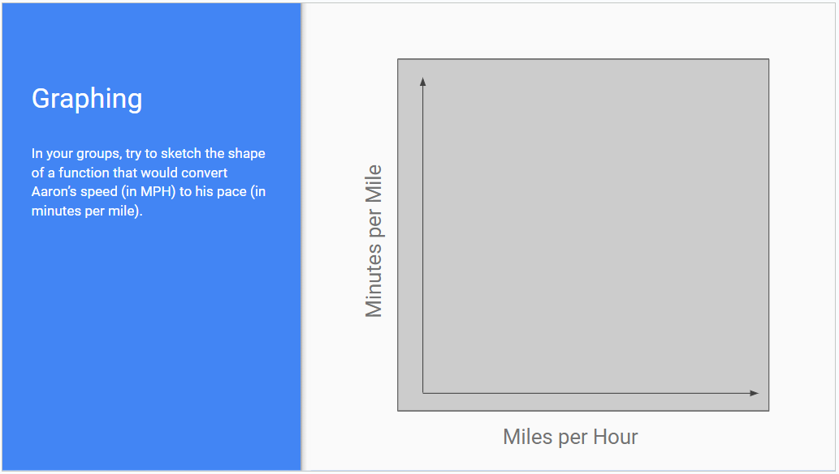

1. (Slide 5) Asks students to think about the pace when Aaron runs at a speed close to 0 mph. This should help them see that speeds close to zero will give a very large number for the pace. This will help them to realize that there is a vertical asymptote at x=0.



1. (Slide 6) Asks students to think about the pace when Aaron runs at a very fast speed. This should help them see that faster speeds will give a smaller number for the pace. This will help them to realize that there is a horizontal asymptote at y=0.



1. (Slide 7) At this point, students should be able to come up with a formula for the function. If the students are struggling, have them think about how they converted 6mph to minutes per mile, then how they converted 3mph to minutes per mile, etc. They should be able to generalize their previous calculations into the function y=60/x. They can then graph this function in their graphing calculators or on Desmos.

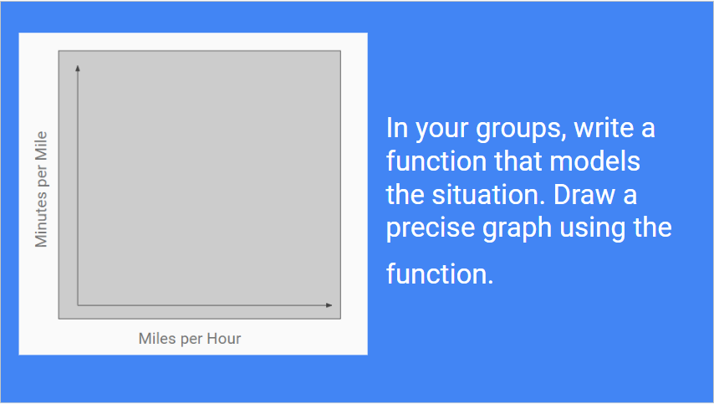

1. (Slide 8) Students should be able to describe the asymptotes in the context of the problem. “A very slow speed in miles per hour will convert to a large number of minutes per mile.”



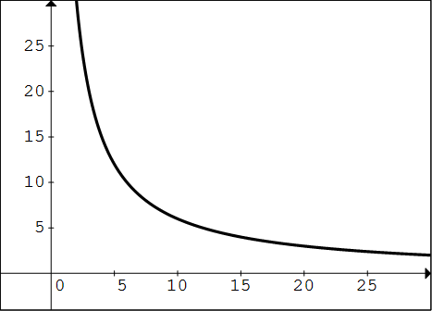

1. (Slide 9 Optional) Students should notice that the graph is concave up. This means that early on, small changes in miles per hour correspond to large decreases in miles per minute, but the faster you go, the decrease in pace will be less dramatic.

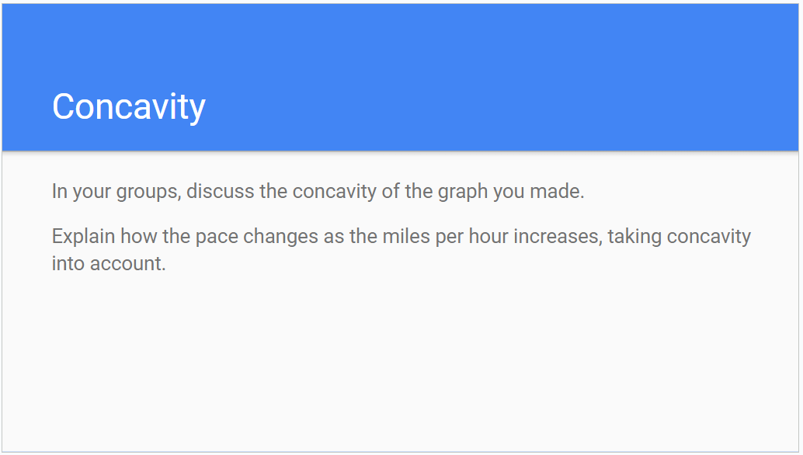

**Common Student Pitfalls:**

* Students might get stuck on drawing a decreasing graph at the very beginning. The teacher could say something like “If I run faster in miles per hour, what does that mean about my pace?” Or “Is a 10 minute mile pace faster or slower than an 8 minute mile pace?”
* Students will probably start with a decreasing linear graph. That is OK. They will deal with what happens when the speed is near zero and when the speed increases without bound in subsequent slides.
* It may be helpful to have students make a table with input values in MPH and output values in minutes per mile so that they can generalize to write the formula. Having them explore very slow speeds or very fast speeds (that are not humanly possible) may be helpful for them to understand the main ideas of the lesson, the asymptotes of this rational function.

| MPH | minutes/mile |
| --- | --- |
| 1 | 60 |
| 2 | 30 |
| 3 | 20 |
| 6 | 10 |
| 10 | 6 |
| 20 | 3 |
| 30 | 2 |
| 60 | 1 |
| *x* | 60/*x* |

* Students may forget how to convert units, or they may struggle with not flipping the fraction.