Guiding Principles
- Active Learning: Students will work together to find a solution to a problem that requires them to seek out or select the information required, perform calculations, and evaluate their actions in the context of the problem.
- Meaningful Applications: Students will work on an interesting application with perhaps multiple solution paths, where they will identify a mathematical function that models the situation.
- Academic Success Skills: Students use intuition and perseverance to recognize that they can find solutions to real-life problems.

Prerequisite Expectations
This discussion project is an introduction to exponentially decreasing functions. It is meant to be used:
- After a lesson in linear functions so that students can contrast the differences between constant rate of change and exponential rate of change.
- After a lesson/discussion of exponential growth functions and their features so that students can compare and contrast the similarities and differences between exponential growth and exponential decay.
Objectives
- To introduce/motivate the idea of exponential decreasing functions.
- To contrast the differences between exponentially decreasing functions and functions decreasing at a constant rate.
- To compare/contrast the similarities/differences between exponentially increasing/decreasing functions.
- To introduce the idea of horizontal asymptotic behavior.
- To set up an exponential function.

Teachers Guide (~45 minutes)
Place students into groups of 2, 3 or 4. Each student should have a blank sheet of paper in front of them.

- Slide 1:
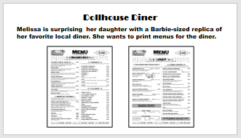
Sets the context of the problem.

- Slide 2:
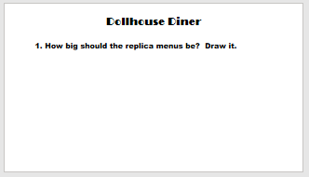
Ask students to draw on their paper what they think the dollhouse diner menu should look like. Have them compare their drawings with their neighbors or their group and discuss their differences. Does anyone think their neighbor or their groupmate’s drawing is significantly wrong? If so, have them debate it. The object of this task is to stimulate their individual intuition and form a hypothesis.

- Slide 3:
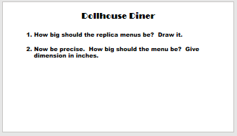
Now it’s time to switch gears from intuition to precision. They need to determine for themselves that “We need more information.” Ask them what information they need. Move onto the next slide only after they’ve determined all three necessary items (original menu size, size of a Barbie, size that Barbie would be if she were a human or size of an average woman). As a group, decide which is more appropriate: the estimate of Barbie’s human size or the size of an average woman (or the size of an average human).
- Slide 4:
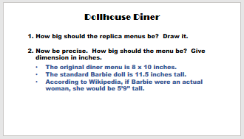
Give students time to solve this proportion problem.

- Slide 5:
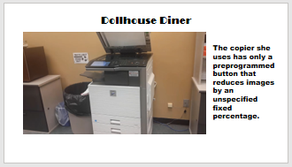
This slide contains a video. Read the question and push play.

- Slide 6:
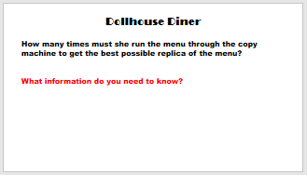
The problem contains missing information. Guide them to ask for the “unspecified” reduction rate. You might ask them to “make a guess” in hope that they realize a guess is pointless without a reduction rate. Since it is not given, ask them if there is a way to determine it.

- Slide 7:
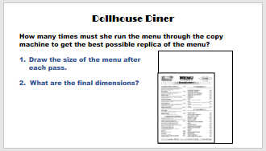
After the class determines that they can get the reduction ratio by looking at a reduced copy, pass out the Dollhouse Diner Handout. Give students time to
  - Measure the reduced menu and determine the reduction ratio.
  - Determine the number of times Melissa must run the menu through the copy machine to get the best possible replica of the menu (based on their answer from slide 3). Students may wish to make a table to record the menu size after each pass through the copy machine, or to write a formula to model the length (or width) of the menu. The objective of this question is to get students to think in terms of an exponential rate of change (and to set up an exponential equation).
Ask the class if anyone subtracted a certain number over and over. Discuss as a class the differences between subtracting a common number over and over vs multiplying a common number over and over. The first is a constant rate problem, the second is an exponential rate problem. Ask and answer: “Why is this an exponential rate of change problem?”

- Slide 8.
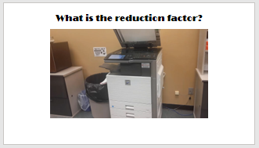
Show the answer video and congratulate the students who got it right. Have a discussion about the meaning of a 75% copy versus a 25% reduction. You can use an example of a discount while shopping: If the item is “25% off” then you pay 75% of the original price.

- Slide 9:
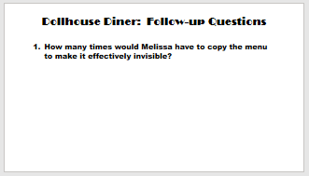
Students should discuss how small the menu must be to make it effectively invisible. Is it when the menu is too small to read, or is it when the menu is not visible to the naked eye? After this discussion, students might make a graph with length on the vertical axis and number of times reduced on the horizontal axis. The purpose of this follow-up question is to discuss asymptotic behavior as x approaches positive infinity. Contrast this linear function with negative slope: constant ratio vs constant difference.

- Slide 10:
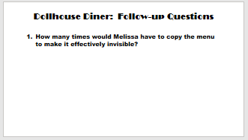
After giving students some time to try to answer this on their own, solve a simpler problem together as a class. Instead of starting with the dollhouse menu and trying to get it back to the original size, start with the first copy (the one that is exactly 75% of the original). What percentage must Melissa set the copier to get it back? Take suggestions first before performing the actual algebraic calculation. Did anybody offer “125%”? If not, ask the class: “Should she set it at 125%?” Follow with “Why/why not?” This would be thinking in terms of constant rate of change as opposed to exponential rate of change thinking.

- Additional discussion questions:
a. Would writing a formula for the length (or width) as a function of the number of times through the copy machine make it easier to answer some of the questions above?
b. If the menu is run through the copier six times, what is the percent reduction from the original? This is another good time to discuss the difference between “percent of” and “percentage reduction” since six times through the copier gives 0.75⁶ or approximately 0.178, so it’s 17.8% of its original size, or an 82.2 % reduction.
Conceptual Understandings of Objectives
- To introduce/motivate the idea of exponential decreasing functions. Students should learn that not all functions increase. Some functions can decrease as well. Analogous to increasing functions, there are different ways a function can decrease (linearly, concave up/down, with/without bound or asymptotically). In particular, exponential functions of the form $f\left(x\right)=a⋅b^{x}$ with $a>0$ will increase/decrease based on the value of $b$. If $0<b<1$, $f$ will decrease asymptotically to $y=0$ (and increase without bound if $b>1$. Exploration Bonus: discuss what happens when $b=1, b=0, b<0, a=0, a<0$. Answer: constant function $f\left(x\right)=a$; constant function $f\left(x\right)=0$ with a hole at $(0,0)$ since $0^{0}$ is undefined; mostly undefined because even roots of negative numbers are imaginary leading to the impossibility of defining irrational values $x$—this is why exponential functions are only defined for $b>0$; constant function $f\left(x\right)=0$; vertical reflection).
- To contrast the differences between exponential decreasing functions and constant decreasing functions. Students should learn that exponentially decreasing functions (with positive coefficient. i.e. $a>0$ for $f\left(x\right)=a⋅b^{x}$) decrease asymptotically to $y=0$. This is because when you repetitively multiply any number by a proper fraction, it reduces, but not to zero or below. This is in contrast to constant decreasing functions $y=mx+b$ with $m<0$, where you repetitively add a number by a negative number $m$. Constant decreasing functions decrease linearly without bound, eventually reaching zero and below.
- To compare/contrast the similarities/differences between exponential increasing/decreasing functions. Students should learn for $f\left(x\right)=a⋅b^{x}$, that the possible values of $b$ are values in the interval $(0, 1)$ or $(1, ∞)$. Differences: $f$ decreases for $0<b<1$, and increase for $b>0$. Similarities: increasing and decreasing functions have similar shape in that they are reflections of each other across the y-axis. Two exponential functions $f_{1}(x)=a⋅{\left(b_{1}\right)}^{x}$ and $f_{2}(x)=a⋅{\left(b_{2}\right)}^{x}$ are exact horizontal reflections of each when $b_{1}$ and $b_{2}$ are reciprocals of each other. Why? Answer: because being reciprocals implies $b_{2}={\left(b_{1}\right)}^{-1}$, thus $f_{2}(x)=f_{1}(-x)$.
- To introduce the idea of horizontal asymptotic behavior. Students should learn that when they multiply any starting value/number by a proper fraction repeatedly, it reduces towards zero, but never reaches zero or below.
- To set up an exponential equation. Students should learn that repeatedly multiplying a starting value $a$ by a number $b$ gives rise to an exponential function:

$a⋅b$
$a⋅b⋅b$
$a⋅b⋅b⋅b$
$⋮$
$f\left(x\right)=a⋅b^{x}$

Active Learning

Active learning is an exciting and great way to engage students inside the classroom to actively participate in math lessons. If you are new to active learning, here are some pointers to get students to participate.
- Guess: ask students to guess what the right answer is. This will give students an intuition of what to expect in a correct answer and offer a starting point to more precise solutions. See if students can recognize any patterns they can exploit. In the case of the dollhouse diner, ask each student to draw about the size they expect the dollhouse menu to be. Have them compare their drawings with others in their group or their neighbors.
- Be Precise: Ask students how they would go about getting a precise answer. What information do they need? When they identify what they need, either give them the information or ask them to search for it themselves. Whenever they settle on an approach/answer, whether or not it is correct, ask students to support and defend their answers. If they came up with a wrong approach/answer, point out flaws in their argument and ask them to modify their approach/answer to address them. If they cannot come up with the correct answer, it is okay to offer hints to guide them in the right direction. In the case of the dollhouse diner, they will need a scaling factor which they can find by googling what the actual height of a typical barbie doll is vs the average height of women in the US.
- Goal: Keep in mind the goal of the lesson and always be guiding/nudging students in that direction. It is best for students to achieve it by themselves or with little guidance, but it is okay to offer more help (in increments—don’t just give them the answer) when necessary to get them over any bumps. The goal of this lesson is highlight properties of exponential decay: (1) repeated multiplication by a constant ratio (less than 1) and (2) learn about asymptotic behavior—i.e. students should learn that this function decreases toward 0 but not beyond like a linear function would.
- Above and Beyond: It is worthwhile to sometimes take lessons to the next level. Sometimes this entails challenging students beyond the primary goals of the lesson. Asking tougher or more interesting questions can get students’ creative juices moving and allows them to see what more they can do with the lesson. Slide 9 is an example of this. Students are intended to set up the equation $y={\left(0.75\right)}^{n}x$ where $x$ is the original size, $y$ is the new size and $n$ is the number of times through the copier; and solve for $x$ by dividing $y$ by ${0.75}^{n}$.

Academic Success Skills

This activity creates an opportunity for students to persevere in problem solving. Teachers can build off of the students’ intuition and challenge them to mathematize their ideas and add specificity. So many math activities present students with a fully formulated math problem and ask them to answer it. The overarching goal of this type of activity is to present students with an engaging problem and involve them in the formulation of the question (e.g. not giving them all the information they will need. Students need to determine what kind of information they need to answer the problem) before answering it. To do this activity well, teachers should resist the urge to be too helpful. Giving information only when students ask for it, asking questions to highlight the error in incorrect approaches, and asking students to justify correct answers. If students can master all three of these:
- Determining what information is essential/needed.
- Determine the error in incorrect approaches.
- Justify correct answers.
their academic success skills will improve.

