This activity is designed to reinforce the idea of linear functions in a real world situation. This can be done after a basic lesson in linear functions. It is designed to highlight the concepts of rate of change of a linear function, and the intercepts of the linear function in an everyday context. In particular, this activity gives students an example of a linear function with a negative slope.

**Guiding Principles**

1. Active Learning: Students will work together to find a solution to a problem that requires them to seek out or select the information required, perform calculations, and evaluate their actions in the context of the problem.
2. Meaningful Applications: Students will work on an interesting application with perhaps multiple solution paths, where they will identify a mathematical function that models the situation.
3. Academic Success Skills: Students use intuition and perseverance to recognize that they can find solutions to real-life problems.

**Materials:**

The PowerPoint, paper, graphing paper, and graphing tools (Excel, Desmos, or other graphing software).

**Objectives**

1. To reinforce the idea of linear functions to make predictions in the real world.
2. To set up a linear function and interpret some key characteristics.
3. To work with an application in which the rate of change is negative.

**Teachers Guide (~25 minutes)**

Place students into groups of 2, 3 or 4.

1. Slide 1: Cover Slide. Each student should have a blank sheet of paper and graph paper to take notes and do calculations.



1. Slide 2: Have the students read it and write down the relevant information.

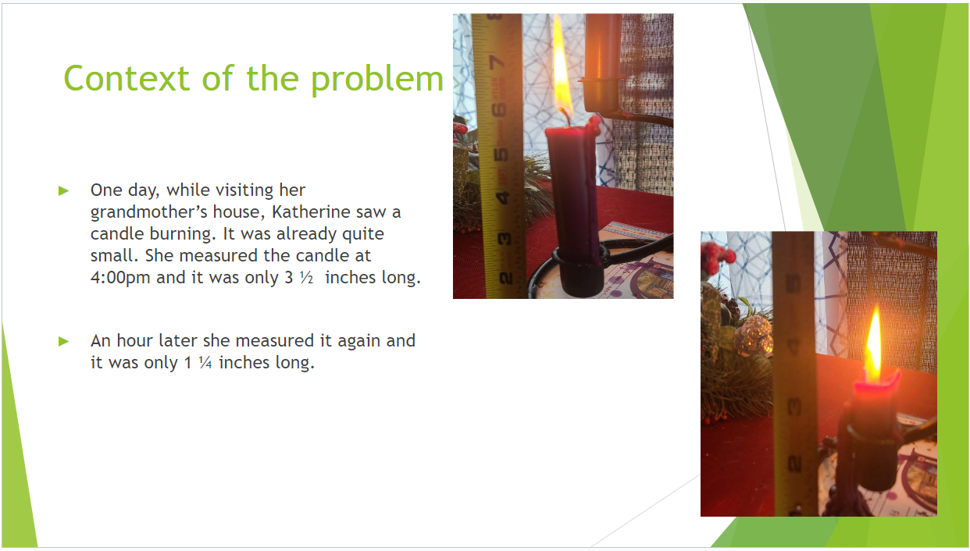

1. Slide 3: This slide gives more information and asks one of the central questions:

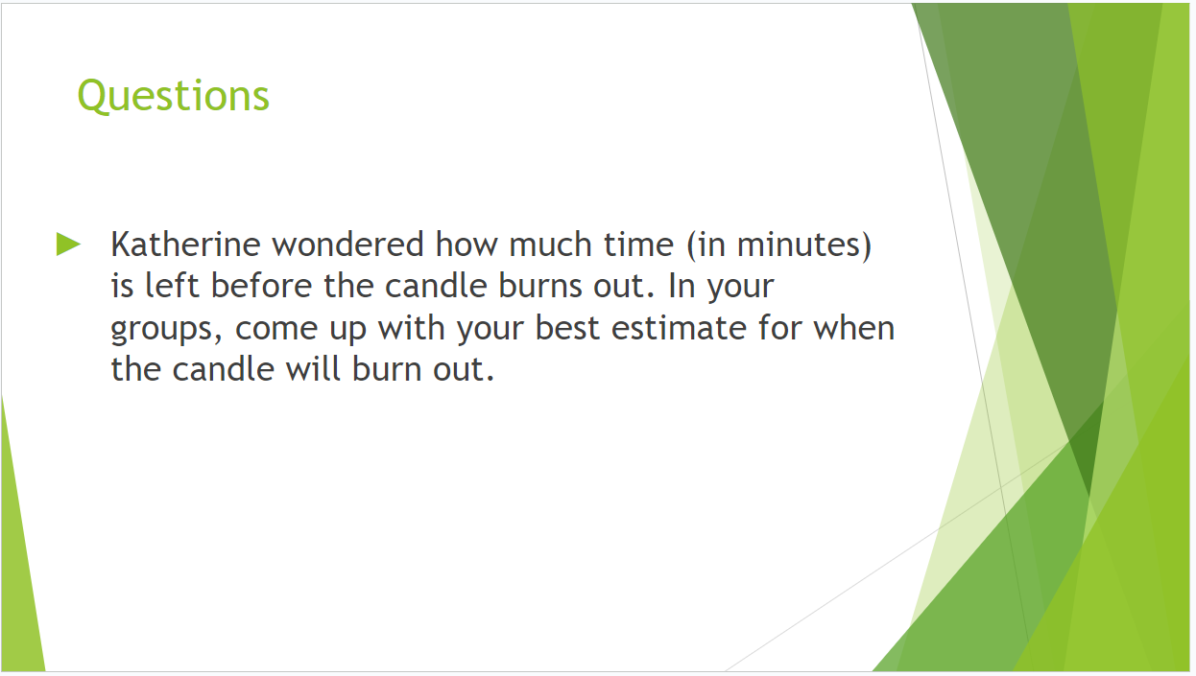

1. Slide 4: Asks the groups to plot the data and draw a graph. They will need to decide what units to use for time.



1. Slide 5: The groups will then discuss the vertical and horizontal intercepts of their graphs. Depending on how they decided to draw the graph, they may have different answers for the meaning of the vertical intercept (say, if they made time t=0 be at 4:00pm, or they may have chosen to make t=0 to be noon, or something else). The horizontal intercept will give the time when the candle’s height is zero (when it burns out).



1. Slide 6: If the students do not yet have a formula for the equation of their line, this would be a good time to encourage them to write a formula. They may also solve this graphically. They will need to convert the number of minutes to hours & minutes, and then subtract from 4:00 to find the time. (It should be approximately 1:07pm)

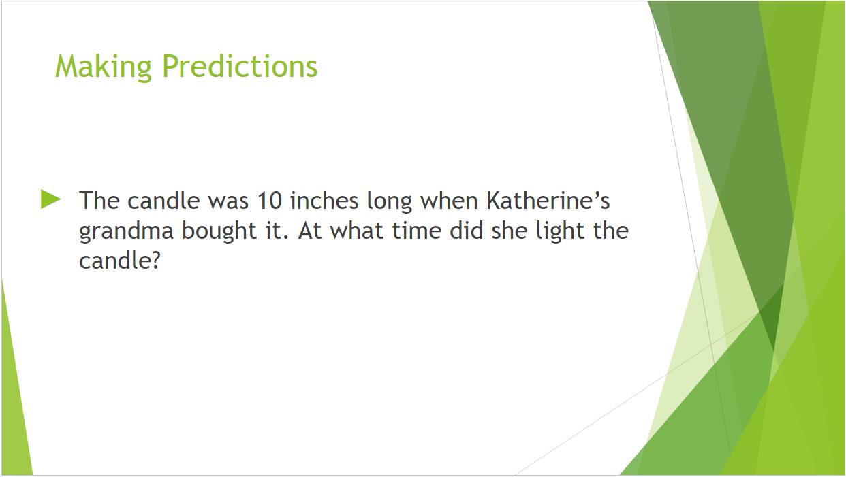

1. Slide 7: In this slide, the students will need to discuss the assumptions that they made. They assumed that the height of the candle will change at a constant rate. If the candle is tapered, then the height probably decreased faster at first. Thus, the previous prediction is too early, i.e. the candle would have been lit sometime AFTER 1:07pm.



**Common Student Pitfalls:**

1. Students may have trouble finding the rate of change and reasoning about why it is negative. If they use inches per minute, the rate of change is -0.0375, which is quite small, so they may struggle to understand the real-world meaning of this number.
2. Students may struggle to convert the -173.33 minutes to the time when grandma lit the candle to a specific time on the clock.