Race to the House
Consider the man trying to outrun the bear to reach the house in the following image:
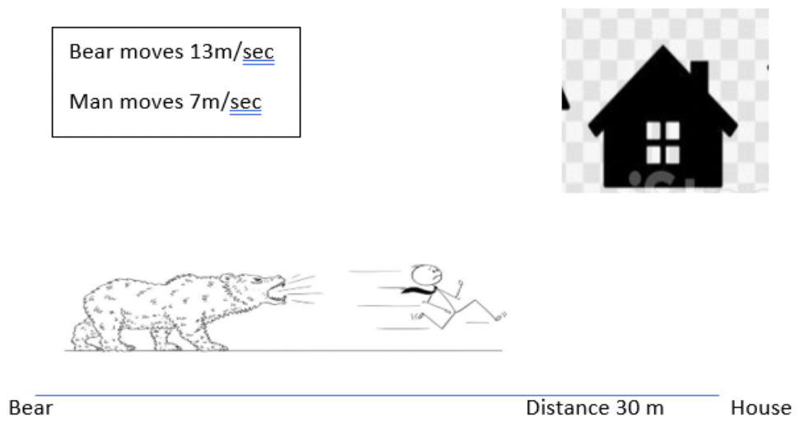
Will he make it?
Remember to approach these problems using the list REACT:
Read
- Read the problem and determine what you are being asked
- Determine what information you are given and what missing information you need

Explore
- Consider multiple potential solution methods

Attempt
- Try to solve the problem using any of the explored strategies

Critique
- Evaluate if the attempted method solved the problem

Teach
- Explain the solution and the reasoning behind it

