Race to the House Instructor Notes
Race to the House
Consider the man trying to outrun the bear to reach the house in the following image:
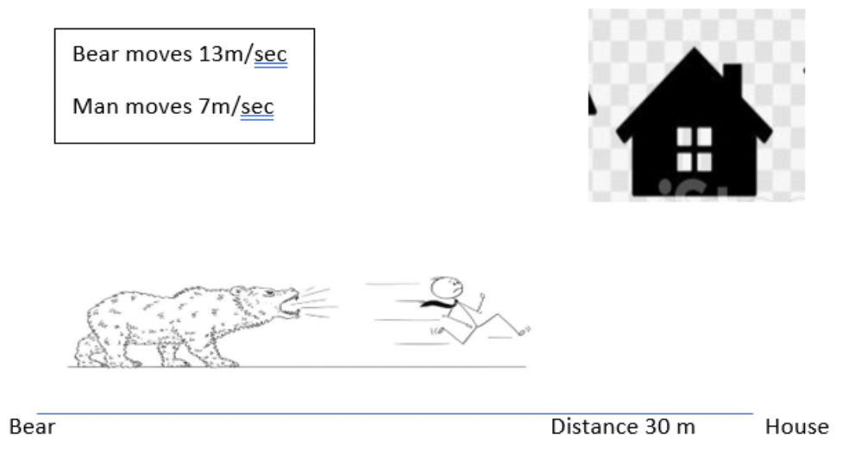
Will he make it?
Remember to approach these problems using the list REACT:
Read
- Read the problem and determine what you are being asked
- Determine what information you are given and what missing information you need

Explore
- Consider multiple potential solution methods

Attempt
- Try to solve the problem using any of the explored strategies

Critique
- Evaluate if the attempted method solved the problem

Teach
- Explain the solution and the reasoning behind it

Instructor Notes
Mathematical Content
Students will build on concepts of:
- Average rate of change in linear functions
- Creating and interpreting graphs
  - Graphing average rate of change in linear functions
  - Points of intersection
  - Increasing/decreasing slope
- Systems of equations using two variables
- Identifying patters (constant rate of change)
- Students will scaffold this task to knowledge based upon the distance formula: d=rt

Learning Objectives
- Students will identify two variables (time and distance)
- Students will create a graph illustrating the activity:
  - Students will put a title on the graph
  - Students will create a legend to describe each data set illustrated on the graph
  - Students will mark each axis of a graph with a label, unit, and scale.
- Students will write equations for functions.
- Students will make predictions using graphical models and reason and communicate about the accuracy/dependability of those predictions.
- Students will use multiple representations to illustrate a situation, including but not limited to
  - Graph
  - Chart
  - Illustration

Mathematical Understandings
- Students will understand average rate of change as follows: if a quantity were to grow in measure at a constant rate of change with respect to a uniformly changing quantity, then we would end up with the same amount of change in the dependent quantity as actually occurred.
- Students will understand a single-variable function as a relationship between an independent variable and a dependent variable, recognizing that the value of the independent variable determines the value of the dependent variable.
- Students will understand that a function is a relationship between two variables such that the value of the input determines the value of the output.
- Students will understand
  - that graph axes’ marks support making sense of the graph and mathematical communication
  - that the label and unit result from the process of quantification, defined as identifying the measurable characteristic of a situation and the way in which it will be measured.

Suggested Materials
- Graph paper/chart paper
- Post it pads
- Colored Pencils
- Measuring tools: blocks, lengths of paper
- Use Desmos or GeoGebra to illustrate the problem.

Active Learning: This activity requires students to construct a description of rate of change and the implications of how rate of change affects other variables (distance/time). To do so, they must accurately plot data points and identify the rate of change from point to point. This activity also requires students to construct a model for the data. Students need the opportunity to identify and describe the rate of change themselves and determine what meaning is learned from the model. This will help students with mathematical understandings of independent and dependent variables, recognizing that the value of the independent variable determines the value of the dependent variable.
Meaningful Applications: Although the context of the problem is generic, it represents a real-world application. The goal is for students to understand how mathematical relationships model real-world events and can be used to predict the success (or lack thereof) of a real-world event. In this activity we focus on graphical representations of data points and their model.
Academic Success Skills: Representing and refining one’s own ideas and being receptive to other ideas are an integral part of this activity. Students often are not able nor comfortable with identifying appropriate modeling techniques or recognizing flaws in the process. Guide students to successfully identify an appropriate mathematical model and help them describe and justify their choice. Engage students in the problem-solving activity of troubleshooting and improving their own arguments. Have them justify the solution based upon the model and the represented data. Collaborative work helps students be less anxious, avoiding math anxiety. Group work allows students to build math identities as they spark ideas from each other, affirming what works, and equally as important, what might not work. Students work together to deconstruct the elements of a problem, to identify how each element affects the problem, and to determine the objective of the problem. Students determine if there is enough information to solve the problem.

Teacher Notes
- Students may choose different ways to represent the data. This is a great way to illustrate data in multiple forms. Ultimately, students should be able to translate their representations into a graphing situation. Whether students are graphing by hand (which is ok in the beginning) or using Desmos, graphing calculator, or another technology tool, they need to be able to use mathematical tools to illustrate real-world applications.
- Students can be supported by recalling the relationship between time, distance, and rate.
- Modeling real data with algebraic functions can help students understand the “why” when it comes to learning about properties of functions.
- Making predictions (projections) using a model helps students evaluate and critique their own solutions to problems and allows for a rich mathematical discussion.
Teachers should first read the REACT framework. They should review the framework with the students before the students attempt to engage with the problem
Read
The prompt asks of the diagram “Will he make it?”. Picture is a bear and a man, each with a different rate of speed, and a set distance from the start of the engagement to the house.

- Students should read the problem, making sense of the image. They should notice the distance represented and discuss what does the actual distance represent: Distance to the house, distance between the bear and the man? And what are the implications in the different interpretations of distance? Begin by grouping students and asking them to decide what story might be told to interpret the picture. Allow groups to share their ideas. Make notes about the significant points of the stories, which are
  - Rate of change for the bear and the man
  - What are the significant units in this story?
  - Starting point for the man and the bear. Why is the starting point important? How far is it to the house? It might be significant to challenge the students to think about how the story would be different if the starting points or total distance was changed.
  - Do the students need to decide some of the details of the story to work out the problem?
  - Ask the students to illustrate the story using various materials provided.
  - Ask students to write a reflection of their problem-solving experience:
  - What did they first notice?
  - What did they wonder about?
  - Did the problem seem to make sense?
  - Did they make changes to solve the problem?
  - Does their solution make sense?

Explore
This activity requires students to construct a description of rate of change and how variability in rate of change can be used to solve a problem. They must identify the rate of change from a given location to another location for both the man and the bear. This activity also requires students to construct a model for the data. Students need the opportunity to identify and describe rate of change and predict solutions based upon the model.

- Students will create a graph with x and y axes.
- Students will determine the variables and label them x and y. Part of the concept focus is determining which variable is the independent variable and which is the dependent variable.
- Students will look for a relationship between the two variables. At this point, students may choose to represent the problem in terms of a drawing or a chart. The relationship between a chart and a function is reinforced by this task. This might also be helpful in assisting students to determine independent and dependent variables: does the data make sense?
- Students will recall-or develop-the formula for the relationship between distance, rate, and time.
Answer
Note: students should spend some time working through the data and making models based on multiple interpretations of the picture to address the wonder questions in the READ part of the problem. This solution illustrates that the man will reach the house 30 m from the origin (0,0) in time if the bear is at the house and the man is only 15 m from the house. Let students work with the location of the y intercepts to find alternative solutions that will affect the time.
Distance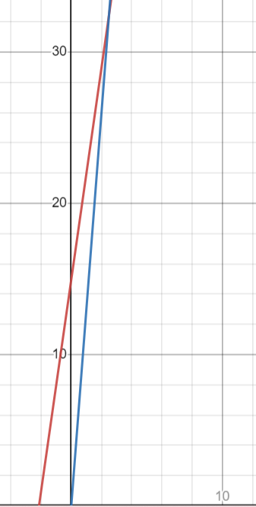
Time
LOs:
- Students will create a graph illustrating the activity:
  - Students will put a title on the graph
  - Students will create a legend to describe each data set illustrated on the graph
  - Students will mark each axis of a graph with a label, unit, and scale.
  - Students will reason and communicate about representing the data visually/graphically.
MU:
- Coordinate the value of one variable with changes in the other.
- Students will understand a single-variable function as a relationship between an independent variable and a dependent variable, recognizing that the value of the independent variable determines the value of the dependent variable.

Attempt
Students write equations for the model after determining the constant rate of change and the location of the bear and the man. This engages students in evaluating the outcome based upon variables.
y=7x + 15
y=13x

LOs
- Students will create a model using data points.
- Students will write equations for functions.
MUs
- Create a model for the data.
- Students will understand that a function is a relationship between two variables such that the value of the input determines the value of the output.

Critique/Teach
Evaluate and discuss the accuracy of different models. Discuss the relationship between two functions and a unique outcome based upon the variables used in each function. This lesson could be extended to introduce systems of equations.
LOs
- Students will make predictions (interpolating/extrapolating) using graphical models and reason and communicate about the accuracy/dependability of those predictions.
MUs
- Create a model (equation of best fit) for the data.

This characterization of average rate of change is adapted from Carlson, Oehrtman, & Moore (2009). Precalculus: Pathways to Calculus, a Problem Solving Approach.

