Activity 2: Competing Social Media Platforms

Suppose that you are a writer for a tech blog and are comparing two new social media platforms – InstaTwit and SnapFace – both of which launched at the same time and are cutthroat rivals. It is now 24 weeks since both platforms have launched, and you are hoping to predict which of the two will reach 200 million total users first.

For InstaTwit, you find the following information:
- After the first 8 weeks of its existence, InstaTwit had 24.2 million total users.
- 16 weeks after launching, InstaTwit had 68.28 million total users.
- 24 weeks after launching, InstaTwit had 111.32 million total users.
For SnapFace, you find the following information:
- During the first 8 weeks of its existence, SnapFace added an average of 7.09 million new users per week
- During the next 8 weeks, SnapFace added an average of 5.54 million new users per week
- During the next 8 weeks, SnapFace added an average of 2.33 million new users per week

Phase 1. Who has more users after the first 24 weeks?

Phase 2. Make a prediction about which website will be the first to reach 200 million total users. Write a sentence explaining your prediction (“we believe that ______________ will reach 200 million total users first because …”).

Phase 3. Consider the total number of InstaTwit users $I$ (in millions) as a function of the number of weeks $w$ since their platform launched. Similarly, consider the total number of SnapFace users $S$ (in millions) as a function of the number of weeks since their platform launched. Use the rationale you based your prediction on to represent the behavior of the total number of users for InstaTwit $I$ and SnapFace $S$ over time in a graph and in a table:
- Use your predictions (and rationale for these predictions) to complete the following tables:
Length of time period (in weeks) | Number of weeks $w$ since the platform launched | Total number of InstaTwit Users $I$  (in millions) | New InstaTwit users added during this time period  (in millions) | Average number of new InstaTwit users added per week during this time period  (millions of new users per week)
--------------- | 0 |  | --------------- | ---------------
 | 8
 | 16
 | 24
 | 32
 | 40
 | 48
 | 56
--------------- |  |  | --------------- | ---------------

- Use the information given above along with your prediction to sketch the behavior of the total number of InstaTwit users and SnapFace users over time:

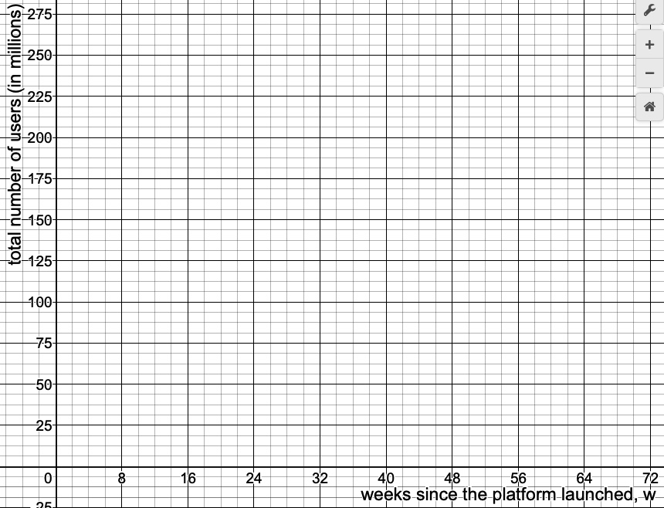

Phase 4 (characterizing concavity in terms of the AROC).

- During the time period depicted in the table and graph, is $I$ concave up or concave down? How can you see this in the table? How can you see this in the graph?

- During the time period depicted in the table and graph, is $S$ concave up or concave down? How can you see this in the table? How can you see this in the graph?

Phase 5 (extending to new scenarios). In the scenario above, the behavior of the average rate of change (i.e. the concavity) gives us additional information about the behavior of the total number of users for SnapFace (in which case the total number of users is increasing, but the average number of new users added per week is decreasing) and InstaTwit (in which case the total number of users is increasing, and the average number of new users is also increasing). Specifically, we already knew that the total number of users was increasing for both, but the average rate of change gave us information about how it was increasing. In the scenarios that follow, the objective will be to determine if the function is concave up, concave down, or has no concavity on the given interval, and then explain what additional information this provides about the function’s behavior.

- Facebook – the non-fictitious, ubiquitous, all-too-real social media platform – wasn’t always an internet giant. As of 2019, there are over 2.3 billion total Facebook users in the world. But 6 months after starting, they had a whopping 0.13 million total users, and it went from there:
Months since 12/31/2003, $m$ | Total Facebook users (in millions)
6 | 0.13
12 | 1.0
24 | 5.5
36 | 12.0
56 | 100.0
59.3 | 130.0
59.5 | 140.0
Consider the total number of Facebook users as a function of the number of months since December 31, 2003.

- The total amount of snowfall 3 hours into a blizzard is 3.25 inches. After 6 hours, it’s 5.72 inches. After 9 hours, it’s 7.11 inches. Consider the total amount of snowfall as a function of the number of hours since the blizzard began.

- You return from summer break to find that you owe the university library $235.16 in late fees for a book titled “Philosophical, Microgenetic, and Anthropomorphic Perspectives on the Experiences of Adolescent Mice Living in Southeastern North America in the Mid-to-Late Middle Ages” by Sue Perrbohring. You work out a payment plan with the library: you will pay 15% of the remaining balance each month. Consider the remaining balance $B$ as a function of the number of monthly payments you’ve made $m$.

- The profit $P$ (in thousands of dollars) of a company that produces and sells magic carpets is given by $P\left(m\right)=P(m)=-m^{2}+184.9m-5805.1$, where $m$ is the number of magic carpets produced. Consider only the production interval from 0 to 150 magic carpets.

