**Activity 3: Characterizing Covariation in Terms of Rate of Change**

**GRAPH 1**

***Do not show this graph to your partner.*** Describe the covariation of *x* and *f*(*x*) to enable your partner to sketch a graph of the function. Do not describe figurative properties of the graph (i.e., “it goes up,” “it is straight,” “it curves down”).

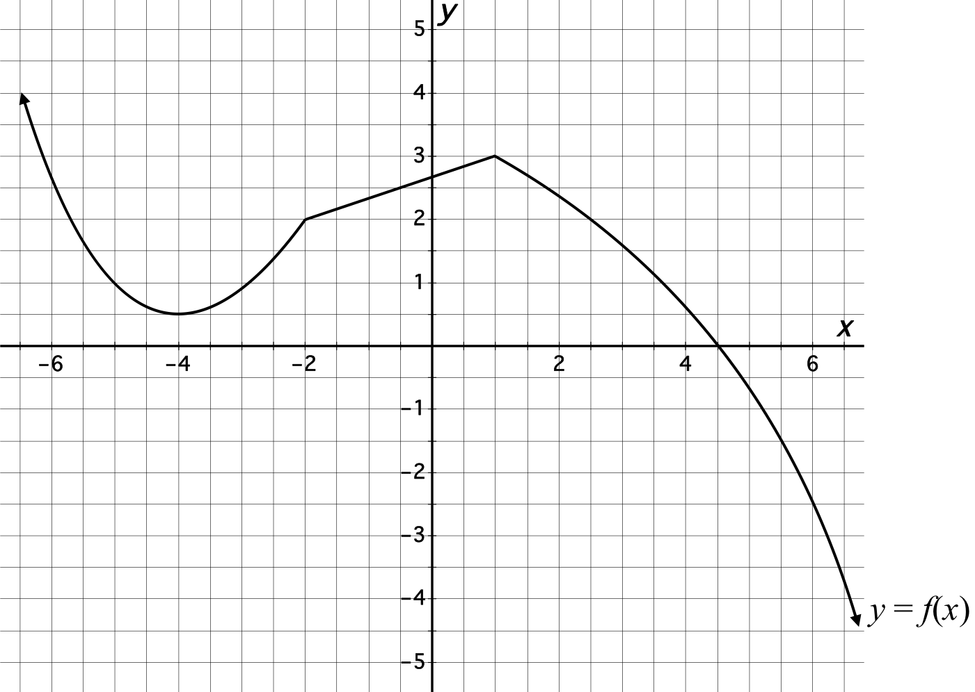

**Activity 3: Characterizing Covariation in Terms of Rate of Change**

**GRAPH 2**

***Do not show this graph to your partner.*** Describe the covariation of *x* and *f*(*x*) to enable your partner to sketch a graph of the function. Do not describe figurative properties of the graph (i.e., “it goes up,” “it is straight,” “it curves down”).

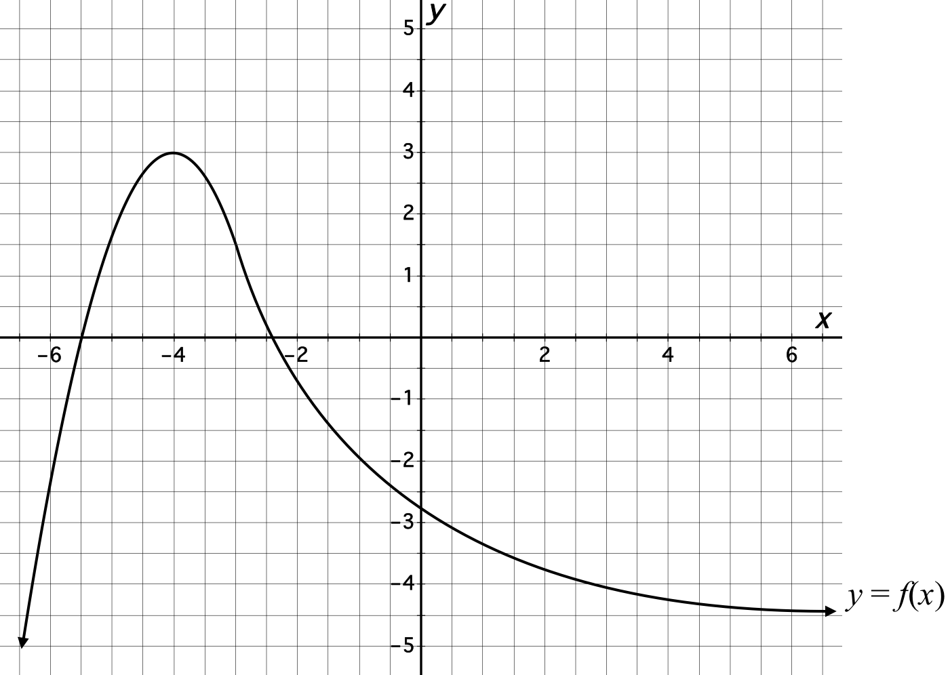

**Activity 3: Characterizing Covariation in Terms of Rate of Change**

**GRAPH 3**

***Do not show this graph to your partner.*** Describe the covariation of *x* and *f*(*x*) to enable your partner to sketch a graph of the function. Do not describe figurative properties of the graph (i.e., “it goes up,” “it is straight,” “it curves down”).

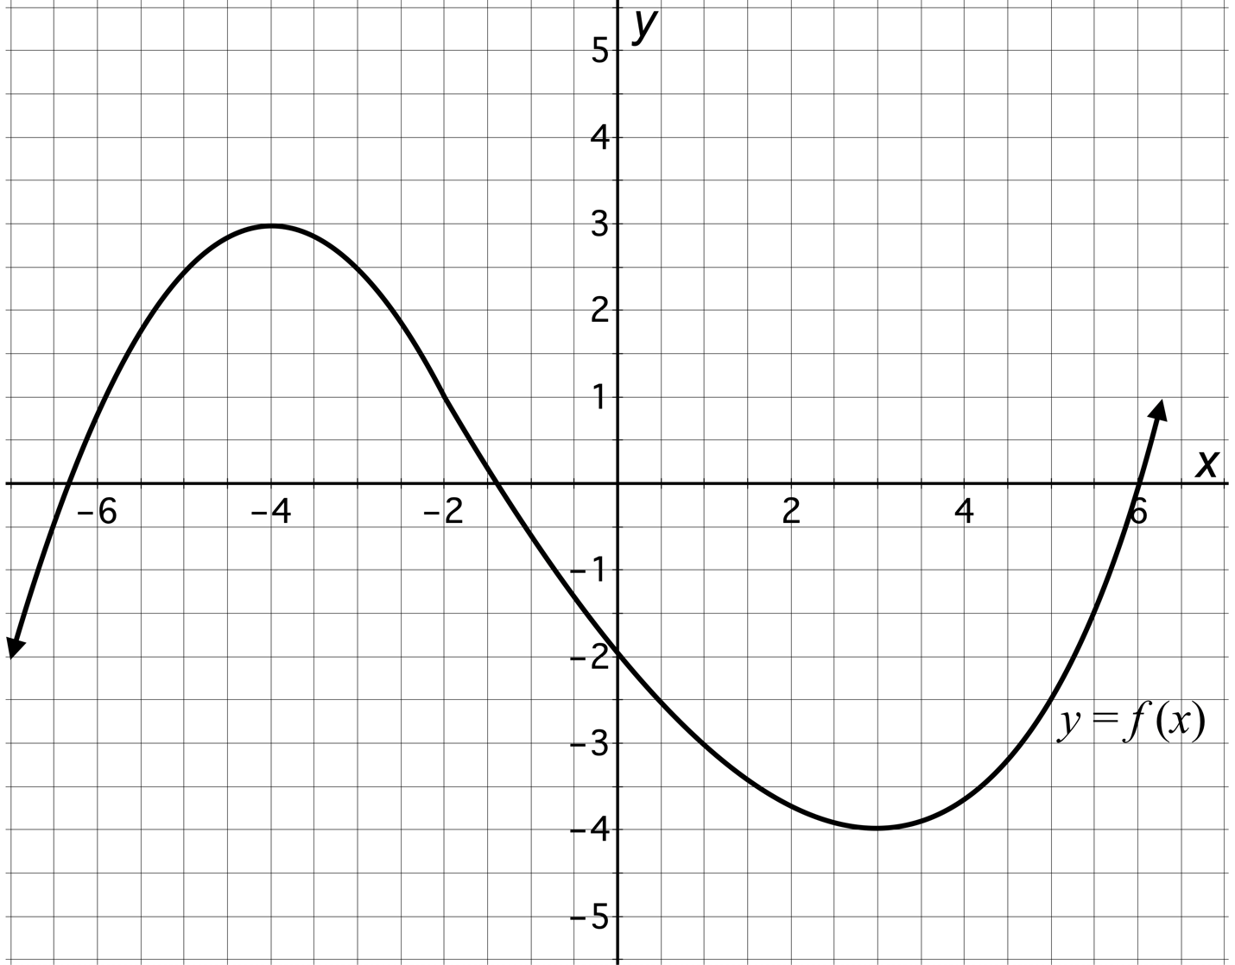

**Activity 3: Characterizing Covariation in Terms of Rate of Change**

**COORDINATE SYSTEM A**

Sketch a graph of the function your partner describes on the axes provided.

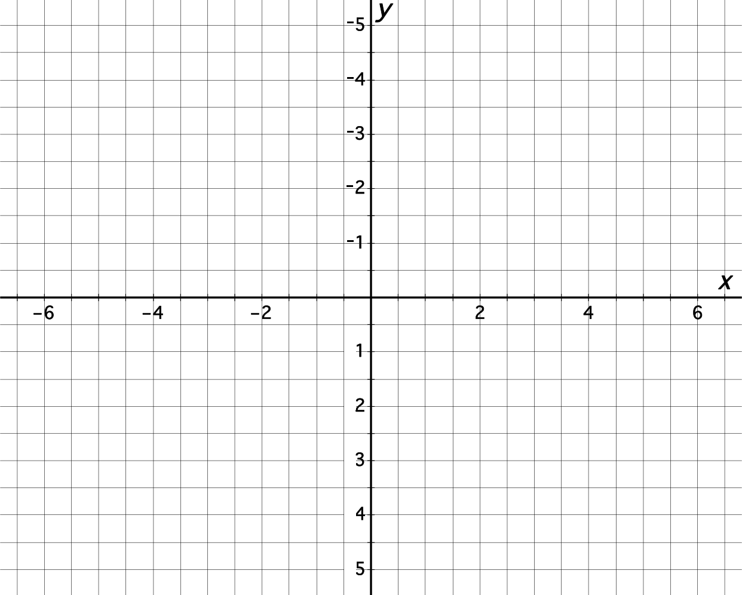

**Activity 3: Characterizing Covariation in Terms of Rate of Change**

**COORDINATE SYSTEM B**

Sketch a graph of the function your partner describes on the axes provided.



**Activity 3: Characterizing Covariation in Terms of Rate of Change**

**COORDINATE SYSTEM C**

Sketch a graph of the function your partner describes on the axes provided.

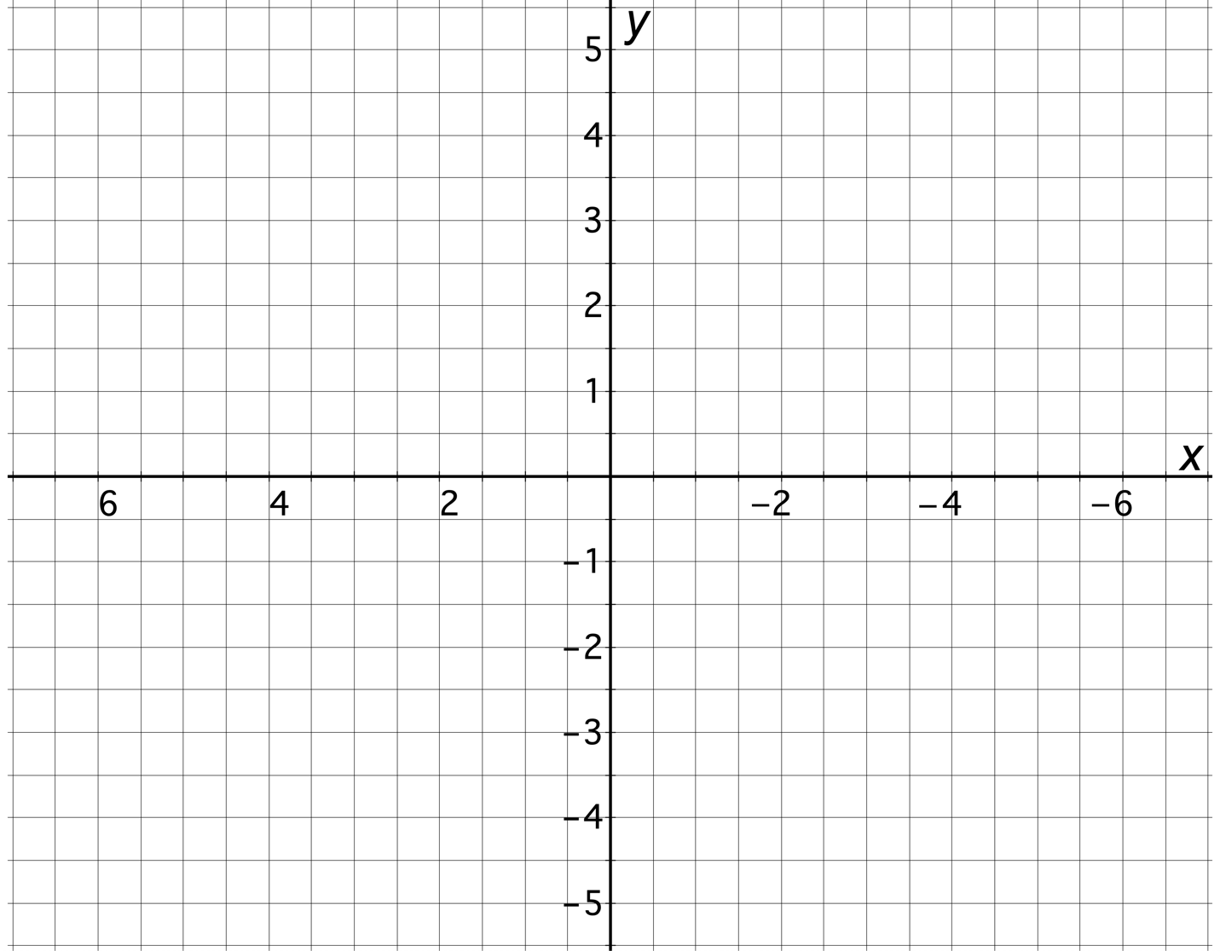

**Activity 3: Characterizing Covariation in Terms of Rate of Change**

Complete the following tasks in collaboration with your partner/group.

1. A car accelerates from rest away from an intersection. Which of the following graphs most accurately represents the relationship between the car’s distance *d* away from the intersection (in meters) and the number of seconds elapsed *t* since the car began accelerating away from the intersection? ***Justify your selection***.

a. b.

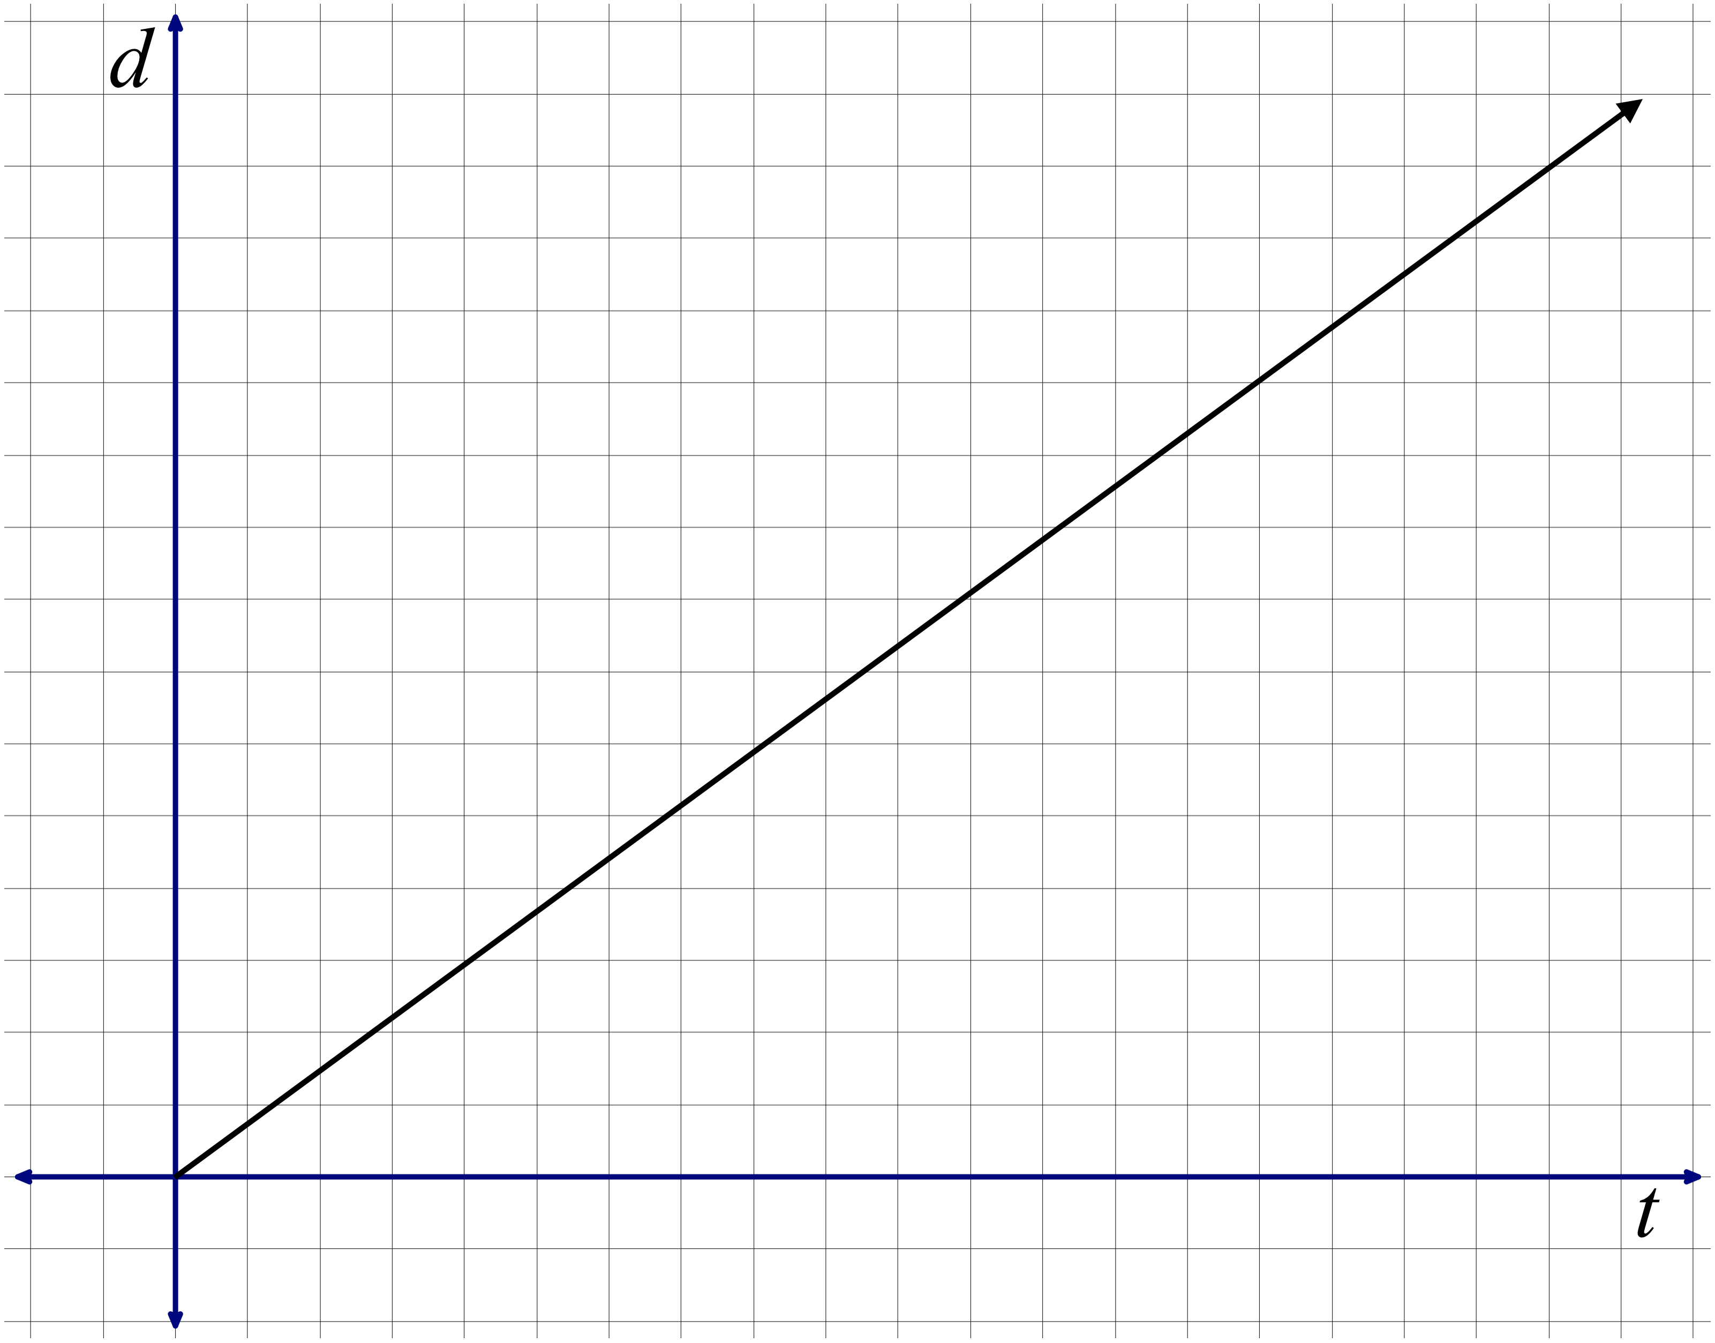 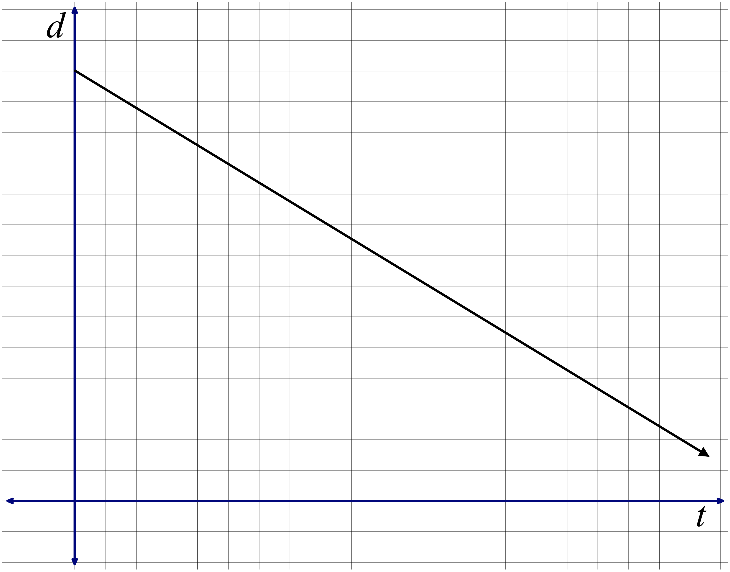

c. d.

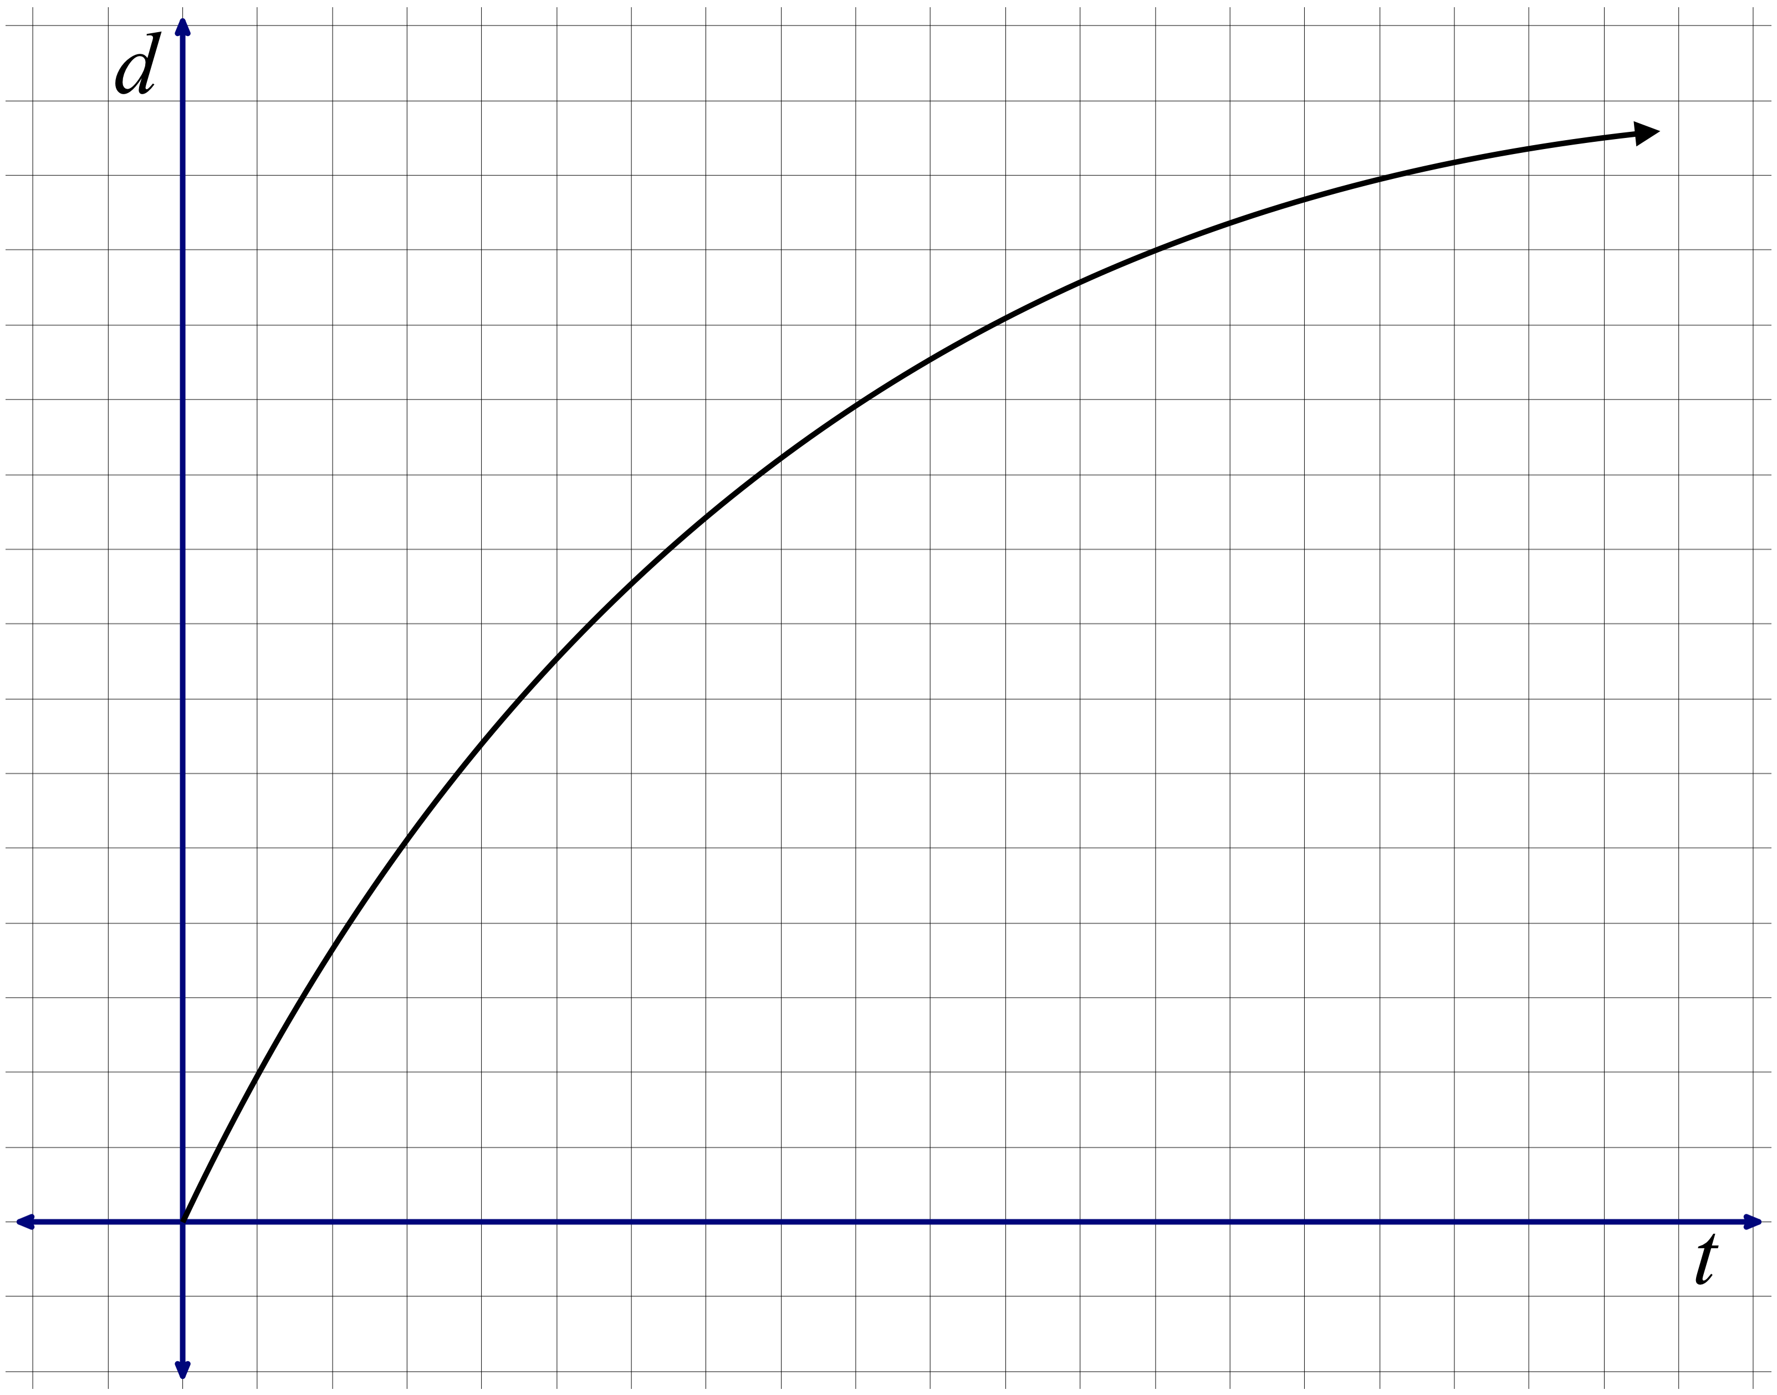 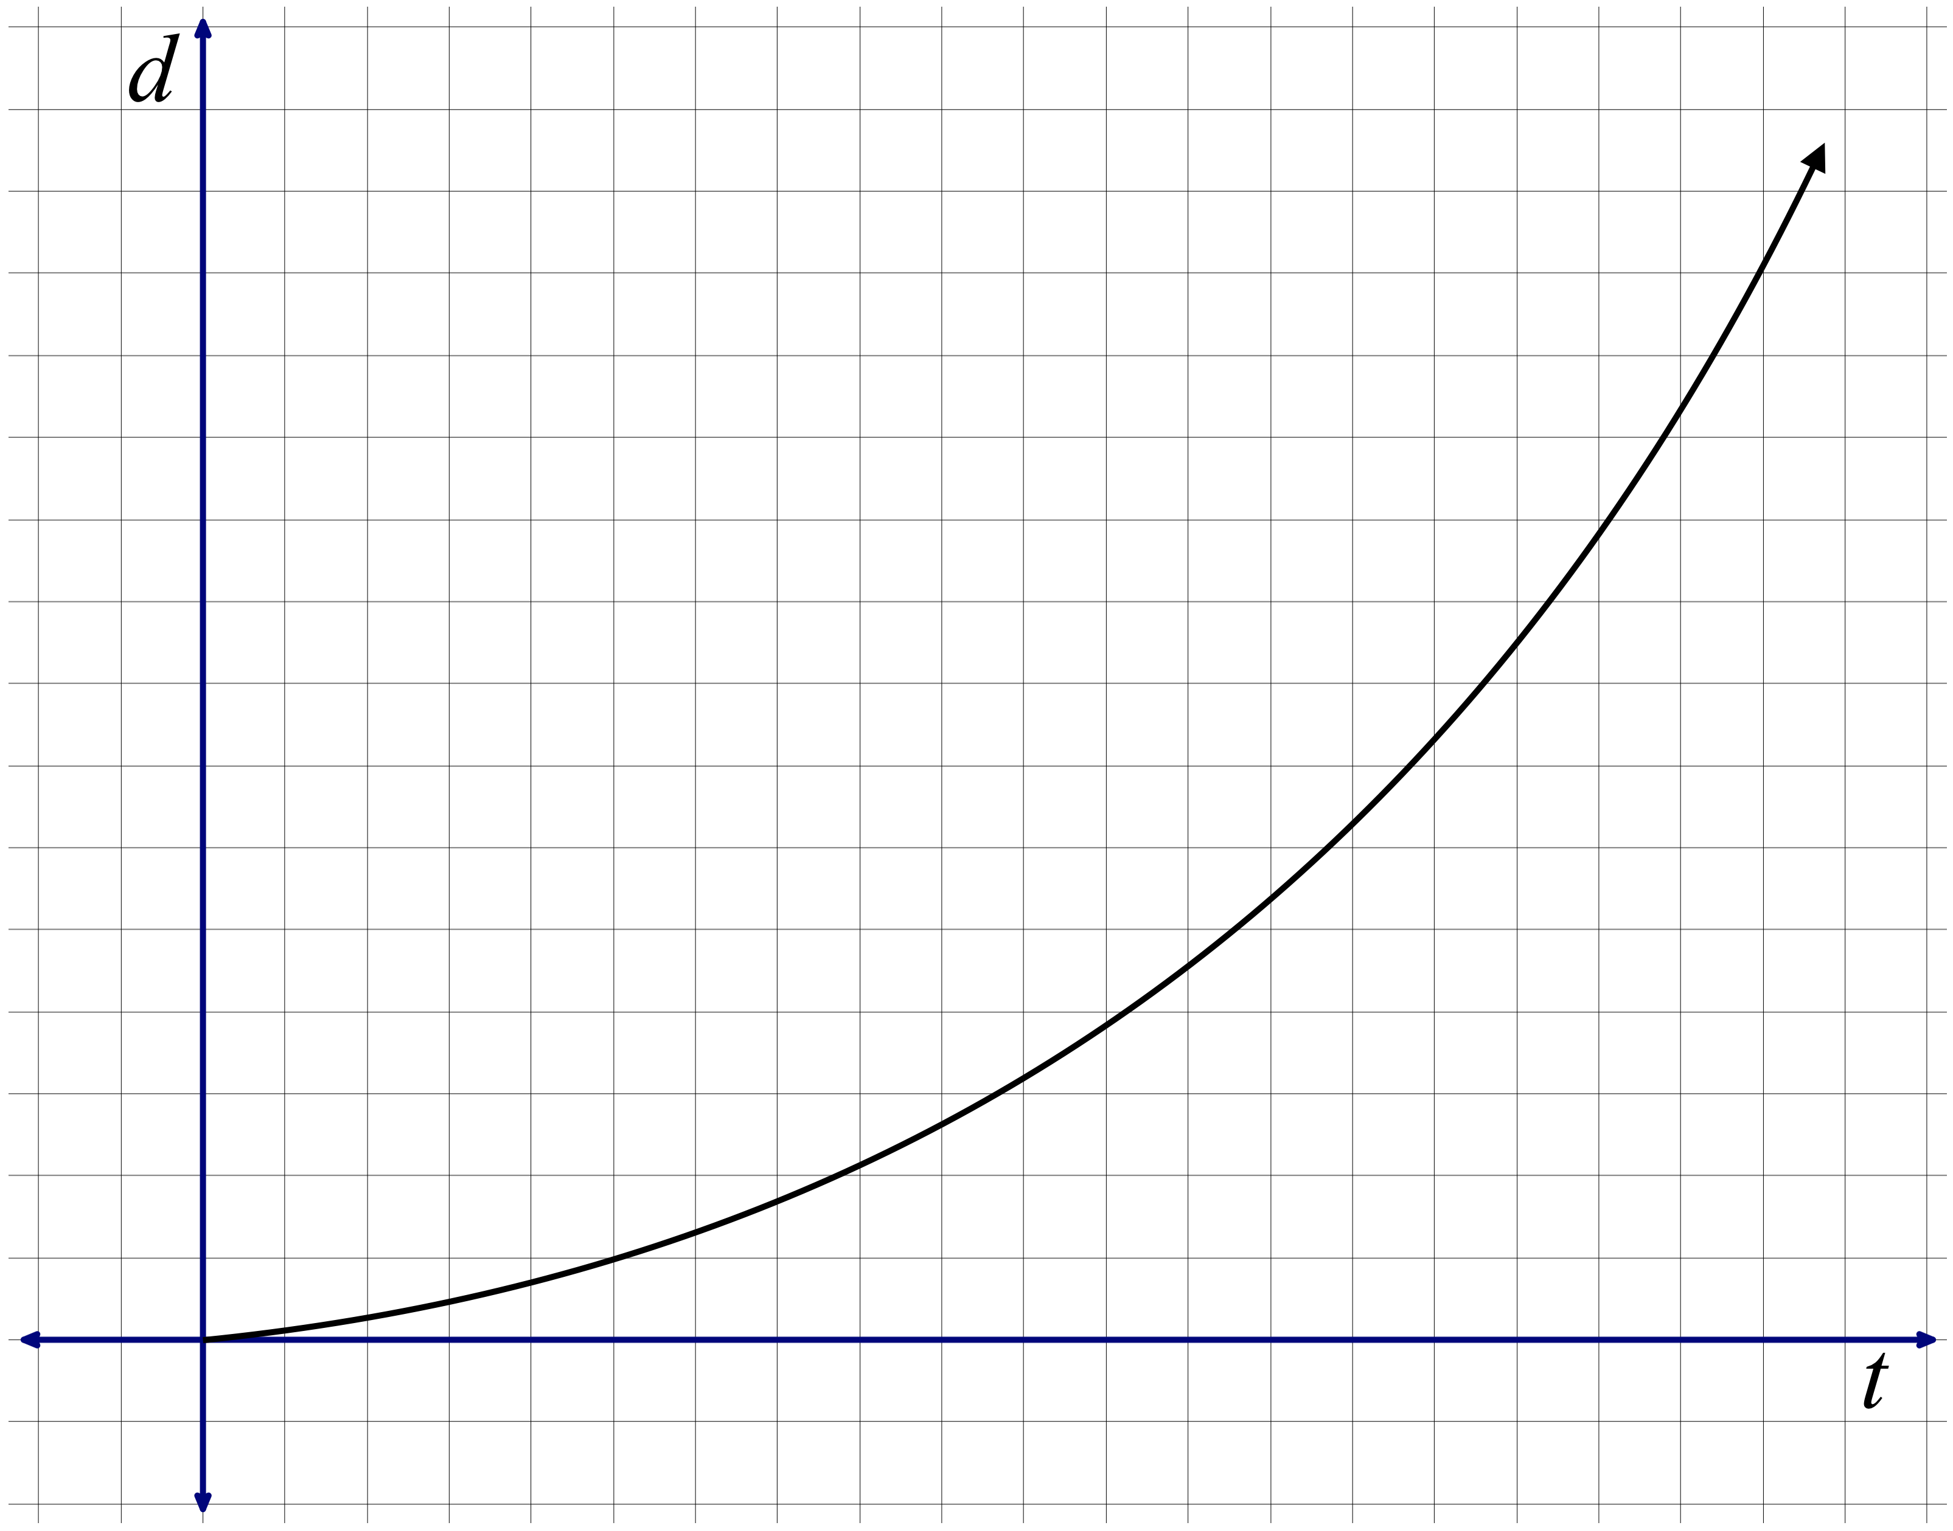

e.

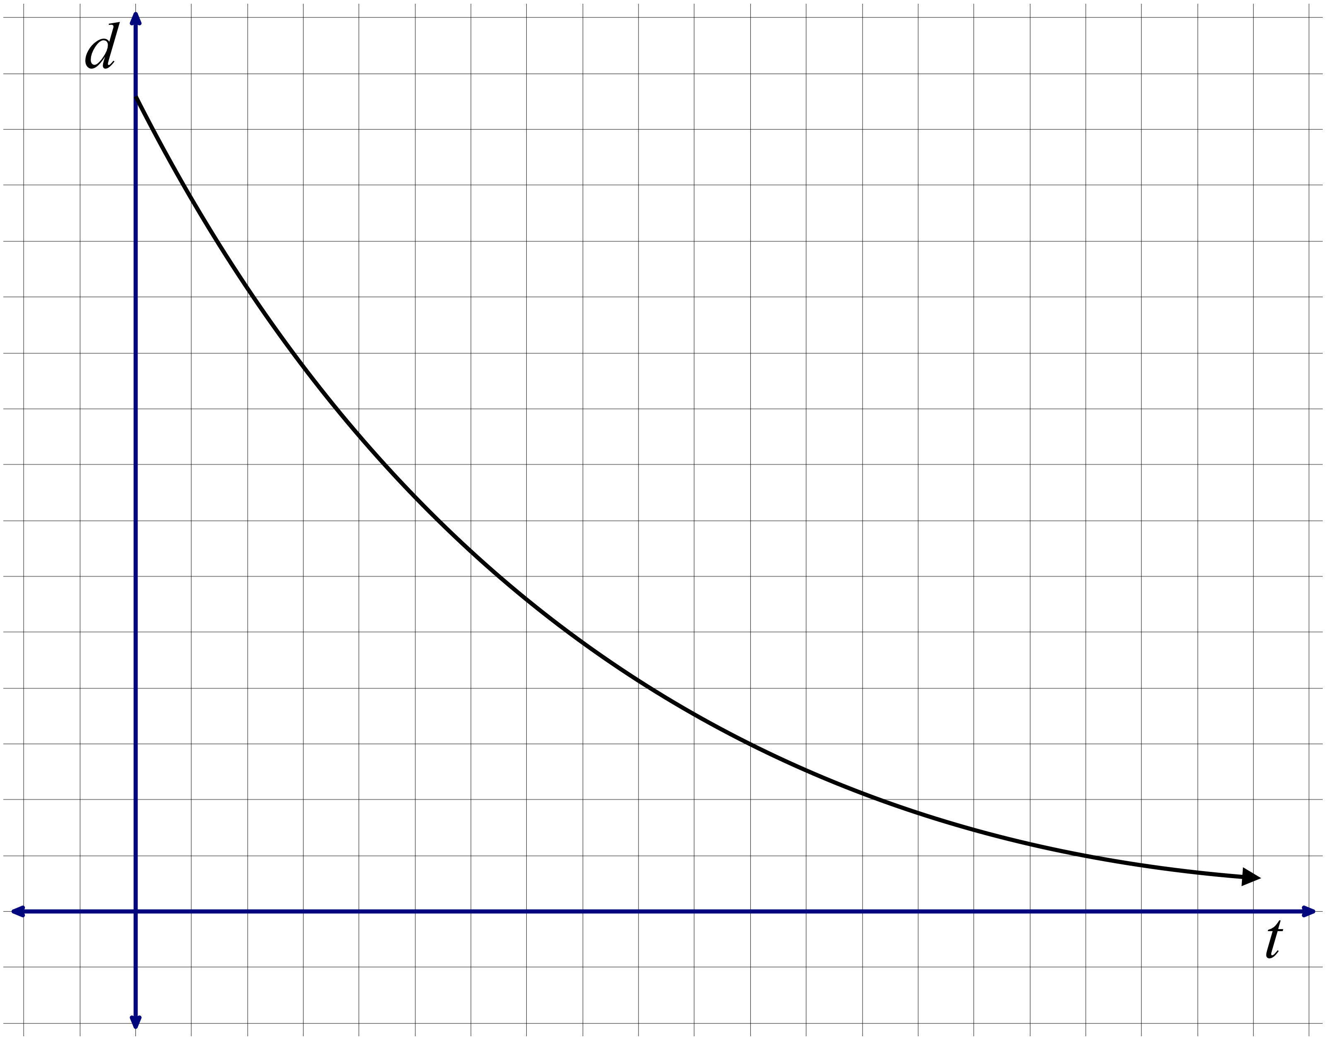

2. Imagine the bottle below being filled with water. Which of the following graphs most accurately represents the relationship between the volume *v* of water in the bottle and the height *h* of water in the bottle? ***Justify your selection***.

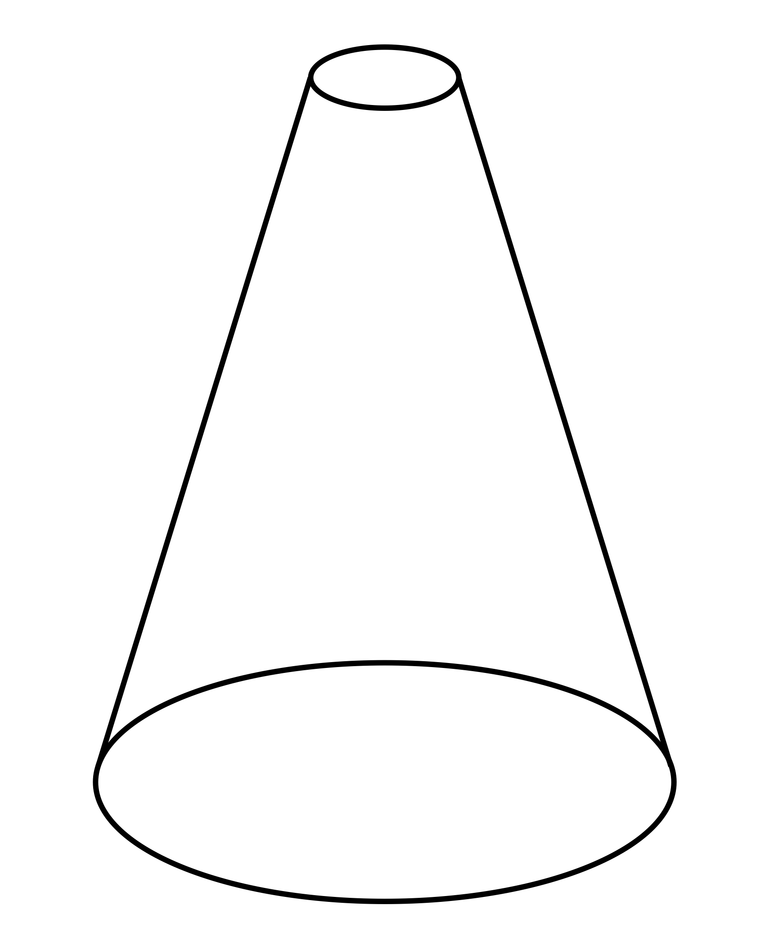

1. b.

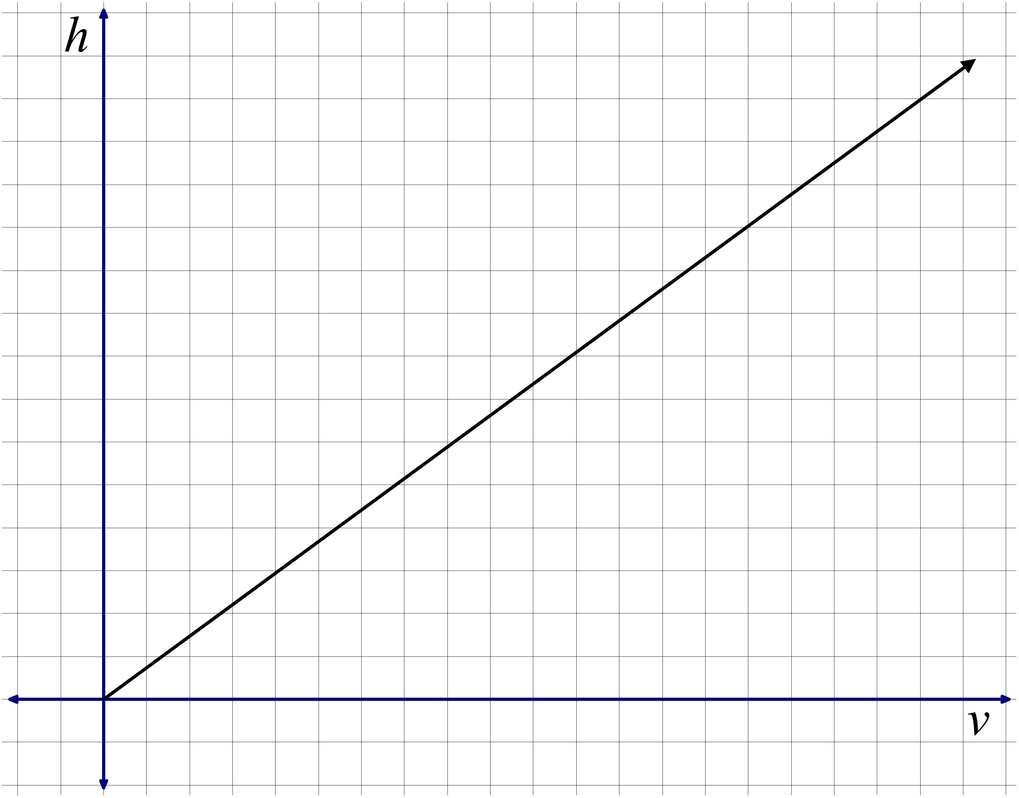 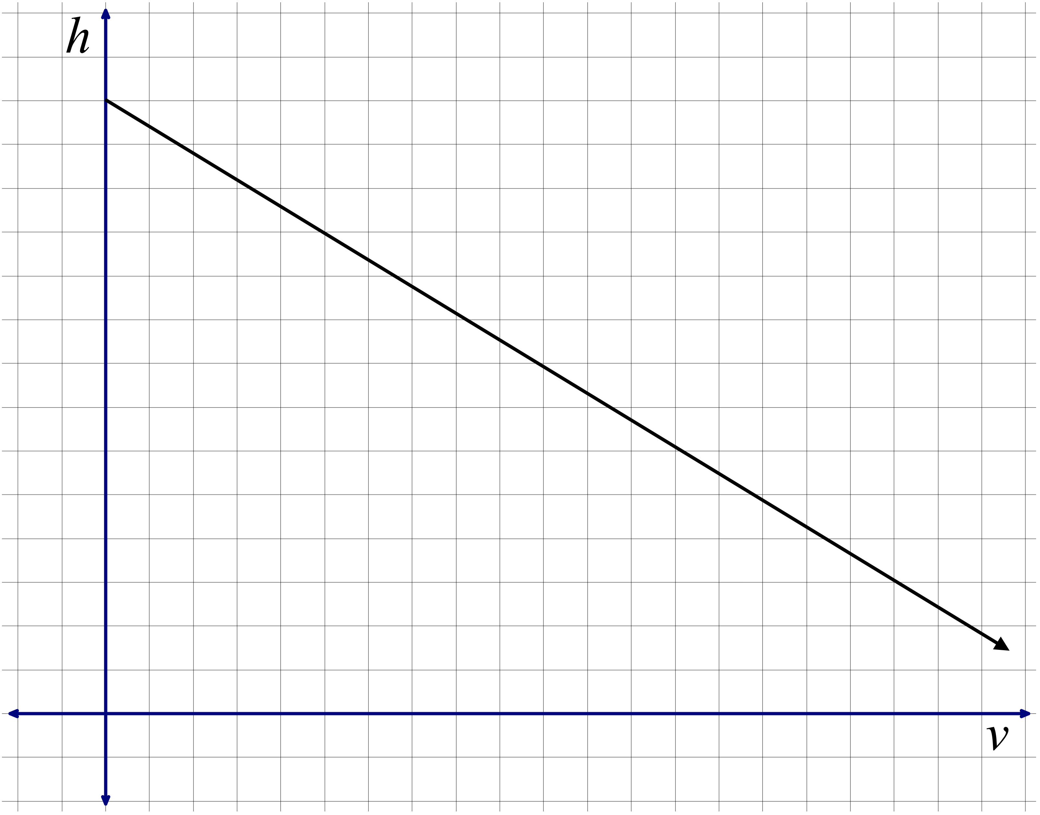

1. d.

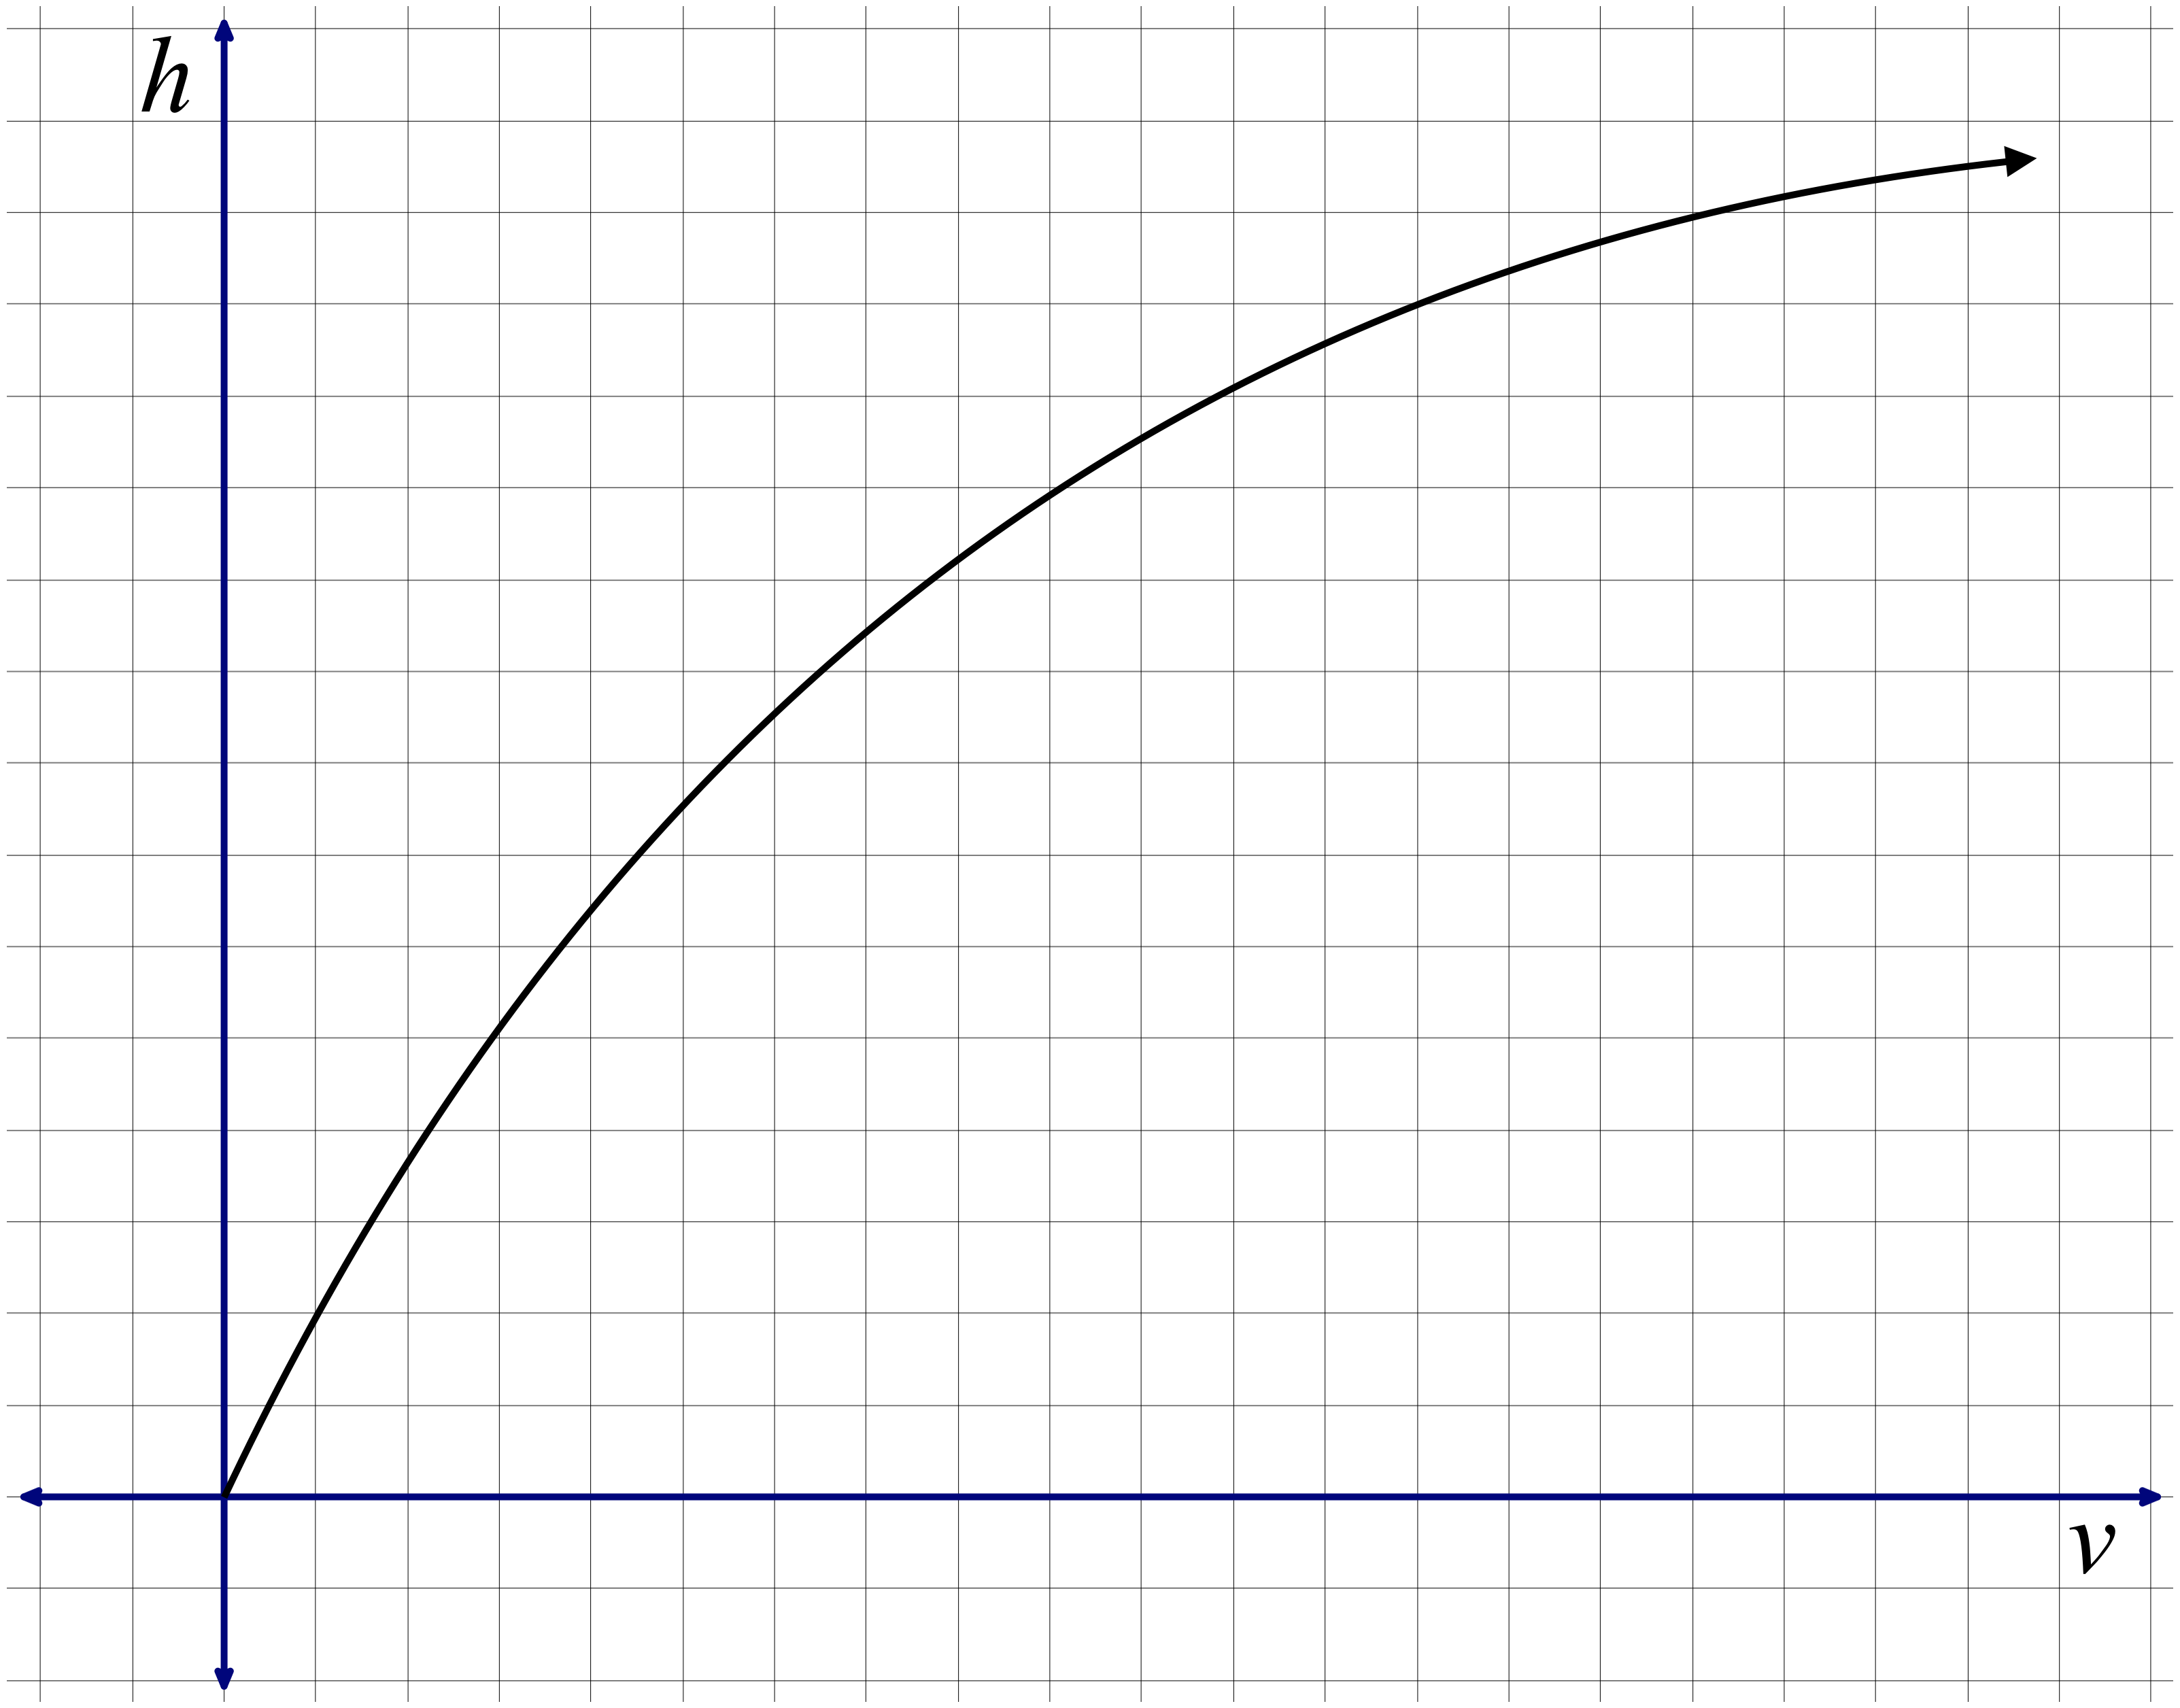 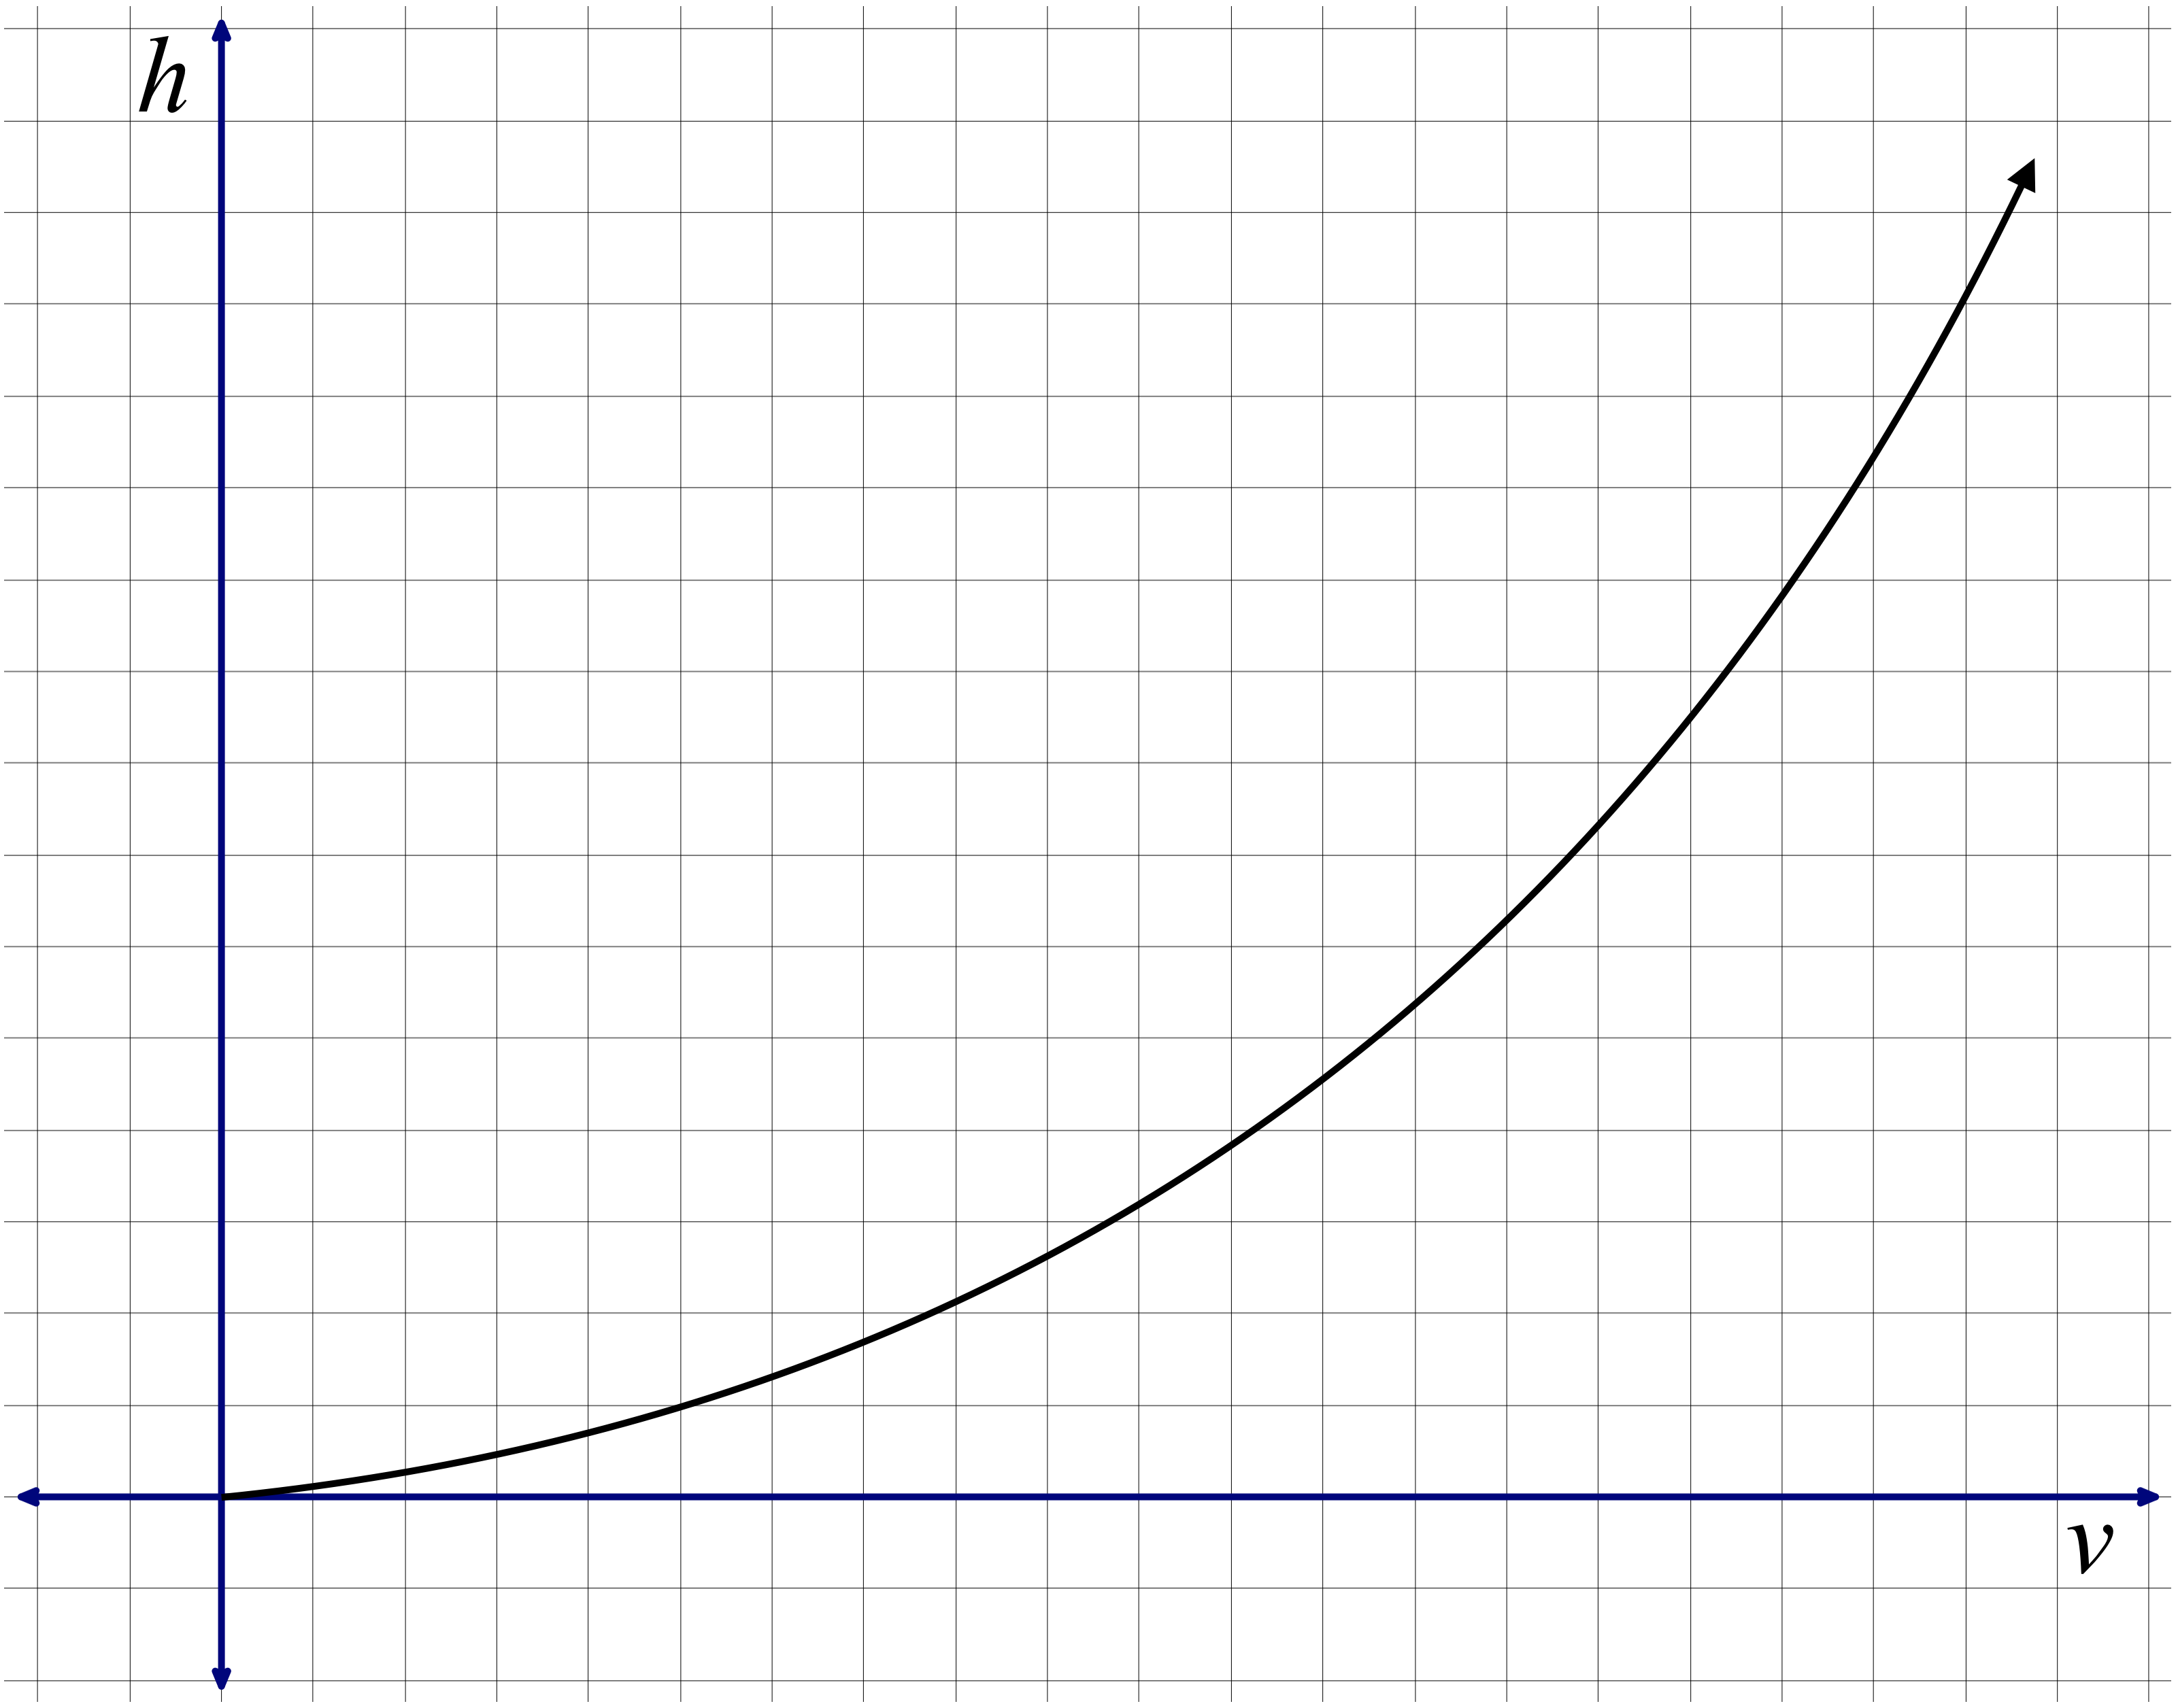

3. Imagine the bottle below being filled with water. On the axes provided, sketch a graph of the relationship between the volume *v* of water in the bottle and the distance *d* from the surface of the water to the top of the bottle.

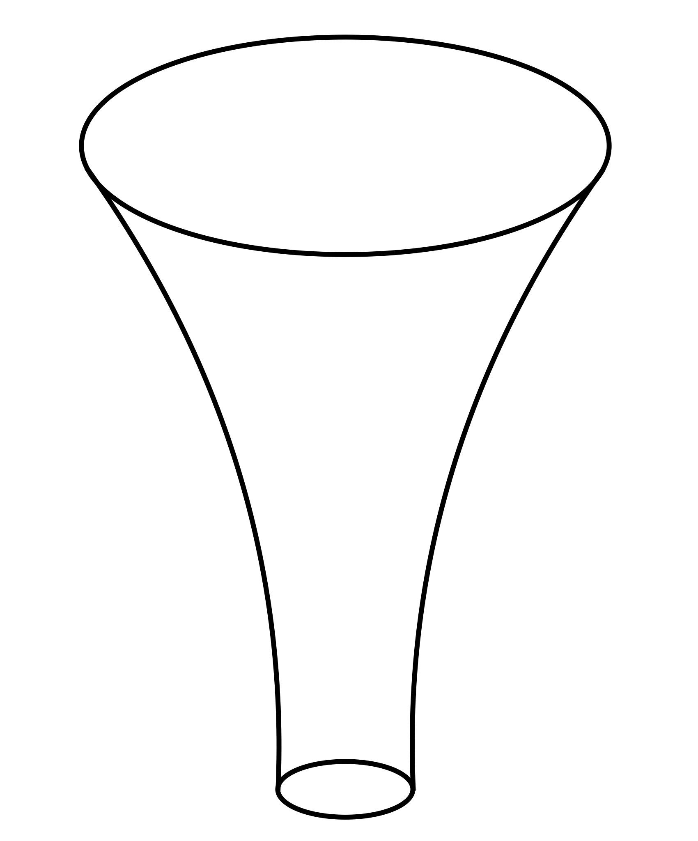



Average rates of change are measurements of how a function’s output quantity changes in tandem with changes in the input quantity. ***Concavity*** is a measurement of how a function’s average rate of change itself changes in tandem with changes in a function’s input quantity. Examples are shown below, along with line segments whose slopes represent the functions’ average rates of change over consecutive intervals.

**Example I**: positive concavity **Example II**: positive concavity

(“concave up”) on the entire domain (“concave up”) on the entire domain

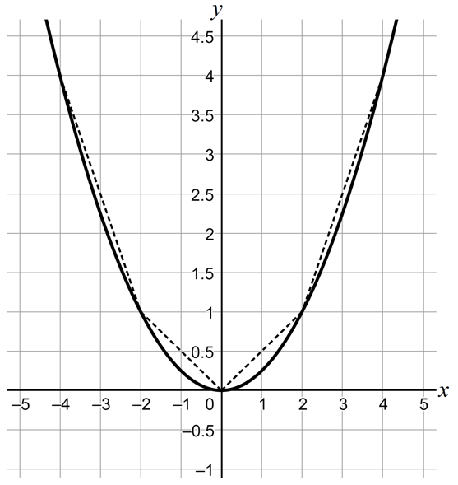 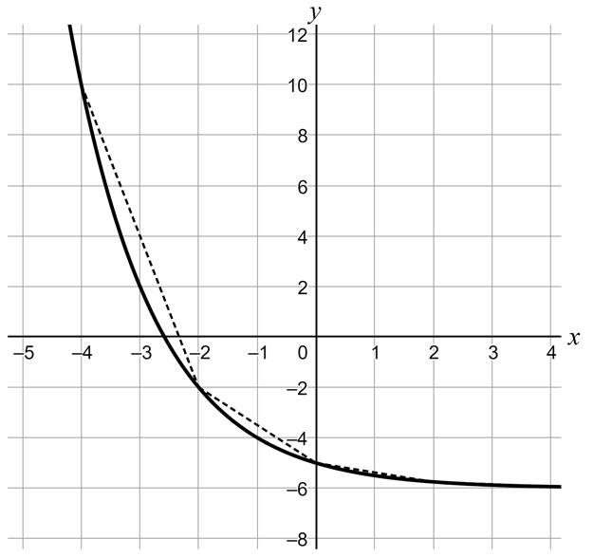

**Example III**: negative concavity **Example IV**: negative concavity

(“concave down”) on the entire domain (“concave down”) on the entire domain

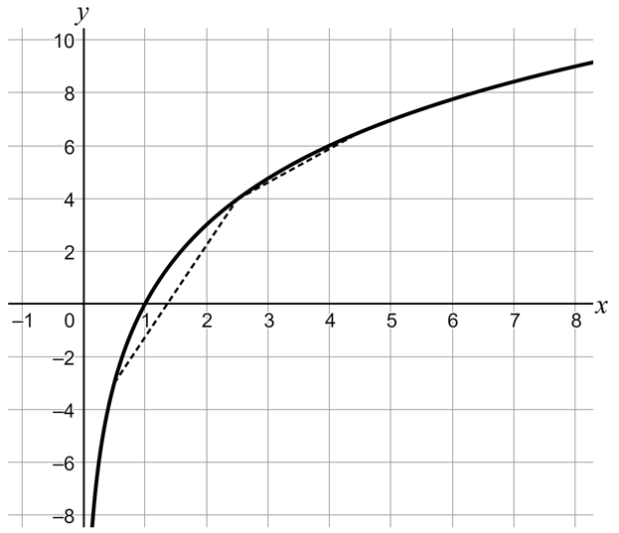 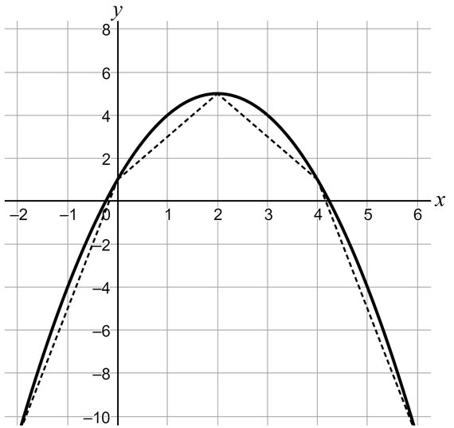

***Concavity***

For any function *f*, imagine looking at an interval of the domain from *x* = *a* to *x* = *b* and dividing it into any number of equal-sized subintervals.

* *f* is said to have ***positive concavity*** on the interval (*a*, *b*) if the function’s average rate over successive intervals always increases.
* *f* is said to have ***negative concavity*** on the interval (*a*, *b*) if the function’s average rate over successive intervals always decreases.

4. a. Using the language of average rate of change, explain why the function displayed in Example I has positive concavity over the interval shown.

b. Using the language of average rate of change, explain why the function displayed in Example II has positive concavity over the interval shown.

c. Using the language of average rate of change, explain why the function displayed in Example III has negative concavity over the interval shown.

d. Using the language of average rate of change, explain why the function displayed in Example IV has negative concavity over the interval shown.

4. Return to the graph that you or your partner sketched at the beginning of this activity. Over what interval(s) of the domain does the function have positive concavity? Over what interval(s) of the domain does the function have negative concavity?

5. At 5:00 pm Karen started walking from the grocery store back to her house.

1. Fill in the table by determining the number of feet Karen is from home, *d.* Then use the information in the table to determine the average rate of change of the number of feet Karen is from home with respect to time (measured in minutes since Karen started walking) on the specified intervals.

|  |  |  |  |  |
| --- | --- | --- | --- | --- |
| Change in the number of minutes since Karen started walking | Number of minutes since Karen started walking  *t* | Number of feet Karen is from home  *d* | Change in the number of feet Karen is from home | Average rate of change of Karen’s distance with respect to time |
|  | 0 | 118 |  |  |
|  | –1.5 |  |
| 0.5 |  |
|  | –3.2 |  |
| 1 |  |
|  | –6.5 |  |
| 1.5 |  |
|  | –7.1 |  |
| 2 |  |
|  |  |  |

b. Does this function have positive concavity (“concave up”), negative concavity (“concave down”), or some combination of both on the interval ? Make sure you can justify your answer.

c. Describe how the quantities *number of minutes since Karen started walking* and the *number of feet Karen is from home* change together.

6. a. The function *h* is defined by. Use *h* to complete the table.

|  |  |  |  |  |
| --- | --- | --- | --- | --- |
|  | *x* |  |  | Average rate of change of *h*(*x*) with respect to *x* |
|  | 1 | 0 |  |  |
|  |  |  |
| 2 | 0.5 |
|  |  |  |
| 4 | 1 |
|  |  |  |
| 8 | 1.5 |
|  |  |  |
| 16 | 2 |
|  |  |  |

1. Is *h* an increasing or decreasing function (or a combination of the two)? Explain.

1. Does *h* have positive concavity (“concave up”) throughout its domain, negative concavity (“concave down”) throughout its domain, or a combination of the two? How do you know?
2. Is  an increasing or decreasing function (or a combination of the two)? Explain.
3. Does  have positive concavity throughout its domain (“concave up”), negative concavity (“concave down”) throughout its domain, or a combination of the two? How do you know?