Cowboy Joe’s Trailers
Instructor notes follow the presentation of the activity.
REACT problem 2: Trailer Sales
Cowboy Joe’s Trailers manufactures and sells small trailers. Each trailer costs $100 to make, and the company’s fixed costs are $4000. In addition, the owner of the company knows that the price of each trailer comes from a price function m(𝑥)=400−3𝑥. Here m is price, measured in dollars ,and x represents the number of trailers.
Remember to approach these problems using the list REACT:
Read
- Read the problem and determine what you are being asked
- Determine what information you are given and what missing information you need

Explore
- Consider multiple potential solution methods

Attempt
- Try to solve the problem using any of the explored strategies

Critique
- Evaluate if the attempted method solved the problem

Teach
- Explain the solution and the reasoning behind it

- If revenue is equal to the number of units sold times the price per unit, find the company’s revenue function 𝑅(𝑥). Here R represents revenue in dollars.
- Find the company’s cost function 𝐶(𝑥). Here C represents cost in dollars.
- Find the company’s profit function 𝑃(𝑥). Here P represents profit in dollars.
- What is the range of number of trailers sold for Cowboy Joe’s to make a profit?
- What is the maximum profit expected for this company and how many trailers must be sold to achieve this?

Instructor Notes
Mathematical Content
- Linear functions/quadratic functions
- Rate of change/graphing/patterns
- Interpretation of a graph/function/line of best fit
- Develop knowledge of variables in equations and what they represent (profit/loss vs production/cost)

Learning Objectives
- Students will be able to identify mathematical patterns
- Students will identify variables (price, cost, # of trailers, revenue, profit)
- Students will reason and communicate about how changes in one quantity will affect change in another quantity
- Students will make predictions using graphical models and reason and communicate about the accuracy/dependability of those predictions.
- Students will analyze the data and write an equation for function.
- Students will analyze a data set to determine if there is a constant (additive) rate of change or a constant multiplicative change.
- Students will predict what type of relationship exists among the data using the information on the graph.
- Students will reason and communicate about representing the data visually/graphically using
  - Graphing paper
  - Charts
  - Graphing calculator
  - Desmos

Mathematical Understandings
Students will understand how to model data using an equation/function. To achieve this understanding, they will
- coordinate the value of one variable with changes in the other.
- understand average rate of change as follows: if a quantity were to grow in measure at a constant rate of change with respect to a uniformly changing quantity, then we would end up with the same amount of change in the dependent quantity as actually occurred.
- create a model of the data using an equation/function. To achieve this understanding, they will consider the relationships between price of a trailer as a function of number of trailers and proft; and between revenue, cost, and profit.
- Students will understand that a constant rate of change aligns to the equation type y = mx +b and is represented by a constant rate of change.
- Create a model for the data.
- Describe their solution based upon a model of the data.
- Students will understand a single-variable function as a relationship between an independent variable and a dependent variable, recognizing that the value of the independent variable determines the value of the dependent variable.
- Students will understand that a function is a relationship between two variables such that the value of the input determines the value of the output.
- Students will understand
  - that graph axes’ marks support making sense of the graph and mathematical communication
  - that the label and unit result from the process of quantification, defined as identifying the measurable characteristic of a situation and the way in which it will be measured.

Suggested Materials
- Graph paper
- Post it pads
- Colored Pencils
- Use Desmos, graphing calculator, or GeoGebra to illustrate the problem.

Teacher Notes
Active Learning
- Students will create a graph with x and y axes.
- Students will determine the variables associated in the problem and label them x and y. Part of the concept focus is determining which variable is the independent variable and which is the dependent variable.
- Students will look for a relationship between the two variables. At this point, students may choose to represent the problem in terms of a drawing, table, or a chart. The relationship between a chart and a function is reinforced by this task. This might also be helpful in assisting students to determine independent and dependent variables.

Meaningful applications:
- Students will use the graph/chart to predict the outcome of the problem, assessing if this outcome makes sense, building on conceptual knowledge of linear functions.
- Students will connect this type of problem with problems of similar nature. Sentence stems might be helpful guiding students to relationship; sentence stems guide students during productive struggle to solutions without telling students what they need to notice . Using variables advances the scope of application from a direct answer to considering the impact of multiple variables and the relationships between them. Examples may include:
  - When I review the rate of change between data points, I notice…
  - When I graph the data, I notice the shape of the graph is…
  - When my independent variable changes, the effect on the dependent variable is…
- Making predictions (projections) using a model helps students evaluate and critique their own solutions to problems and allows for a rich mathematical discussion.

Academic Success Skills
- Collaborative work helps students be less anxious, avoiding math anxiety.
- Group work allows students to build math identities as they spark ideas from each other, affirming what works, and equally as important, what might not work.
- Students work together to deconstruct the elements of a problem, to identify how each element affects the problem, and to determine the objective of the problem.
Teachers should first read the REACT framework. They should review the framework with the students before the students attempt to engage with the problem.
Read the problem
Students will read the problem. The goals are to find formulas for revenue, cost, and profit, then to determine the number of trailers Joe must sell to make a profit, the maximum profit, and the number of trailers that must be sold to achieve that maximum proft. The given information is the price of a trailer as a function of number of trailers. Information is also given as to how to compose a revenue function. Students might need to find information about what goes into a cost function and/or what goes into a profit function.

Explore the Data
- Write the functions as prompted in the problem. What is the relationship between profit, revenue and cost?
Graph the data.
Determine how the fixed cost affects the y axis. Describe what this means in terms of cost.
What does the point where the two lines intersect mean?
What quadrant is relevant to this example? Describe why you chose this quadrant.
LOs:
- Students will reason and communicate about how changes in one quantity (cost) will affect change in another quantity (production).
- Students will reason and communicate about representing the data visually/graphically.

MU:
- Coordinate the value of one variable with changes in the other.

Attempt
Students will graph the equations.
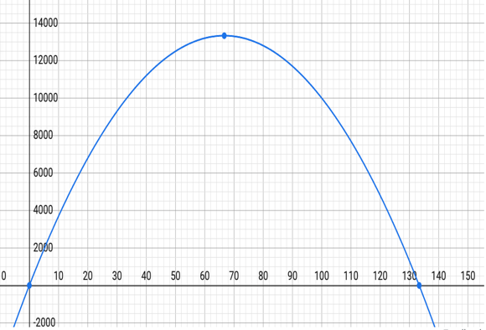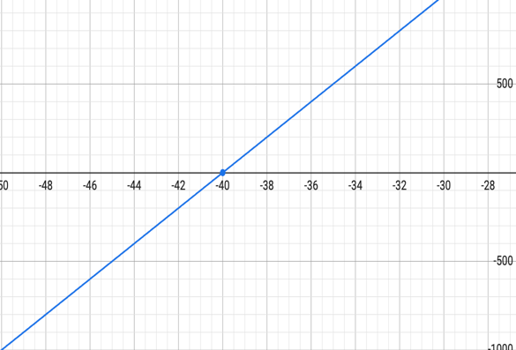
1) R(x) = 400x-3$x^{2}$ 2) C(x) = 4000+100x

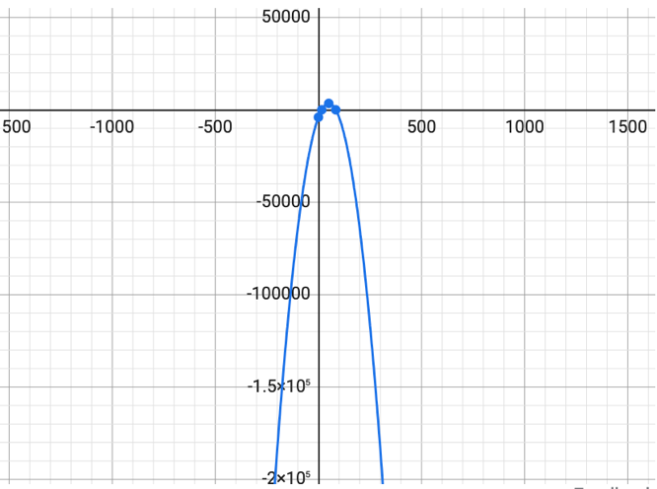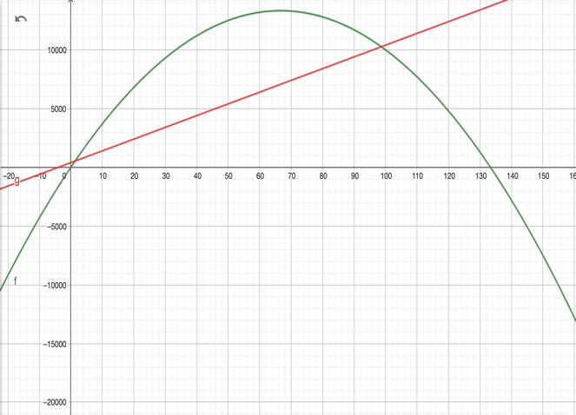
3) P(x) = -3$x^{2}$+300x-4000 4) Range to break even is between 2 and 99 trailers
5) The vertex is (50,3500) so, max profit is $3500.
LO
- Students will create a model using data points and appropriate technology.
MU
- Describe their solution based upon a model of the data

Critique & Teach
Evaluate and discuss the accuracy of your model.

NOTES: In evaluating and discussing the accuracy of the model, students can start to compare the ideas of functions and what the relationship is between the functions. This can also help them develop a critical eye when looking at other models. This creates an opportunity to discuss systems of equations.
LOs
- Students will identify variables
- Students will reason and communicate about how changes in one quantity will affect change in another quantity.
Mus
- Create a model for the data.
- Students will discuss the information the data reveals.

This characterization of average rate of change is adapted from Carlson, Oehrtman, & Moore (2009). Precalculus: Pathways to Calculus, a Problem Solving Approach.

