**Credit Card Activity - Handout**

Suppose that as a Freshman you apply for the [Chase Unlimited Freedom](https://creditcards.chase.com/a1/freedom-unlimited/affiliates2023?CELL=6H8X&AFFID=soUklM1vUj4-5bz8yctcXzoXXSQbSoh_qg&pvid=168720222094506823571W2293_6490aa4ab747b&jp_cmp=cc/1331005/aff/15-31608/na) credit card and receive your credit card with a $2000 credit limit. This credit card has a 0% annual percentage rate (APR) for the first 15 months, meaning you don’t pay ANY interest during this time. After that, if you do not pay your bill, you owe 30% APR, which is accrued monthly.

After these 15 months, you have maxed out your credit and have a $2000 bill due the next month. You think perhaps you should wait to pay your credit card off until you graduate and get a job to pay for it. (In this case, where no payments are made, there are often additional fees owed; however, we will not consider this here in this example.)

1. Suppose after 15 months, you decide not to make your minimum payment on your credit card:
   1. In this case, you will owe a **30% annual interest rate.** How much of the 30% annual interest is owed after one month?
   2. How much total interest do you owe after the first month?
   3. How much is your credit card balance after the first month?
2. Suppose you cannot pay your credit card after the first **two months**.
   1. How much interest do you owe after the second month?
   2. How much do you owe on your credit card after the second month?
3. Suppose you cannot pay your credit card after the first **three months**.
   1. How much interest do you owe after the third month?
   2. How much do you owe on your credit card after the third month?
4. Use [Google Sheets](https://www.google.com/sheets/about/) or Microsoft Excel to repeat the calculations from steps 2-3, up to 36 months!
   1. Follow the steps described in [this video](https://drive.google.com/file/d/1iXiCs9ctqT0g01WVDsGt-mB7JQ3vEhfo/view?usp=drive_link) or together in class.
   2. Based on your calculations, how much do you owe after 36 months?
   3. How much interest have you accrued?
5. In this step, we’ll use the compound interest formula to calculate how much you would owe after 36 months.
   1. If you have not yet, familiarize yourself with the compound interest formula. Identify what each variable means.
   2. Use the compound interest formula to calculate how much you owe after 36 months.
   3. Compare with your answer in 4b.
6. Suppose after 15 months, you decide to get a part-time job to pay $100/month on your credit card. Let's do an experiment and compute how long it would take to pay off your credit card that way.
   1. Modify the formula in cell B3 to subtract 100 from each month's balance.

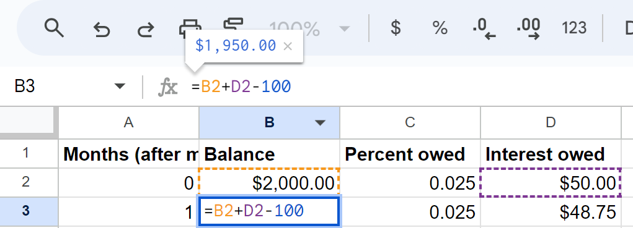

* 1. Then copy the formula in cell B3 down as you did in step 4b(iii).
  2. How long does it take to pay off your bill at this rate?
  3. After the last month in which you would pay your credit card off, how much total money would you have paid? (Make sure you include the total of all the payments you have made plus the last month's interest.)
  4. At this point, how much total interest have you paid? Compare with your answer from 4c.

1. (Optional) Suppose that, from the very beginning of college, you decided to get a part-time job and paid $100/month on your credit card. Let’s find out how much you would pay that way.
   1. Suppose again, you spend $2000 on your credit card during the first 15 months, but pay $100/month to pay it off. How much do you owe on your credit card after the first 15 months?
   2. If you continue to pay $100/month on your credit card after the first 15 months, how long would it take to pay it off?
   3. After the last month in which you would pay your credit card off, how much total money would you have paid? (Again, make sure you include the total of all the payments you have made plus the last month's interest.)
   4. By the time you pay your credit card off, how much interest have you paid?
2. Based on this, discuss with your group/class how this informs your approach to credit cards and loans. Write a 2-paragraph summarizing:
   * 1. The tools used for finding your results.
     2. Results and their significance.
     3. How can these results contribute to better decision-making?